Trans-Saharan Trade Networks: Document Analysis Activity
The Trans-Saharan Trade Networks were integral to Afroeurasian exchange in the period ca. 1200-1450 CE. You’ll be looking at several primary sources and analyzing them. Then be prepared to discuss these with your
peers!
Writings of Al Bakri (1057)
From the Boston University Pardee School of Global Studies, African Studies Center
The following description of the Kingdom of Ghana was written by Al-Bakri, a member of a prominent Spanish Arab family who lived during the 11th century. A Muslim geographer, he lived most of his life in Cordova and Almeria, and never left Islamic Spain. He wrote about the Sahara after gathering information from merchants and other visitors. In Roads and Kingdoms (1057), he wrote the following excerpts:
On Religion:
The city of Ghana consists of two towns situated on a plain. One of these towns, which is inhabited by Muslims, is large and possesses twelve mosques, in which they assemble for the Friday prayer. There are salaried imams and muezzins, as well as jurists and scholars... The king’s town is six miles distant from this one...
Between these two towns are continuous habitations. ...In the king’s town, and not far from his court of justice, is a mosque where the Muslims who arrive at his court pray. Around the king’s town are domed buildings and groves and thickets where the sorcerers of these people, men in charge of the religious cult, live. In them too are their idols and the tombs of their kings ... The king’s interpreters, the official in charge of his treasury and the majority of his ministers are Muslims... The king adorns himself like a woman (wearing necklaces) round his neck and (bracelets) on his forearms, and he puts on a high cap decorated with gold and wrapped in a turban of fine cotton. He sits in audience or to hear grievances against officials in a domed pavilion around which stand ten horses covered with gold-embroidered materials. Behind the king stand ten pages holding shields and swords decorated with gold, and on his right are the sons of the (vassel) kings of his country wearing splendid garments and their hair plaited with gold... At the door of the pavilion are dogs of excellent pedigree who hardly ever leave the place where the king is, guarding him. Round their necks they wear collars of gold and silver studded with a number of balls of the same metals...
Their religion is paganism and the worship of idols...
On every donkey-load of salt when it is brought into the country their king levies one golden dinar and two dinars when it is sent out. ... The best gold is found in his land comes from the town of Ghiyaru, which is eighteen days’ traveling distance from the king’s town over a country inhabited by tribes of the Sudan whose dwellings are continuous...
The king of Ghana when he calls up his army, can put 200,000 men into the field, more than 40,000 of them archers.
On Oases
Here is an excerpt about the Oasis town of Awdaghost Awdaghost is a former Berber town in current
Mauritiania. It was an important oasis in the Southern end of a caravan route.
In Awdaghust there is one cathedral mosque and many smaller ones all well attended. In all the mosques there are teachers of the Koran. Around the town are gardens with date palms. Wheat is grown there, by digging with hoes and it is watered with buckets. Only the kings and the rich eat wheat there. The rest of the people eat sorghum. Excellent cucumbers grow there, and there are a few small fig trees and some vines, as well as plantations of henna that produce a large crop. Awdaghust possesses wells with water. Cattle and sheep are so numerous that for a mithqal one may buy 10 rams or more. Honey too is very abundant, brought from the land of the Sudan. The people of Awdaghust enjoy extensive benefits and huge wealth. The market there is at

all times full of people, so that owing to the great crowd and the noise of voices it is almost impossible for a man to hear the words of one sitting beside him. Their transactions are in gold, and hey have no silver. There are handsome buildings and fine houses.
On Salt and Gold
On every donkey-load of salt when it is brought into the country their king levies one golden dinar, [a coin probably worth about two-weeks work for a North African laborer in the eleventh century] and two dinars when it is sent out. From a load of copper the king’s due is five mithqals, [i.e., the weight of five dinars] and from a load of other goods ten mithqals. The best gold found in his land comes from the town of Ghiyaru, which is eighteen days’ traveling distant from the king’s town over a country inhabited by tribes of the Soudan whose dwellings are continuous. The nuggets found in all the mines of his country are reserved for the king, only this gold dust being left for the people. But for this the people would accumulate gold until it lost its value. The nuggets may weigh from an ounce to a pound. It is related that the king owns a nugget as large as a big stone. The town of Ghiyaru is twelve miles from the [Niger River] and contains many Muslims.
Al-Bakri, The Book of Routes and Realms, cited in Levitzion and Hopkins, Corpus of Early Arabic Sources for West African History, (Cambridge University Press, 1981) pp. 79-81.
Al-Umari’s Observations of Cairo
From the Boston University Pardee School of Global Studies, African Studies Center
The following description of the visit to Cairo in 1324 by the King of Mali, Mansa Musa, was written by Al-Umari, who visited Cairo several years after the Mansa Musa’s visit.
From the beginning of my coming to stay in Egypt I heard talk of the arrival of this sultan Musa on his Pilgrimage and found the Cairenes eager to recount what they had seem of the Africans’ prodigal spending. I asked the emir Abu...and he told me of the opulence, manly virtues, and piety of his sultan. “When I went out to meet him {he said} that is, on behalf of the mighty sultan al-Malik al-Nasir, he did me extreme honour and treated me with the greatest courtesy. He addressed me, however, only through an interpreter despite his perfect ability to speak in the Arabic tongue. Then he forwarded to the royal treasury many loads of unworked native gold and other valuables. I tried to persuade him to go up to the Citadel to meet the sultan, but he refused persistently saying: “I came for the Pilgrimage and nothing else. I do not wish to mix anything else with my Pilgrimage.” He had begun to use this argument but I realized that the audience was repugnant to him because he would be obliged to kiss the ground and the sultan’s hand. I continue to cajole him and he continued to make excuses but the sultan’s protocol demanded that I should bring him into the royal presence, so I kept on at him till he agreed.
When we came in the sultan’s presence we said to him: ‘Kiss the ground!’ but he refused outright saying: ‘How may this be?’ Then an intelligent man who was with him whispered to him something we could not understand and he said: ‘I make obeisance to God who created me!’ then he prostrated himself and went forward to the sultan. The sultan half rose to greet him and sat him by his side. They conversed together for a long time, then sultan Musa went out. The sultan sent to him several complete suits of honour for himself, his courtiers, and all those who had come with him, and saddled and bridled horses for himself and his chief courtiers....
This man [Mansa Musa] flooded Cairo with his benefactions. He left no court emir nor holder of a royal office without the gift of a load of gold. The Cairenes made incalculable profits out of him and his suite in buying and selling and giving and taking. They exchanged gold until they depressed its value in Egypt and caused its price to fall.” ...
Gold was at a high price in Egypt until they came in that year. ... from that time its value fell and it cheapened in price and has remained cheap till now... This has been the state of affairs for about twelve years until this day by reason of the large amount of gold which they brought into Egypt and spent there. ...

Al-Umari cited in Levitzion and Hopkins Corpus of Early Arabic Sources for West African History (Cambridge University Press 1981) pp. 269-273.
Kingdom of Mali/Hajj
In 1324, Mansa Musa left Mali for the hajj to Mecca. On the trip, he gave away enormous amounts of gold.
Because of this, Europeans learned of Mali’s wealth. In 1375, a Spanish mapmaker created an illustrated map
showing Mansa Musa’s kingdom in western Africa. Drawn on the map is Mansa Musa holding a gold nugget.
“This map shows the trip to Mecca made in A.D. 1324 by the fabulously wealthy king Mansa Musa (reigned, 1312?-37) of the Mali Empire. With the map is an explanation of some of the symbols it uses. This facsimile [exact copy] of the Catalan Atlas, probably by Abraham Crèsques (d. 1387), edited and with commentary by Georges Grosjean, was published as Mapamundi, the Catalan Atlas of the Year 1375 (Dietikon-Zurich: Urs Graf; sole distributor in the United States and Canada: Abaris Books, 1978). (Copyright © 1978 by Urs Graf, Publisher, GmbH, 1978. Used by permission of Abaris Books.)” - From the Library of Congress
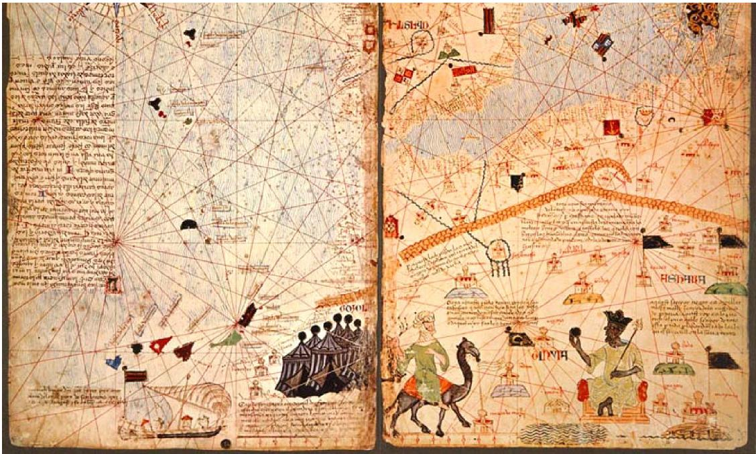

Discussion Questions:
- How do these documents discuss the rise and impact of states like Ghana and Mali? Refer to specific evidence from the readings.

- How are these states discussed by the featured historians of the day? Refer to specific evidence from the readings.

- Did these documents corroborate (confirm or give support) with your reading or enhance your understanding?

- Source each author. Who are they, what time period and or place are they from?

- How can each author ‘s sourcing impact our understanding of Mali as a state and economic force in the region?

