International Trade and the Bubonic Plague

With a surge in international exchange, there were a lot of unintended effects. While religions, crops, ideas, and technologies were all exchanged as much as the goods traveling over land and sea, pathogens were also exchanged. One of the main epidemic diseases, the bubonic plague (or “Black Death”) was spread along these trade routes. Today you will take a look at the “black death” and its effect on Europe.

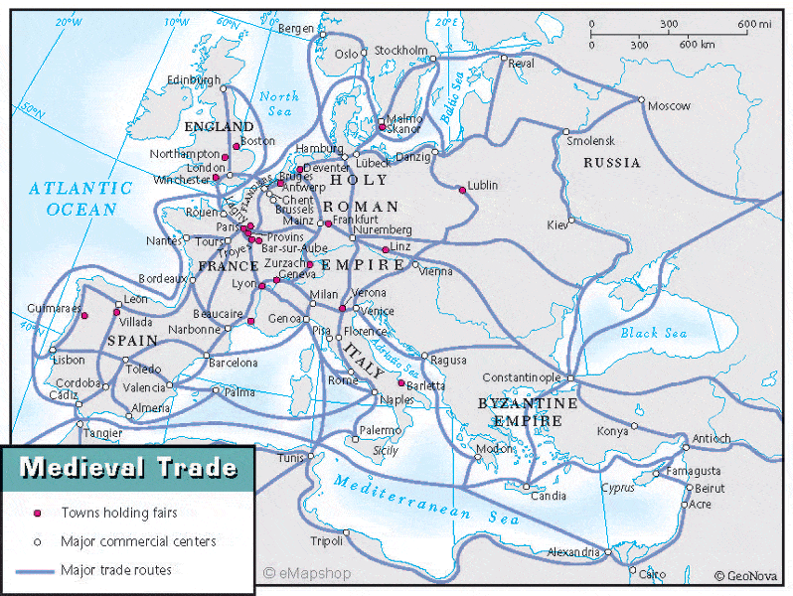
Let’s take a look at European trade networks to better understand the spread of the plague. Analyze the map to the right for these questions:

What do the land trade routes and the markets represent about trade in Europe during the late Middle Ages?
What do the sea routes represent about trade in Europe during the late Middle Ages?

Watch this National Geographic Video: Plague 101. Answer the questions below:

What are the Three causes of the plague, according to the video? | 1 -
 | 2 -
 | 3 -
Shibasaburo and Yersin changed history through what developments? | 1 - | 3 -
 | 2 - | 4 -
At the end of the video (from 2018) the narrator says “...the disease helped catapult advances in science and public health, very well making plague pandemics a thing of the past.” Even though the coronavirus is a virus, not a bacteria, why do you think we still have such pandemics today?

Watch the History Channel Video: The Black Death and answer the questions below about the disease!

What happens in the Pneumonic version?
What happens in the septicemic version?

Read this article on new theories concerning The Black Death (as of 2018) and answer the questions!

What is the new theory about the spread of the Black Death?
What evidence does the author have to back her claims?
What have we learned from “The Black Death” according to biologist Michael Antolin?

Look at the map, as well as this quick source on the Black Death from Renaissance writer Giovanni Boccaccio, the introduction to The Decmeron, and answer the questions below!
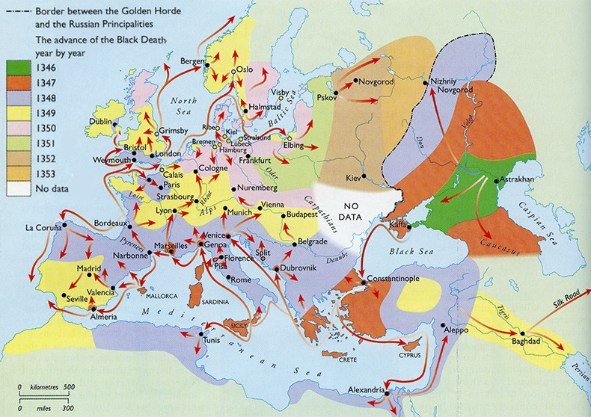
What are your reactions to the descriptions in the document?
What were the impacts on European society?
What is either a similarity or a difference between our society’s reaction to coronavirus and their society’s reaction to black death?

Answer this SAQ question: “Explain ONE effect of the increase in international trade ca. 1200-1450 CE.”

