Empires Thesis Statement Activity

- They have 5 minutes to make a thesis statement for the question. *Time Yourself!
- The more complex piece, that often loses students the point, is the “establishes a line of reasoning” piece. Students need have to have their reasoning behind their answer within the statement as well. See Heimler’s Video on Thesis Writing for more.
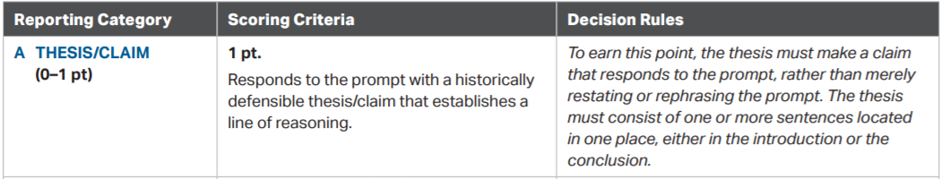

- Evaluate the extent to which imperial expansion relied on technological advancements in both hemispheres during the period ca. 1450 to 1750 CE.

- Evaluate the effects of the rise of the Manchu (Qing) Dynasty on East Asia.

- Evaluate the extent to which the Ottoman Empire was similar to another region in the conquest of their respective regions between ca. 1450 and 1750 CE.

- Analyze the extent to which the Ottoman Empire changed the Middle East in the period ca. 1450 to 1750 CE.

- Evaluate the effect of religious tension in South Asia in the period ca. 1450 to 1750 CE.

- Evaluate the factors responsible for the rise of land-based empires in the period ca. 1450 to 1750 CE.

- Analyze the causes of religious tension within and between states during the period ca. 1450 and 1750 CE.

- Evaluate the extent to which religions or belief structures was a primary factor in expansion of states during the period ca. 1450 to 1750 CE.

- Evaluate the extent to which political and religious disputes led to rivalries and conflict between states during the period ca. 1450 to 1750 CE.

