Task 2, Unit 3 – Columbian Exchange Diagram & Summarizing Paragraph
Engaging Scenario: You are a part of a news broadcast team. Major events are occurring right before your eyes! Changes including: new technologies, the introduction of life changing foods and animals, people never seen before are an everyday sight, unfamiliar cultures and traditions are all around and new life-threatening diseases are ravishing communities! People back home are confused and want to know what is going on. You have been assigned to cover these events in great detail and produce a News Report to inform the people.
Task 2 Student Directions: You will research background information on the Columbian Exchange. A picture of the exchange network is below. You will have a blank template (on back page) and students will complete their template with information from the board and their textbook (Ch. 17, Lesson 2, pages 391-392). Using the diagram below regarding the exchange of items during the Columbian exchange, you will complete the chart about the exchange. After completing the diagram on the back page, students will then write on the back a summarizing paragraph (5-10 sentences) where they will, identify 3 positive and 3 negative effects of each category (plants, animals, diseases) and will identify 2 specific details/ regions for each effect.
*Task 2 is due ___________________________

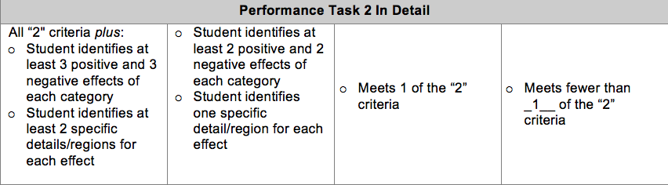
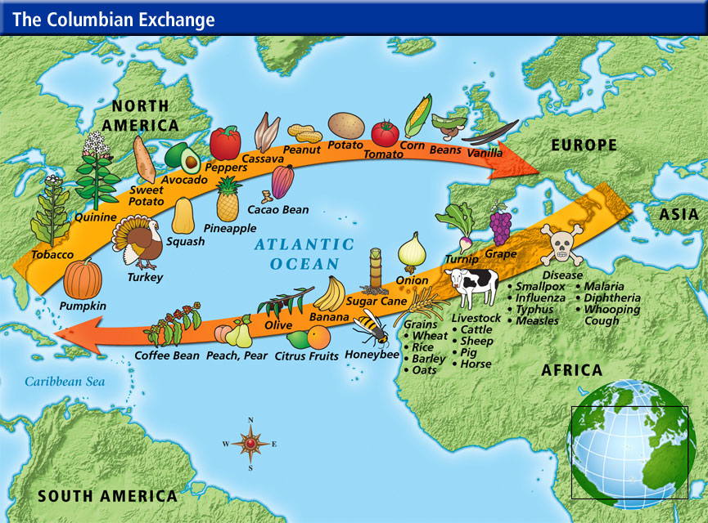
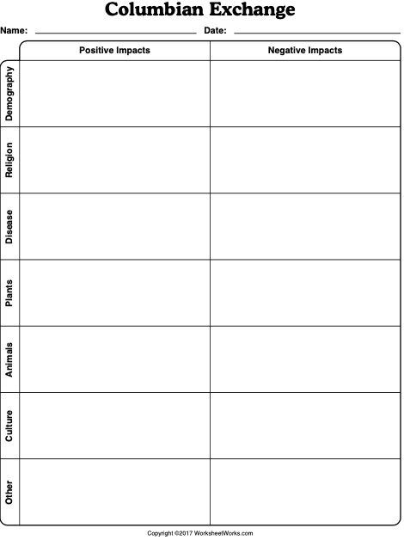

Summarizing Paragraph: Students will write a summarizing paragraph (5-10 sentences) below where they will, identify 3 positive and 3 negative effects of each category (plants, animals, diseases) and will identify 2 specific details/ regions for each effect.

