Name:_______________________________________________________________________ Date:_________ Period:_______
Topic 1.1 East Asia Graphic Organizer (600 - 1450 CE)
Song Dynasty, 860 -1278 C.E.
AMSCO Ch. 10, p. 183-195, Ways of the World Ch. 2 p.51-63
Social
- Social classes & social hierarchy
- Who has power in society?
- Gender roles and relations/patriarchy
- Family and kinship
Political
- Type of government
- Role of the government
- Who rules?
- How do they maintain power?
Interactions with the Environment
- How did the environment shape and/or impact this society?
- Patterns of settlement

Cultural
- Religions, Belief systems, philosophies, & ideologies
- The arts and architecture
- Written works, theater, plays
Economic
- Agricultural and pastoral production
- Trade and commerce
- Labor systems
- Tax collection and purposes
Technology  - Human adaptation and innovation  - Writing systems  - Farming/agricultural implements  - Instruments that improve/expedite trade  - Methods of production | Learning Objective: Explain the effects of innovation on the Chinese economy over time.
Chinese Influence on . . . .
Learning Objective: Explain the effects of Chinese cultural traditions on East Asia over time. Describe the cultural, political, social, economic, and technological influences that China had on other East Asian empires during this time period. Label these places on the map to the right.
 | Positive | Negative | 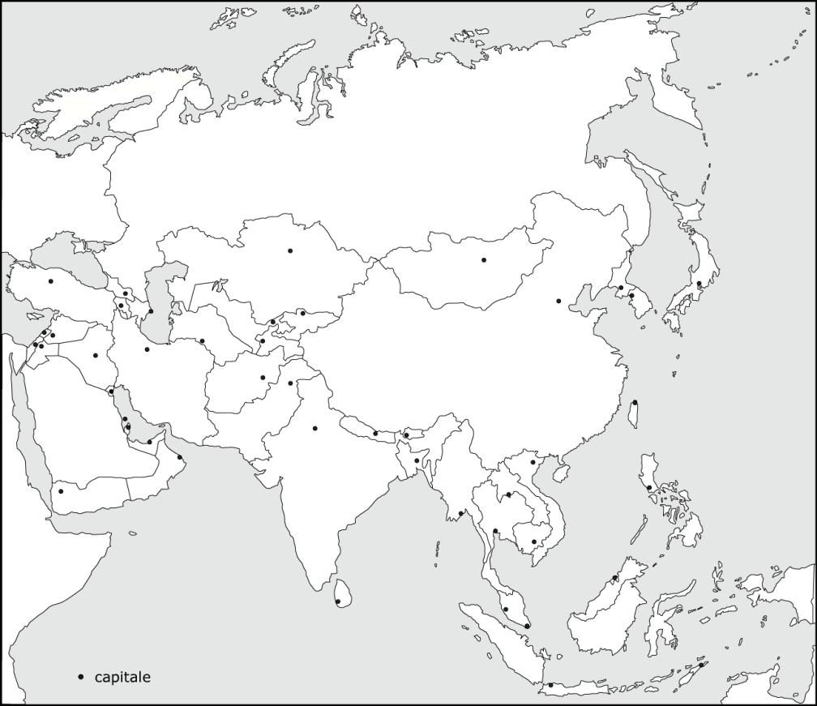  Explain the systems of government employed by Chinese dynasties and how they developed over time.  Explain the effects of Chinese cultural traditions on East Asia over time.  Explain the effects of innovation on the Chinese economy over time.
Korea

Japan

Vietnam

