Name: ___________________________________ Date: ___________ Period:______

Topic 1.2 Dar al-Islam Graphic Organizer (c. 500s – 1200s)
AMSCO Ch. 8 pgs. 146-155,
Ways of the World Ch. 2 pgs. 63 – 69

Time/Place of Founding
Deity(s)

Founder/
Prophet/
Leaders
Holy Book(s)
Basic Beliefs & Practices
Women’s Roles in Islam
What role, if any, could women play in this belief system? How did Islam impact women’s roles in society?
Political & Social Role
How was this religion/belief system utilized to assert political authority and/or reinforce social hierarchies?
Expansion/
Influence
Where did it spread?
How did it spread there?

Spread of Islam
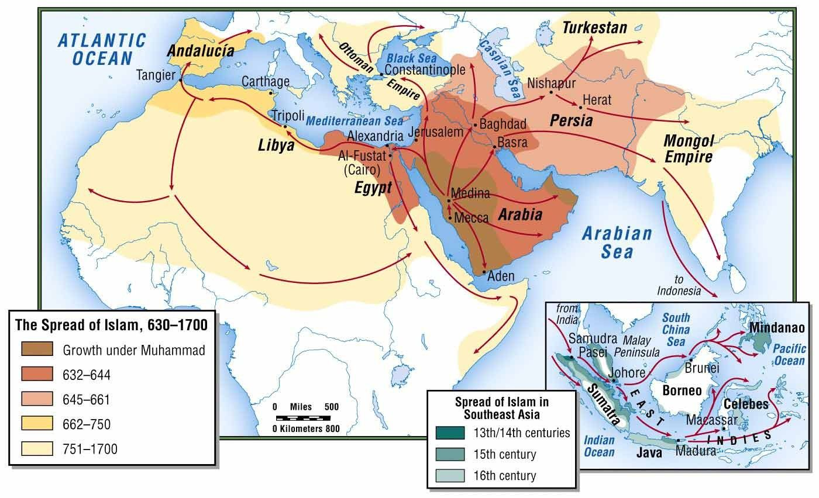
Mamluk Sultanate | Seljuk Empire
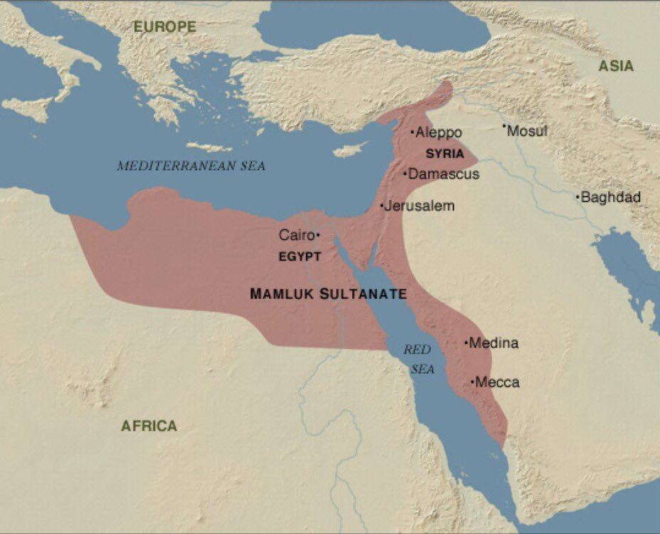 | 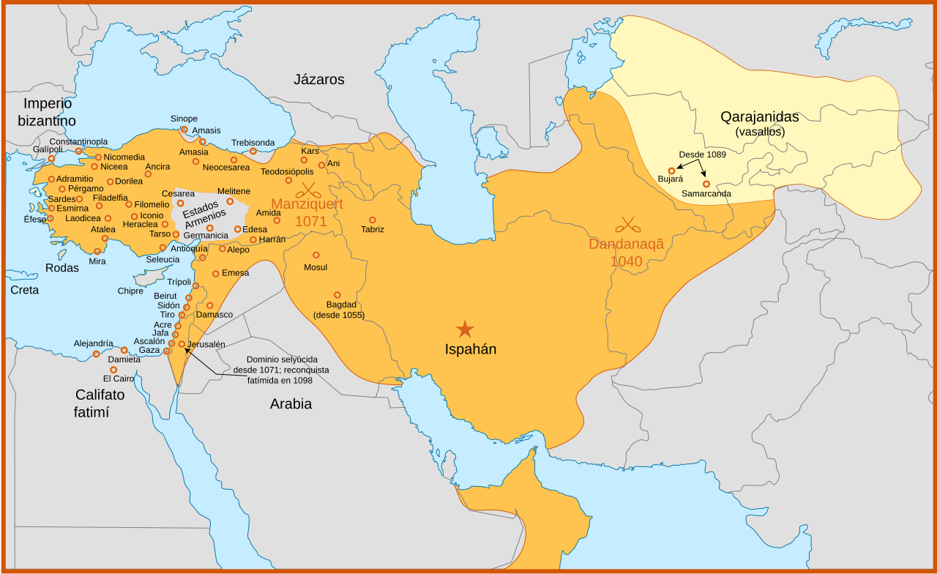
Learning Objective F: Explain the causes and effects of the rise of Islamic states over time.
(AMSCO pgs. 146-155, World Civilizations
pgs. 132-135, 139, 152-170, 176-185, 218-221, 326-328)
Causes of the Rise of Islamic States |  | Effects of the Rise of Islamic States

