Name: _________________________________________ Date: _________Period: ______
Topic 1.2 Islamic States Graphic Organizer (c. 1200 - c. 1450)
Use the Teacher 1.2 Mini-Lecture Power-Point, AMSCO pgs. 146-155, Ways of the World pgs. 63 – 69
 | Seljuk Empire | Mamluk Sultanate | Delhi Sultanate
Geographic Location and Dates they maintained power
Social
- Social classes & social hierarchy
- Who has power in society?
- Gender roles and relations/patriarchy
- Family and kinship
Political
- Type of government
- Role of the government
- Who rules? How do they maintain power?
Interactions with the Environment
- How did the environment shape and/or impact this society?
- Patterns of settlement
Cultural
- Religions, Belief systems, philosophies, & ideologies
- The arts and architecture
- Written works, theater, plays
Economic
- Agricultural and pastoral production
- Trade and commerce
- Labor systems
- Tax collection and purposes
Technology
- Human adaptation and innovation
- Farming/agricultural implements
- Instruments that improve/expedite trade
- Methods of production

The Growing World of Islam, 900–1500
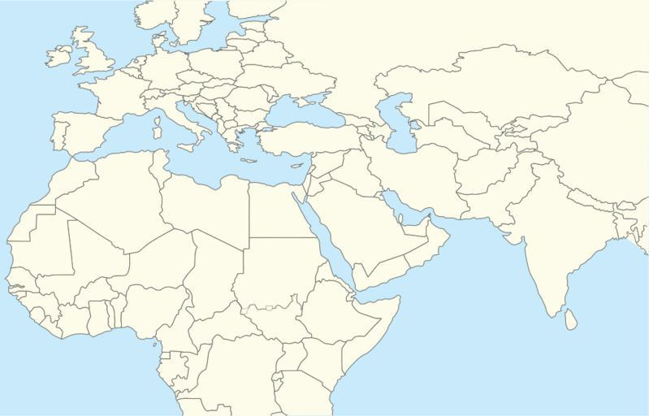 | Describe Muslim Spain  _______________________________________________________________________________________________________________________________________________________________________________________________________________________________________________________________________________________________________________________________________________________________________________________________________________________________________________________________________________________________________________________________________________________________________________

Advances in Math | Advances in Literature | Advances in Medicine

