Muslim Thinkers and Innovators

Some of the most significant, yet unsung, contributions to science and forward thinking were by Muslim philosophers, scientists, teachers, and intellectuals. Dar al-Islam, as you already know, spread far and fast. The resulting Abbasid Empire and its eventual off-shoots were hot spots of intellectual activity.

Use the following to shape your thinking as you look at the documents and formulate your ideas for the discussion we will have together:
Explain the effects of intellectual innovation in Dar al-Islam.

Document 1: Islamic Architecture.
Left Photo = Great Mosque at Cordoba, Spain. Built between 784 and 987 CE. (Wikimedia Commons)
Right Photo = Alhambra Palace in Grenada, Spain. Built between 889 - 1050s CE. (Wikimedia Commons)

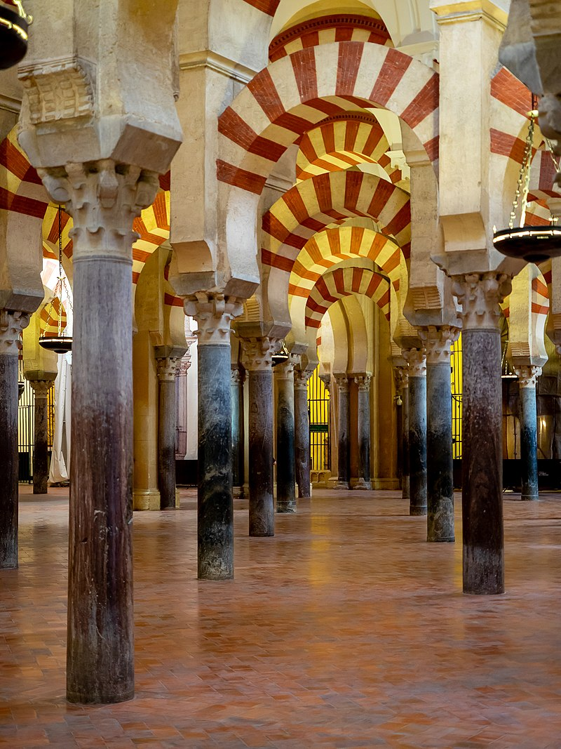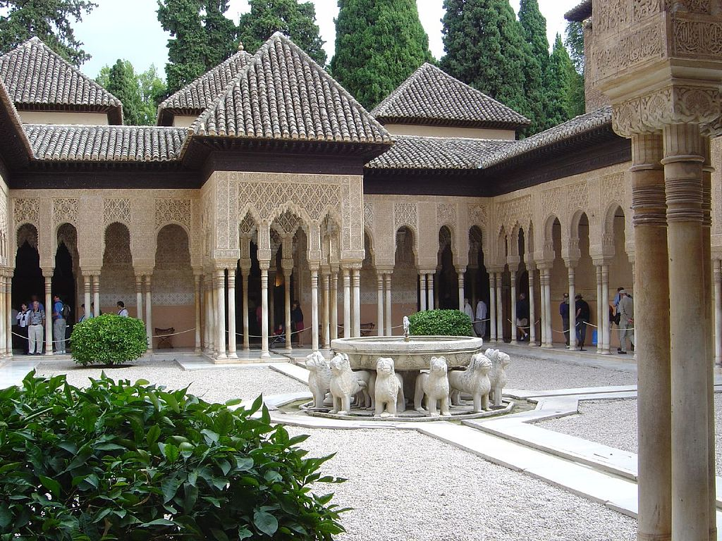

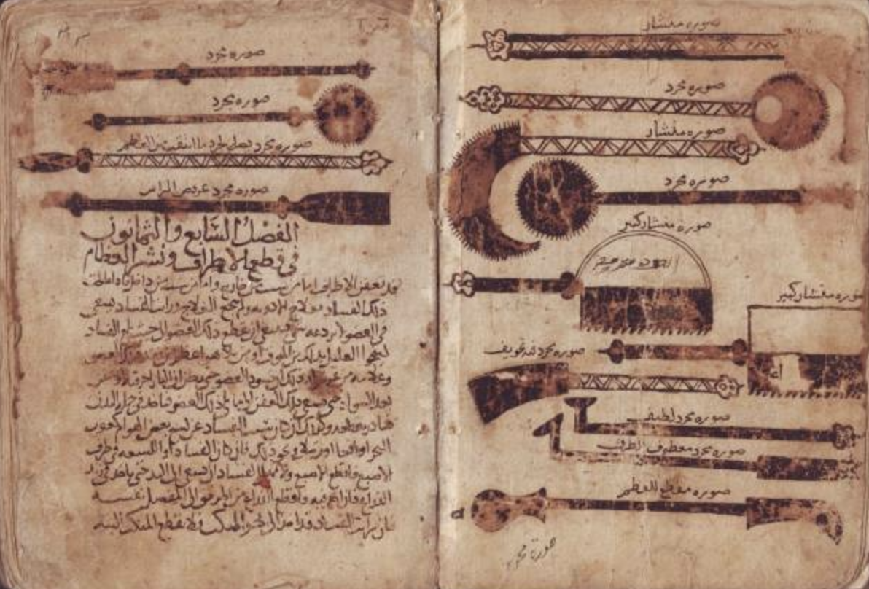
Document 2: The Method of Medicine (Kitab Al-Tasrif) by Abu al-Qasim al-Zahrawi, ca. 1,000 CE. A 30 Volume Encyclopedia on Medical Practices. Zahrawi lived in Al-Andalus (Islamic Iberia - Spain and Portugal). He is considered by many to be the father of modern surgery. The excerpt is from the beginning, and the image is of his surgical inventions.

"Before practicing surgery one should gain knowledge of anatomy and the function of organs so that he will understand their shape, connections and borders. He should become thoroughly familiar with nerves, muscles, bones, arteries and veins. If one does not comprehend the anatomy and physiology one can commit a mistake which will result in the death of the patient. I have seen someone incise into a swelling in the neck thinking it was an abscess, when it was an aneurysm and the patient dying on the spot."
Document 3: Illustrations from the Kitab al Filaha - or the Book of Agriculture by Ibn al-Awwam, 1185. It has chapters about raising animals, 585 plants, 50 fruit trees, soil, manure, diseases affecting plants, and even beekeeping.

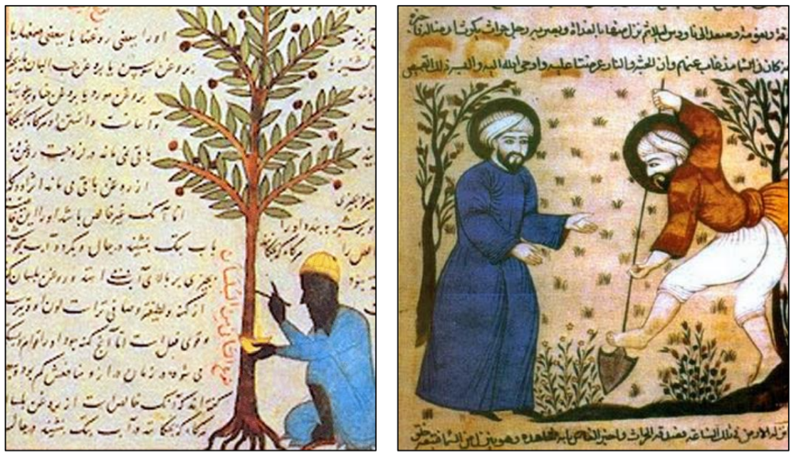

Document 4: Nasir al-Din al-Tusi (Polymath, Mathematician, Architect, Philosopher, Physician, etc.) lived 1201-1274 CE. This particular achievement is known as The “Tusi Couple” - Tusi convinced the Hulegu Khan (when they were under the Ilkhanate) to build the Rasad Khaneh observatory. While working there, Tusi made observations of the movements of planets, and from that, created his “Tusi Couple.” It’s a technique for geometry that uses two circles to end up creating a line. Below the first picture is a page from his sketches (Library of Congress). The second is a gif made to explain it. (Wikimedia Commons)

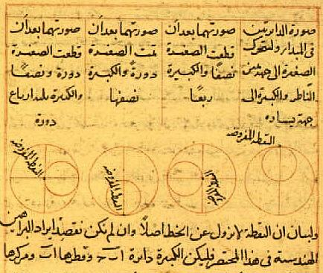

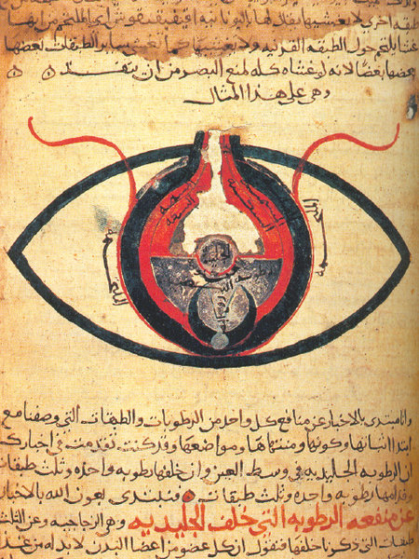
Document 5: Anatomy of the Eye by al Mutadibih, ca. 1200 CE. Muslim Scholars and physicians described eye diseases and conditions like glaucoma. They also coined words like “retina” and “cataract” that we still use today.

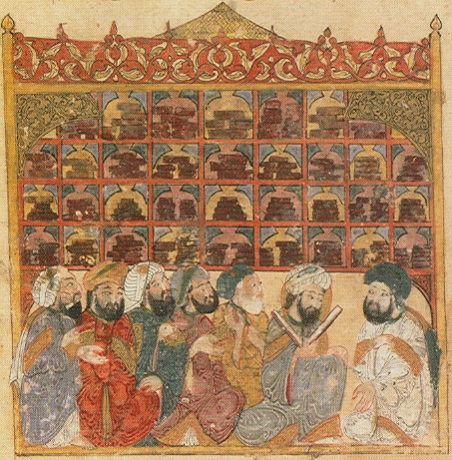

Document 6: An image from Yahya ibn Vasetia’s manuscript called the Maqama of Hariri, written in 1237. It shows a library (likely in Basrah, Iraq) with students. Maqamas were a style of Arabic literature. (Bibliotheque Nationale de France).

