Name:_____________________________________________ Date:_________ Period:_______
Topic 1.3 South & Southeast Asia Graphic Organizer (c. 1200 – 1450)
Ways of the World Ch. 3 pgs. 116-120; AMSCO Ch. 11 pgs. 202-212
 | Srivijaya Empire | Khmer Empire | Rajput Kingdoms
Geographic Location and Dates they maintained power
Social
- Social classes & social hierarchy
- Who has power in society?
- Gender roles and relations/patriarchy
- Family and kinship
Political  - Type of government  - Role of the government  - Who rules?  - How do they maintain power? | Learning Objective: Explain how they developed and maintained power. | Learning Objective: Explain how they developed and maintained power. | Learning Objective: Explain how they developed and maintained power.
Interactions with the Environment
- How did the environment shape and/or impact this society?
- Patterns of settlement
Cultural  - Religions, Belief systems, philosophies, & ideologies  - The arts and architecture  - Written works, theater, plays | Learning Objective: Explain how belief systems affected this society. Consider the impacts of Hinduism, Buddhism, and Islam. | Learning Objective: Explain how belief systems affected this society. Consider the impacts of Hinduism, Buddhism, and Islam. | Learning Objective: Explain how belief systems affected this society. Consider the impacts of Hinduism, Buddhism, and Islam.
Economic
- Agricultural and pastoral production
- Trade and commerce
- Labor systems
- Tax collection and purposes
Technology
- Human adaptation and innovation
- Farming/agricultural implements
- Instruments that improve/expedite trade
- Methods of production

Srivijaya Empire | Khmer Empire | Rajput Kingdoms
 | 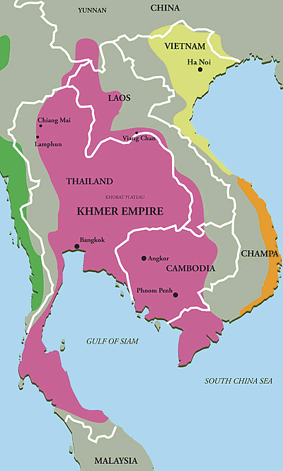 | 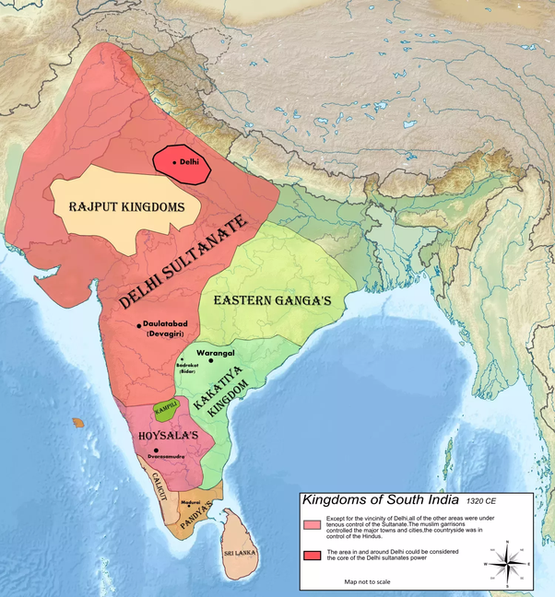
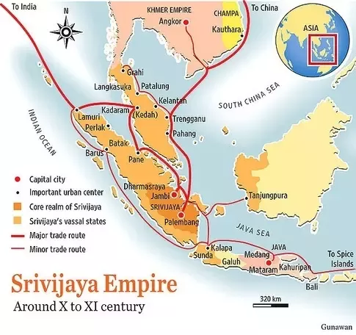
Discuss the impact of the following beliefs and practices on South and Southeast Asian societies:
 | Bhakti Movement | Sufism | Buddhist Monasticism
Define
What is this belief/practice? Which belief system?
Impacts
How did this belief/practice have an effect on one or all of the South/Southeast Asian societies?

