Name:_______________________________________________________ Date:_________ Period:_______
Topic 1.5 State-Building in Africa Graphic Organizer (c. 1200 – 1450)
AMSCO Ch.9 pgs. 161-173; Ways of the World pgs. 120-123
 | Great Zimbabwe | Ethiopia (Axum)
Development:
HOW did this society develop? What enabled this society to grow in power?
CHANGE: What changes did this society experience during the 1200 to 1450 time period?
Social
- Social classes & social hierarchy
- Who has power in society?
- Gender roles and relations/patriarchy
- Family and kinship
Political
- Type of government
- Role of the government
- Who rules?
- How do they maintain power?
Interactions with the Environment
- How did the environment shape and/or impact this society?
- Patterns of settlement
Cultural
- Religions, Belief systems, philosophies, & ideologies
- The arts and architecture
- Written works, theater, plays
Economic
- Agricultural and pastoral production
- Trade and commerce
- Labor systems
- Tax collection and purposes
Technology & Innovation
- Human adaptation and innovation

Great Zimbabwe | Ethiopia | Bantu Migrations
 | 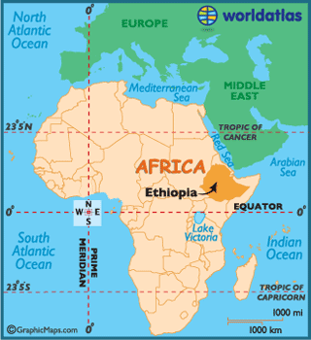 | 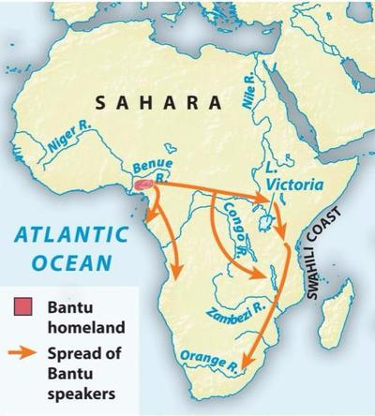  What was the impact of the Bantu migrations?
