Name:_______________________________________ Date:_________ Period:_______
Topic 1.6 Developments in Europe Graphic Organizer (c. 1200-1450)
AMSCO Ch. 7 pgs. 131-140 & Ch. 12 pgs. 219-234; Ways of the World Ch. 2 pgs. 69-85
 | The Byzantine Empire (600 CE – 1200 CE) | Latin West/Feudal Europe (600 CE – 1000 CE)
Social  - Social classes & social hierarchy  - Who has power in society?  - Gender roles and relations/patriarchy  - Family and kinship |  | LO: How did agriculture affect social organization?  What is the role of coercive labor?
Political
- Type of government
- Role of the government
- Who rules?
- How do they maintain power?
Interactions with the Environment
- How did the environment shape and/or impact this society?
- Patterns of settlement
Cultural  - Religions, Belief systems, philosophies, & ideologies  - The arts and architecture  - Written works, theater, plays | LO: How did beliefs and practices of Greek Orthodoxy affect Byzantine society? | LO: How did beliefs and practices of Roman Catholicism affect medieval European society?
Economic
- Agricultural and pastoral production
- Trade and commerce
- Labor systems
- Tax collection and purposes
Technology & Innovation
- Farming/agricultural implements
- Instruments that improve/expedite trade
- Methods of production

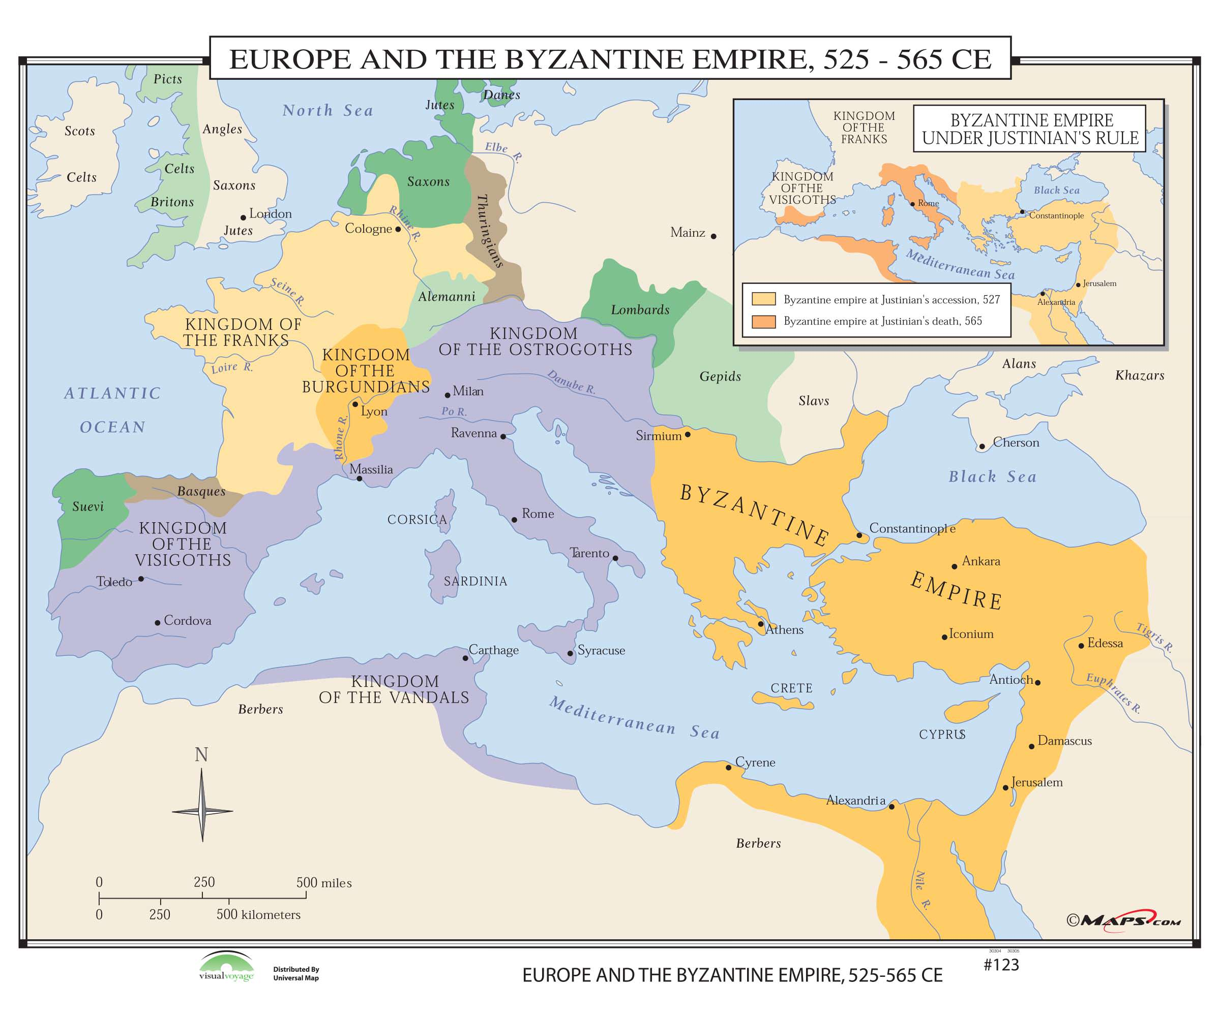 | 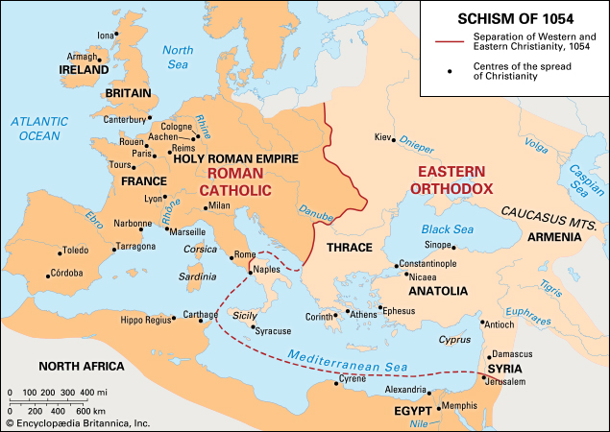
Learning Objective: Explain the causes and consequences of political decentralization in Europe from c. 1200 to c. 1450.
Causes of Political Decentralization | Consequences of Political Decentralization

