Name:_________________________________________________________ Date:_________ Period:_______
Topic 2.2 The Mongol Empire’s Graphic Organizer
AMSCO Ch. 13 pgs. 241- 249; Ways of the World Ch. 4 pgs. 153-179

 | East Asia - China  Yuan Dynasty / Khanate of the Great Khan | Russia  Khanate of the Golden Horde | Middle East  Il-Khan Empire
Political Changes Brought by the Mongols
Economic Changes Brought by the Mongols

Cultural Changes Brought by the Mongols
- Transfers of Greco-Islamic medical knowledge to Europe
- Transfer of numbering systems to Europe
- Adoption of Uyghur script
Continuities During Mongol Rule
What aspects of SPICE-T remained the same, regardless of Mongol rule?

Learning Objective: Explain how the expansion of the Mongol Empire influenced trade and communication over the 1200-1450 time period. | Influences on Trade | Influences on Communication
 | ________________________________________________________________________________________________________________________________________________________________________________________________________________________________________________________________________________________________________________________ | ________________________________________________________________________________________________________________________  ________________________________________________________________________________________________________________________________________________________________  _______________________________________

Learning Objective: Explain the significance of the Mongol Empire in larger patterns of continuity and change.  The front of this handout addressed changes brought by the Mongols, what were the continuities? | ________________________________________________________________________________________________________________________________________________________________________________________________________________________________________________________________________________________________________________________________________________________________________________________________________________________________________________________________________________________________________________________________________________________________________________

Key Players in the Mongol Empire  Who was this person? What were their impacts? |  | 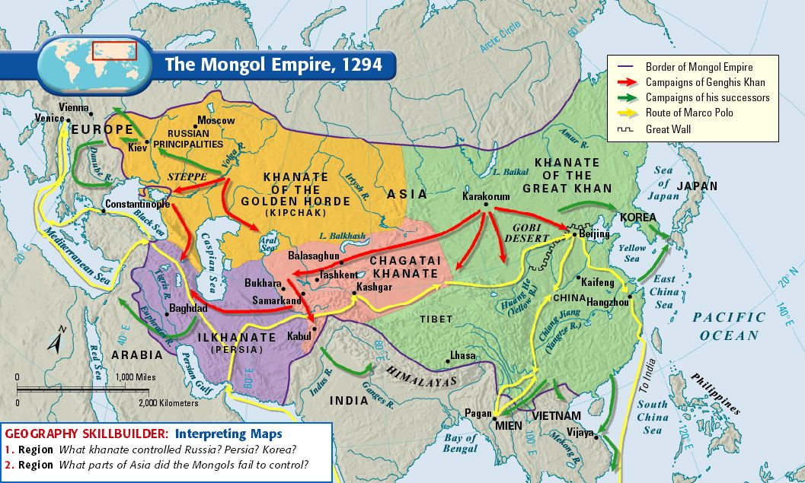
Ghengis Khan
Batu
Hulegu
Kublai Khan

