Topic 2.3 Indian Ocean Basin Trade Activity
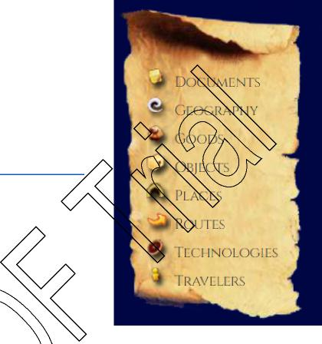

The Indian Ocean Trade Network facilitated massive cultural diffusion, syncretism, and economic activity. You’ll be using the website Indian Ocean History, https://www.indianoceanhistory.org/, to check out the importance of this route ca. 300-1450 CE. Even though our course begins in 1200 - this route began long before the Romans ever dominated the Mediterranean. However, the trade network became increasingly popular from 600-1450 CE.
“Medieval Trade”: We will spend time in the section on the website: “Medieval Trade,” https://www.indianoceanhistory.org/LessonPlan/MedievalEra.aspx.
- Pay attention to the Key on the map, it will help you answer the questions →
- Begin by scrolling your cursor over the various symbols. You’ll notice different documents, goods, etc. pop up with a title. You’ll click on those to answer the questions below. Start in East Asia - China specifically. The questions will move West from there!

Click on the technology “Chinese Junk, Song Dynasty, 1271  CE” (China) | How did the junk affect and facilitate trade networks?
Click on the technology “Stern Rudder for Steering Ships.” (China) | How did the stern rudder affect and facilitate trade?
Click on the technology “Magnetic Compass” (China) | How did the compass diffuse to other parts of Afroeurasia, and what was its effect?
Click | How did the astrolabe affect and facilitate trade?
on the technology “Astrolabe” (jump over to the Middle East, along the Silk Roads)
Click on the technology “Arab Dhow”  (Between Arabian Peninsula and India) | How did the dhow affect and facilitate trade networks?
Click on the technology  “Lateen Sail”  (Red Sea) | How did the lateen sail affect and facilitate trade?
Click on the document in “Blue and White Porcelain”  (Jump back over to the Philippines) | Why was Ming porcelain a luxury item?

Click on the document “Ming Voyages Stone Stele”  (China) | What was the significance of these voyages to global interaction?
Click on the goods “Cloves” and “Nutmeg.” (SE Asia) | Why were these spices so sought after in the Indian Ocean Trade?
Click on the traveler “Zheng He’s First Expedition”  (Java, Indonesia) | Describe Zheng He’s Expeditions as well as their purpose in the Indian Ocean.
Click on the place “Calicut” (Indian Peninsula) | Why was Calicut an important city of the Indian Ocean Basin Trade Network?
Click on the traveler “Allan Bin Hassun, A Jewish Merchant from Cairo”  (By Somalia) | Read his document. What does his account show us about Indian Ocean Trade?
Click on the objects “Mangrove Poles” and “Ivory”  (East Africa) | Why were these a likely export from East Africa?
Click on the place  “Kilwa”  (East Africa) | What do you think Kilwa represents about the Indian Ocean Trade Network?
Click on the object “Giraffe of Treasure Ships”  (East Africa) | What does the giraffe represent about trade relationships of the era?
Click on the good  “Bananas”  (East Africa) | How do Bananas represent the EFFECTS of international trade?

