Name:____________________________________________________________ Date:_________ Period:_______
Topic 2.4 Trade & State-Building in Africa

 | Mali Empire (Trans-Saharan Trade)  AMSCO Ch. 9 pgs. 161, 168-169  Ways of the World Ch. 3 pgs. 124-128 | Swahili City-States (Indian Ocean Trade)  AMSCO Ch. 9 pgs. 166-167, 170  Ways of the World Ch.3 pgs. 124-128
Development:
HOW did this society develop? What enabled this society to grow in power?
CHANGE: What changes did this society experience during the 1200 to 1450 time period?
Social
- Social classes & social hierarchy
- Who has power in society?
- Gender roles and relations/patriarchy
- Family and kinship
Political
- Type of government
- Role of the government
- Who rules?
- How do they maintain power?
Interactions with the Environment
- How did the environment shape and/or impact this society?
- Patterns of settlement
Cultural  - Religions, Belief systems, philosophies, & ideologies  - The arts and architecture  - Written works, theater, plays | Impact of Islam: | Impact of Islam:
Economic
- Agricultural and pastoral production
- Trade and commerce
- Labor systems
- Tax collection and purposes
Technology
- Human adaptation and innovation

Mali Empire | Swahili City-States
 | 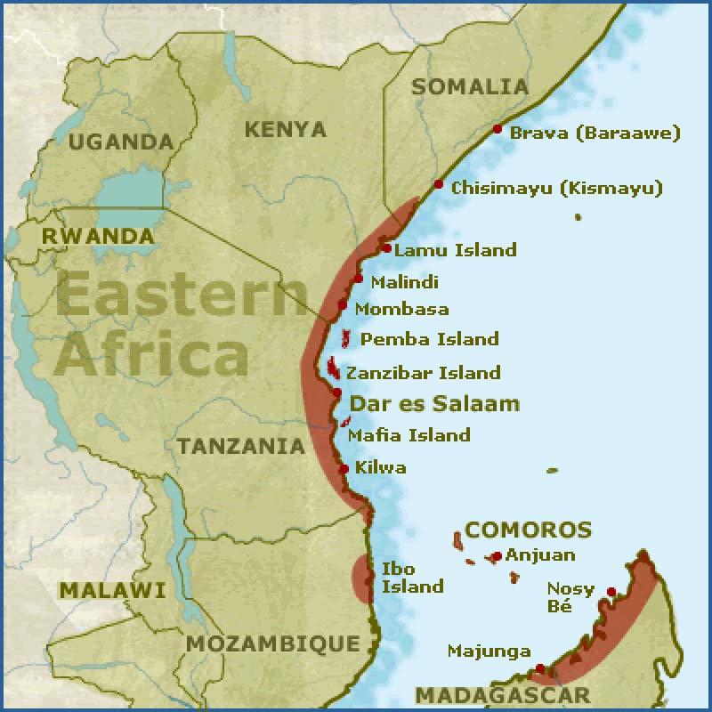
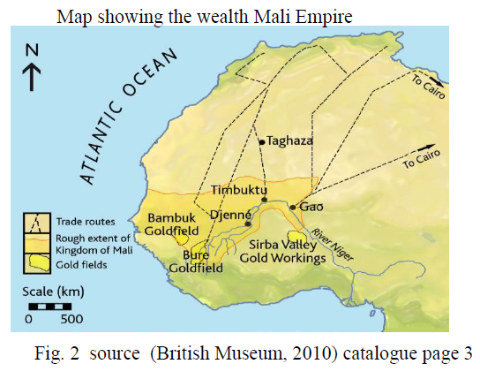

Causes of the Growth of trans-Saharan trade networks. | Effects of the growth of trans-Saharan trade networks.

