Name:________________________________________________________ Date:_________ Period:_______
Unit 2: Topic 2.5 Cultural Consequences of Connectivity Map
Learning Objective: Explain the intellectual and cultural effects of the various networks of exchange in Afro-Eurasia from c. 1200 to c. 1450.
Annotate this map and complete this handout with AMSCO: Buddhism: Ch. 5 p. 99, Ch. 10 pgs. 182-183, 189-190, 193, 194, 206; Hinduism: Ch.11 p. 207; Islam: Ch. 7 p. 133, Ch. 8 p.147, p.148-149; Gunpowder: Ch. 10 p. 186, Ch. 12 p. 227, Ch. 13 p. 244, 248; Paper: Ch. 8 p. 149, 189; Timbuktu: Ch. 9 p. 169; Kilwa: Ch. 9 166-167; Malacca: Ch. 11 p. 211; Guangzhou (Canton): Ch. 10 p. 187; Calicut: Ch. 11 p. 205; Venice: Ch. 7 p. 137, Ch. 12 p. 228; Marco Polo: Ch. 10 p. 185, Ch. 12 p. 229, Ch. 13 p. 246; Ibn Battuta: Ch. 9 p. 161, 170; Ways of the World Ch. 3 pgs. 111-114 and 129-137
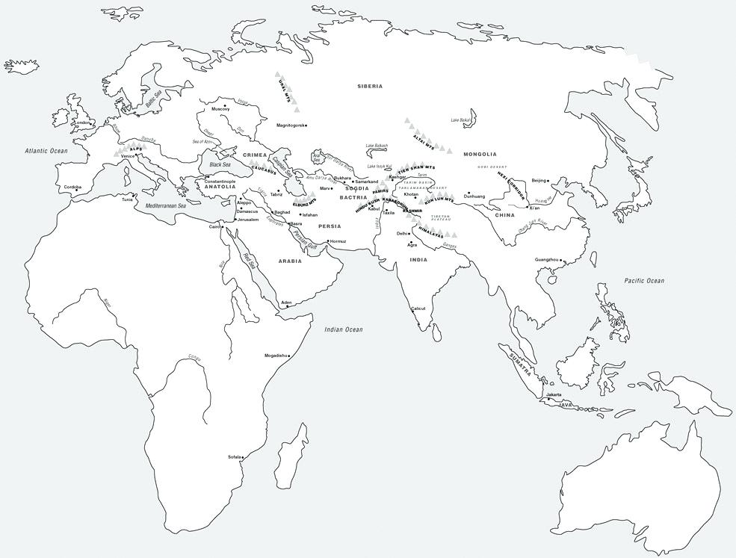 | Diffusion of cultural traditions:  - Spread of Buddhism  - Spread of Hinduism  - Spread of Islam  Diffusion of scientific or technological innovations:  - gunpowder  - paper  Major trading cities:  - Timbuktu  - Kilwa  - Samarkand  - Kashgar  - Malacca  - Guangzhou (Canton)  - Calicut  - Venice  Travelers:  - Route of Marco Polo  - Route of Ibn Battuta

Impacts of Islam  (include examples of syncretism) | Impacts of Buddhism  (include examples of syncretism) | Impacts of Hinduism  (include examples of syncretism)

Intellectual Effects of Networks of Exchange  c. 1200 - 1450. | Cultural Effects of Networks of Exchange  c. 1200 - 1450.

