Name:_________________________________________________ Date:_________ Period:_______
Topic 2.6 Environmental Consequences of Connectivity Graphic Organizer

Learning Objective: Explain the environmental effects of the various networks of exchange in Afro-Eurasia from c. 1200 to c. 1450.
Annotate this map and complete this handout with notes from AMSCO – Bananas: Ch. 9 p. 162; Rice: Ch. 10 p. 185; Cotton: Ch. 11 p. 205; Bubonic Plague: Ch. 12 p. 228; Ch. 13 p. 248 and Ways of the World Ch. 3 pgs. 129-137 and 170-179.
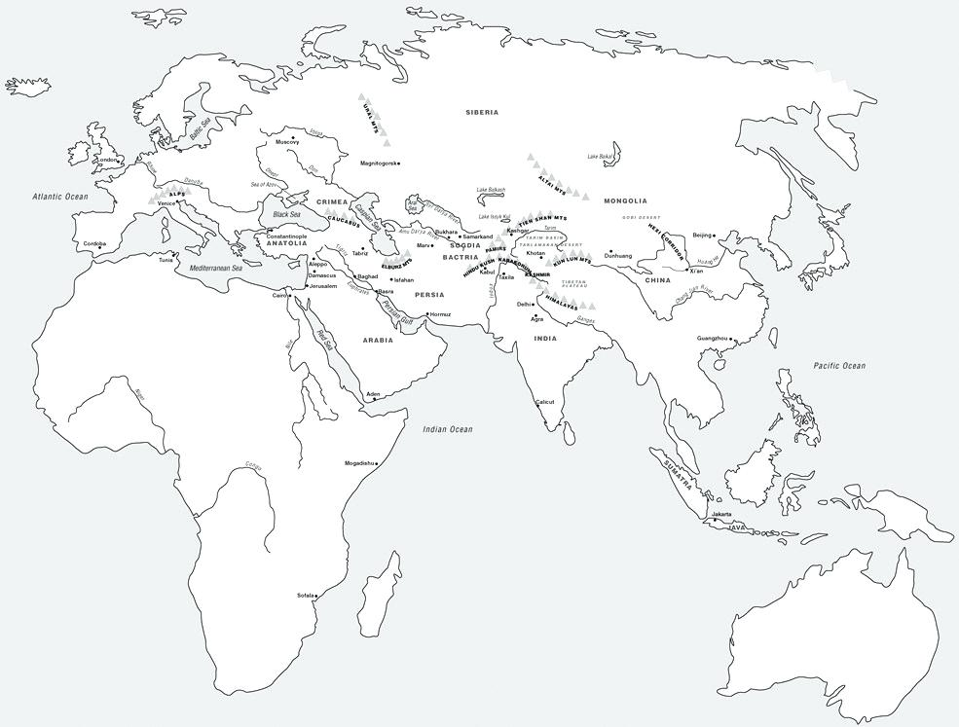 | Diffusion of Disease:  - Spread of the bubonic plague  Diffusion of Crops:  - Bananas  - Rice  - Cotton  - Citrus

Effects of the Plague | Effects of Champa Rice on China | Effects of Bananas on Africa
Which network(s) of exchange most facilitated the spread of this disease? | Which network(s) of exchange most facilitated the spread of this crop? | Which network(s) of exchange most facilitated the spread of this crop?

Positive environmental effects of Networks of Exchange  c. 1200 - 1450. | Negative environmental effects of Networks of Exchange  c. 1200 - 1450.

