FILIAL PIETY: Document 1 ( From Asia for Educators )

The Confucian “Classics” are not easy for ordinary people to understand. Printing now allowed writers to rectify this by composing books of moral instruction meant for a mass audience. The excerpts below are from a popular tract widely circulated from the Yuan through the Qing dynasties in many different editions.
Selections from The Twenty four Exemplars of Filial Piety
11. Mosquitoes Gorged Freely on His Blood
Wu Meng... was eight years old and served his parents... The family was poor, and their bed had no mosquito net. Every night in summer many mosquitoes bit him, gorging on his blood. But despite their numbers he did not drive them away, fearing that they would go and bite his parents. This is the extreme of love for parents.
17. Playing in Colored Clothes to Amuse His Parents
Old Master Lai... was extremely filial. He respectfully cared for his two parents, preparing delicious food for them. He was over seventy, but he never mentioned the word “old.” He... played children’s games at his parents’ side. Often he... pretended to slip and fall; then he would cry like a baby to amuse his parents.
22. Carving Statues to Serve As Parents
When Ding Lan.... was young his parents passed away. He was unable to care for them, and yet was aware of how they had toiled to bring him up. So he carved wooden statues of them and served them as if they were alive. After a long time his wife ceased to revere them, and in jest she pricked one of their fingers with a needle. It bled, and when the statues saw Lan, they wept. Lan discovered the reason and brought forth his wife and divorced her.
MERIT AND DEMERIT: Document 2
With Neo-Confucianism in place, it was important to show the combination of Buddhism with Confucianism. This text Yuan Huang (1533-1606), a successful Ming scholar and official, tries to show how people can act.
Excerpt from Ledger of Merit and Demerit By Yuan Huang

Conduct for which one gains one hundred points of merit:
Saving a person’s life
Ensuring the fidelity of a woman
Conduct for which one gains fifty points of merit:
Maintaining the family lineage
Adopting an orphan
Burying a corpse no one cares for
Preventing someone from drowning a child or aborting a baby
Preventing a person from abandoning a village [because of famine]

Conduct for which one gains thirty points of merit:
Getting an evildoer to change his way Rectifying an injustice
Conduct for which one gains ten points of merit:
Recommending a virtuous person for office Eliminating something harmful to the people
Conduct for which one gains five points of merit:
Getting a litigant to withdraw a lawsuit Saving the life of a domestic animal
Conduct for which one gains one point of merit: Praising someone’s good deed  Not joining in someone’s bad deed Curing someone’s illness | Providing a meal to a hungry person  Burying a dead domestic animal  Saving the life of an insect or watery creature | 1

WOMEN - Document 3 ( From Asia for Educators )
Lü Kun (1536-1618), a scholar-official of the Ming dynasty, wrote on education from a number of perspectives. The following document on the education of women is an example.
Preface to Models for the Inner Quarters, By Lü Kun
The early kings valued the instruction of women. Therefore women had female teachers, who would explicate the sayings of old and cite examples from ancient worthies so that [the women] would carefully adhere to the principle of “thrice obeying” ( sancong) [i.e., to obey one’s father when young, one’s husband when married, and one’s son when old] and to revere the four virtues [i.e., proper behavior, speech, demeanor, and employment] so as to bring glory on their husbands and not bring down shame on their parents. With the decline of education today, women in the inner quarters have really ceased to be governed by rites and laws. Those born in villages are accustomed to hearing coarse words and those [born] in rich households have loose, proud, and extravagant natures. Their heads are covered with gold and pearls and their entire bodies with fine silks. They affect lightheartedness in behavior and cleverness in speech, but they mouth no beneficial words and perform no good deeds. Their parents and sisters - in - law will not be able to pass on reputations for worthiness or filiality, and neighbors and relatives will hear only of their obstinacy — all because they are uneducated.
... Alas, [moral sentiments of] filiality, prudence, chastity, and martyrdom [in choosing death over remarrying] are inherent in one’s Heaven - given nature. To have a fine reputation that lasts for generations, one need not be literate, but it is rare that someone who learns to recite orally [accounts about] those with fine lasting reputations, fails to follow their good example.
WOMEN - Joseon Dynasty Korea - Document 4
Shin Yun Bok painted portraits and also genre painting. Genre painting ( 풍속화 pungsokhwa ) depicts people in everyday life. In Korea, genre painting really came into its own during the Joseon period.
During the Joseon period, a lot of paintings were done to teach a moral lesson. Portraits of noblemen were supposed to encourage ordinary people to lead better lives. Paintings were also used to record events, so one of the tasks of the artists at the Dohwaso – Royal Bureau of Painting – was to depict as accurately as possible all the events that happened at the palace. Paintings that portrayed the common people as well as noblemen in social situations, whilst still classed as genre painting, came to be known as 속화 sokhwa . In these paintings we find commoners going about their everyday business, peasants working in the fields, people playing games, taking part in ceremonies with shaman, and socializing.
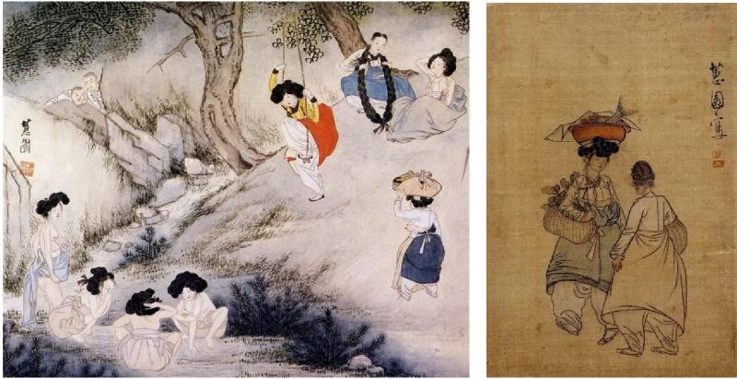
Scenery on Dano Day and Women at a Firsh Market by Shin Yunbok (late 1700s)
2

CHRISTIANTIY AND CONFUCIANISM: Document 5 ( From Asia for Educators )
Beginning in the late sixteenth century, Portuguese merchants began coming to trade in southern China, bringing Jesuit priests along with them. Jesuits, notably the Italian Matteo Ricci (1552-1610), aimed to convert members of the scholar-official elite who, they hoped, would then assist in spreading their religion among the people. While welcomed by the late Ming and early Qing emperors for their expertise in areas such as astronomy, calendar-making, cannon and other firearms, and mathematics, the Jesuits made relatively few converts among the general populace.
By the late seventeenth century, Christianity faced growing opposition among the officials and from the imperial government. Nonetheless, the Jesuits had succeeded in making significant converts among eminent Confucians, and there were small circles of elite Christian men who desired not merely to be Christians, but to make Christianity Chinese by exploring the differences and similarities of Christian doctrine and Confucian philosophy. The following document was written by Zhang Xingyao (1633-c. 1715) between 1702 and 1715.
An Examination of the Similarities and Differences Between the Lord of Heaven Teaching [Christianity] and the
Teaching of the Confucian Scholars
By Zhang Xingyao
It is clear in the China of my day that the Lord of Heaven (Tianzhu) [of the Western missionaries] is the same as the Lord - on - High (Shangdi) [of Chinese antiquity]. ...
... From the time the Buddha’s books entered China, a teaching spread that was altogether deviant. The followers of Laozi promoted this teaching, and thereafter the minds of the people in China lost their ability to question anything. People all degenerated into a condition of merely acquiescing in what they were told, and the Buddha said, “In Heaven above and Earth below, I alone am worthy of honor.” The ability to discern the Lord - of - Heaven degenerated ... Consequently, the Three Mainstays [of ruler - minister, parent - child, and husband - wife] and the
Five Constraints [of Humaneness, Rightness, Ritual Decorum, Wisdom, and Trustworthiness] became hated and there was no effort to urge these on mankind. These people have all gone to hell without end and the followers of Confucius are not able to save them, because Confucius can neither reward nor punish nor judge the living and the dead. ...
Heaven and Earth naturally possess correct principles, already present in Confucian teaching, but, with some things still not completely understood by Confucian teaching, it would not do to be without the added benefit of the teachings of the Lord of Heaven.
3

QING DYNASTY: OFFICIALS - Document 6 ( From Asia for Educators )
The Qing government employed officials at the imperial, provincial, and county levels to carry out the responsibilities of government. Those qualified for appointments as officials had passed a highly competitive series of examinations based largely on the Confucian classics. Qing officials were responsible for a wide range of duties — in addition, they were expected to be morally upright gentlemen. (Needless to say, they were not always so in practice.) The following excerpts are from the writings of Chen Hongmou (1696-1771). Chen had a long career as a provincial governor, serving in that post in a number of provinces.
On the Duties of an Official By Chen Hongmou
We in official service ought to look at all matters from the point of view of what is good for the people’s livelihood. We must plan for the long term, rather than for the moment. We should concentrate on the substantial and the practical, rather than disguising our inaction with empty words. To do otherwise would violate the court’s principle that officials exist for the good of the people.
...
As our dynasty has long exercised benevolent rule, the population has continually grown. All available natural resources have been turned into productive assets. I fear, however, that our limited supply of land cannot adequately support our growing population. Under these conditions, officials cannot sit idly by and watch as potentially useful land remains undeveloped, on the excuse that the effort involved would not yield immediate results. Now, feeding the people directly by the government is not as good as developing the means whereby the people can feed themselves.
...
In governing, good intentions and good policies alone are insufficient. There are those policies that sound admirable but that prove impossible to implement in practice. ... If the local official truly approaches each matter from the standpoint of the people’s livelihood, in carrying out any new policy he will first thoroughly canvas local public opinion on the matter. He will then consider every aspect of its implementation, noting in which aspects it is advantageous to the people and in which aspects it will cause them hardship.
QING DYNASTY: OFFICIALS - Document 7 ( From Asia for Educators )
On Substantive Learning By Chen Hongmou
The noble words and essential ideas of the sages are scattered throughout the classical canon. Only by studying these works closely can one begin to extract from them their meaning and put their ideas into practice
The examination system promotes scholars on the basis of their literary achievement. But scholarly practices tend to decline over the course of time, to become less concerned with fundamentals and more with style ...
The examinations test first the candidate’s knowledge of basic principles revealed in the classical texts, and then move on to legal and policy questions. ... Imperial edicts have repeatedly ordered that, in the provincial ‑ level examinations, equal weight be given to this second part, in order to scrutinize the candidates’ understanding of political economy ... But students in fact do not diligently prepare for these practical policy questions ... instead, they quickly cram for them as the examination approaches, by memorizing standardized crib book answers.
4

QING DYNASTY GOVERNMENT: Document 8 ( From Asia for Educators )
The “Sacred Edict” was a set of moral and governmental instructions promulgated by imperial authority for use in local rituals conducted throughout the Qing Empire. The Edict was promulgated by the Kangxi emperor (r. 1662-1722) and revised to its current form of Sixteen Maxims by his son, the Yongzheng emperor (r. 1723-1735). The Edict would be recited regularly at village lectures, which were a form of moral instruction initiated by the Ming emperor Hongwu but more systematically carried out by the Qing than by the Ming imperial government.
The Qing Dynasty “Sacred Edict”
- Esteem most highly filial piety and brotherly submission, in order to give due importance to human moral relations.
- Behave with generosity toward your kindred, in order to illustrate harmony and benignity.
- Cultivate peace and concord in your neighborhoods, in order to prevent quarrels and litigations.
- Give importance to agriculture and sericulture, in order to ensure a sufficiency of clothing and food.
- Show that you prize moderation and economy, in order to prevent the lavish waste of your means.
- Foster colleges and schools, in order to give the training of scholars a proper start.
- Do away with errant teachings, in order to exalt the correct doctrine.
- Expound on the laws, in order to warn the ignorant and obstinate.
- Explain ritual decorum and deference, in order to enrich manners and customs.
- Attend to proper callings, in order to stabilize the people’s sense of dedication [to their work].
- Instruct sons and younger brothers, in order to prevent them from doing what is wrong.
- Put a stop to false accusations, in order to protect the honest and good.
- Warn against sheltering deserters, in order to avoid being involved in their punishment.
- Promptly remit your taxes, in order to avoid being pressed for payment.
- Combine in collective security groups ( baojia ), in order to put an end to theft and robbery.
- Eschew enmity and anger, in order to show respect for the person and life.
5

JOSEON DYNASTY IN KOREA - PAINTINGS: Document 9
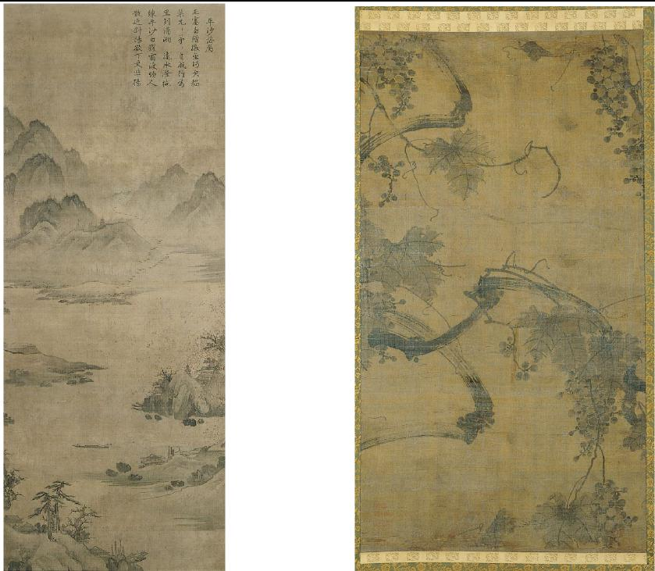
6
Introduction By: Soyoung Lee, Department of Asian Art, The Metropolitan Museum of Art, October 2004
Alongside the king, a class of men known collectively as the yangban governed society during the Joseon dynasty in Korea (1392–1910). The term yangban refers to members of the “two orders” of civil or military officialdom. Whether his post was civil or military (the former was considered more prestigious than the latter), a yangban was, essentially, a literati [ well-educated person who is interested in literature] . The yangban was expected to hold public office, follow the Confucian doctrine through study and self-cultivation, and help cultivate the moral standards of Joseon society...
A defining characteristic of the Joseon yangba n was his scholarly knowledge and pursuits, specifically of the Confucian classics and Neo-Confucian thought. Numerous texts authored by members of the yangban class provide insight into the ancient and contemporary texts they studied, the new ideas they developed, how they discoursed among themselves, and how they developed government policies. Their work was invariably written in Classical Chinese, the preferred mode of writing by learned men, even after the creation of the Korean alphabet (hangeul) in 1443... Many in the yangban class were accomplished artists, practicing calligraphy and ink painting, traditionally the two media considered most appropriate for literati. Ink monochrome paintings of bamboo, orchid, plum blossom, and chrysanthemum were especially popular among the yangban ; originally associated with the four seasons, these motifs came to represent the Confucian scholar...
Wild geese descending to sandbar late 15th century, hanging scroll; ink on silk |  |  | Grapevine in the Wind  16th century, Hanging scroll; ink on silk

JOSEON DYNASTY IN KOREA - PAINTINGS: Document 10
A Joseon painting which represents the Jungin (literally "middle people"), equivalent to the petite bourgeoisie. 1853
https://commons.wikimedia.org/wiki/File:Middle_Class_in_Joseon.jpg
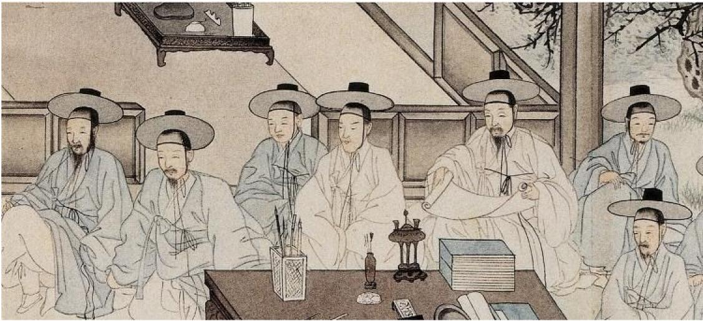
A Joseon painting style of Scholar’s Books and Personal Items called Ch aekgeori, by painter yi Eungrok 1808.
http://asianart.emuseum.com/view/objects/asitem/items$0040:13843
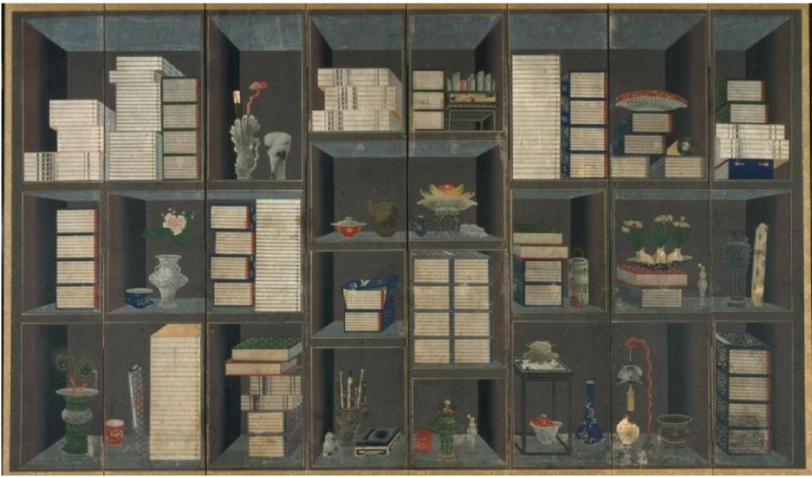

Student Directions: 7

For each document, 1-10, students will provide a sourcing of the document in a paragraph (3-5 sentences) where students will explain how the authors or artists historical setting or background impacts how we view the document.

Document 1:

Document 2:

Document 3:

Document 4:

Document 5:

Document 6:

Document 7:

Document 8:

Document 9:

Document 10

