Causation in European Exploration Activity

Description of one cause of the influence of the innovation or of its influence on European exploration. | Innovation  (Click on the link to read about it, or make it larger) | Description of one effect of the innovation on the ability of Europeans to explore.
Carrack or Nao (Spanish Carrack ca. 1510)
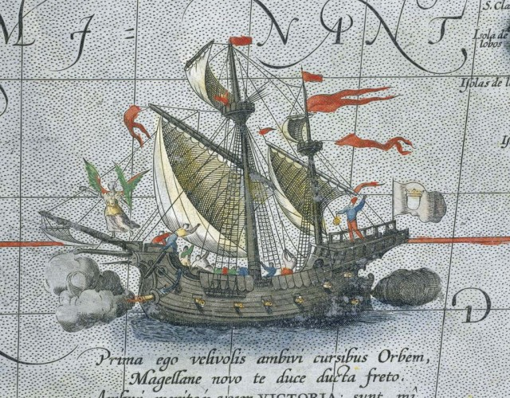
Dutch Fluyt (This image is of a 1677 Fluyt)
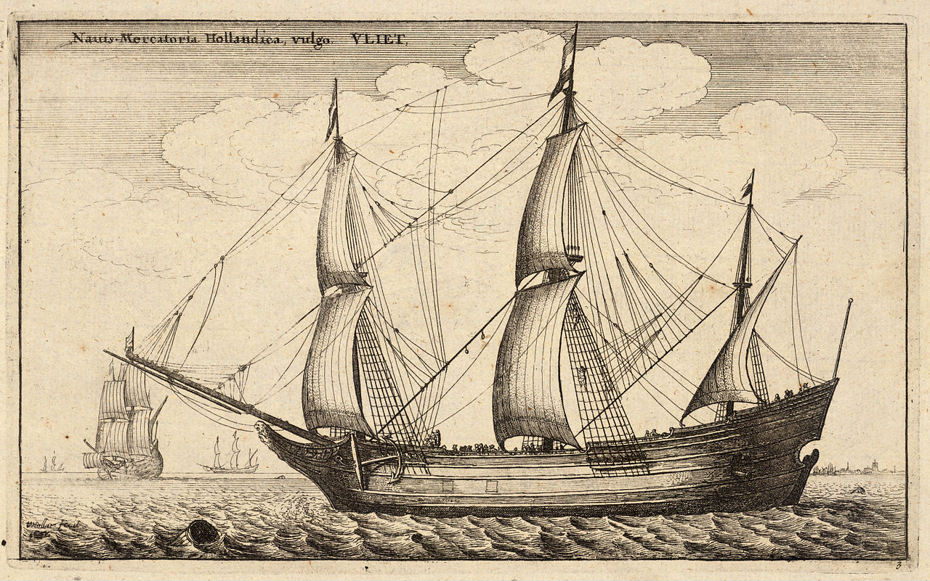
Astrolabe (Image 1645)
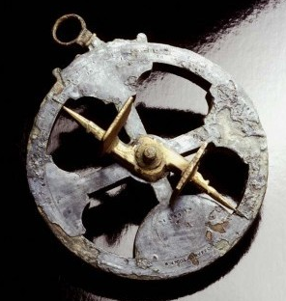
Compass (image 1643)
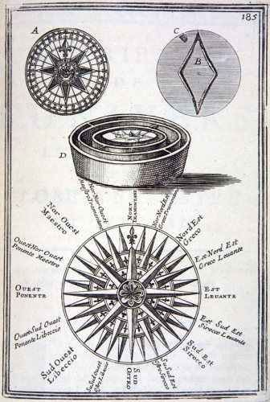
Astronomical Chart (from 1515)
