Bartolome de las Casas
Literature Circles
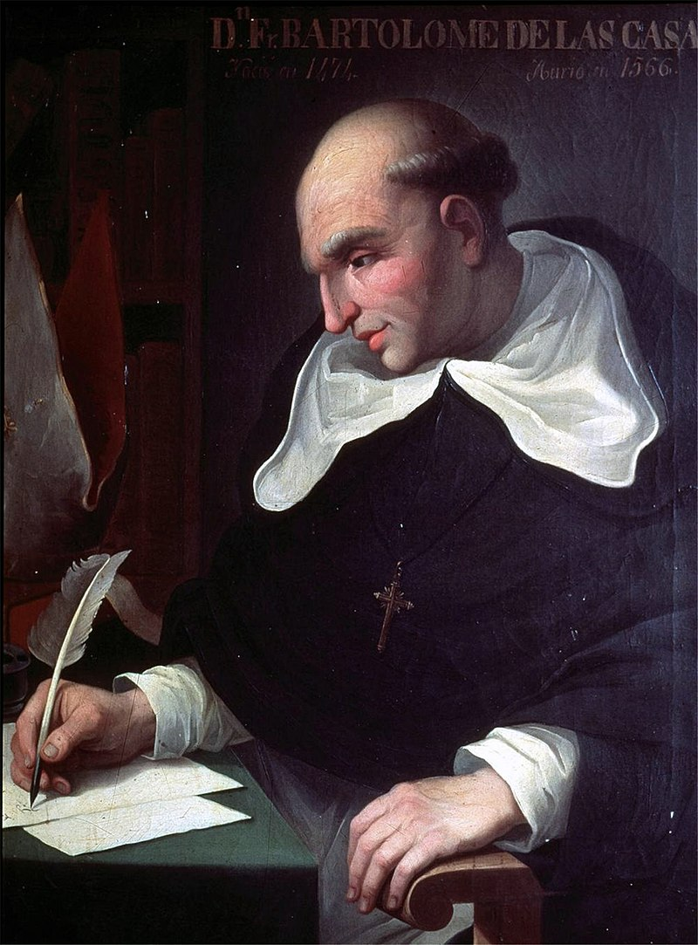
Learning Target: I can explain the effects of Spanish colonization of the Americas.

We will be reading selections from A Short Account of the Destruction of the Indies by Bartolome de las Casas, and then participating in a Literature Circle (small group) discussion based on those excerpts. So what will you be expected to do?

- You will then take one of the roles below in order to facilitate the discussion surrounding the excerpts. You will be expected to turn in what you have brought with you, so come to class prepared. Of course, depending on the number of people who choose each source, there may be more than one of each role in a group.

*Note - if you have extra people in the group, you can double up on any role EXCEPT Discussion Director. It just gets too awkward to have that many people asking questions. :)

  - Discussion Director: You will develop a list of questions that your group might want to discuss about your excerpt. These should facilitate discussion and not be “yes or no” or “simple to answer” questions. You could even focus on some of the AP World course themes!

  - Connector: You will find connections between what you read in the excerpt and the textbook, what you already know, other units and time periods, etc. You are welcome to discuss any other connections that strike you as well, even personal connections.

  - Literary Luminary: You will locate a few special sections or quotations in the text for your group to discuss. The idea is to help your peers dig into some interesting, powerful, puzzling, or important sections of the reading and think about them more carefully. As you decide which passages are worth going back to, be sure to write out why you picked each section. Note them by Page, Section, and number.

  - Researcher: You will find some information or material that helps your group to better understand the excerpt and its importance. This is NOT a research paper! Just investigate something that really interests you – something that struck you as puzzling or curious while you were reading. It can be about the time period, the setting, the author, things that might have influenced the author, why it was published when it was rather than earlier or later, etc.

- When you get to class, you will get into your small group and have an in depth discussion concerning the excerpt. It will be led by the discussion director, but everyone will be expected to participate heartily through the lens of their roles and more.

- After the original lit circle we will come back as a class to discuss how the source represents the effects of exploration, your personal opinions, its historical importance, if you think it’s important for others to read it, important connections, etc.

