Name:_______________________________________________ Date:___________ Period:_______
Topic 4.2 Comparison of Sea-Based Empires (c. 1450-1750)
AMSCO Ch. 16 pgs. 302-312; Ways of the World Ch. 5 pgs. 199-203, 209-219; Ch. 6 pgs. 247-254
 | Spain | Portugal

Government

Explain the process of state building and expansion.
How did they build and manage their empires? Who was in charge? What type of govt?
Trading Posts and/or Colonies Established

Technological Innovations

What technologies did this empire utilize or develop to establish and maintain their sea-based empire?
Economic
How did the trading posts and/or colonies contribute to this empire’s economic development?

Social
What social changes were brought by the establishment of their trading posts and/or colonies?

Culture
What cultural changes were brought by the establishment of their trading posts and/or colonies?

 | Netherlands (Dutch) | France | England

Government

Explain the process of state building and expansion.
How they build and manage their empires? Who was in charge? What type of govt?
Trading Posts and/or Colonies Established

Technological Innovations
What technologies did this empire utilize or develop to establish and maintain their sea-based empire?
Economic
How did the trading posts and/or colonies contribute to this empire’s economic development?

Social
What social changes were brought by the establishment of their trading posts and/or colonies?

Culture
What cultural changes were brought by the establishment of their trading posts and/or colonies?

Explain how mercantilist policies and practices allowed European rulers to expand and control their economies and claim overseas territories. | Explain the role of European monopoly companies on the development of overseas territories.
Economic CAUSES of maritime exploration by European states. | Economic EFFECTS of maritime exploration by European states.
Summarize some of the cultural impacts European colonies and/or trading posts had on local beliefs and practices. | Summarize some of the social impacts European colonies and/or trading posts had on local beliefs and practices.

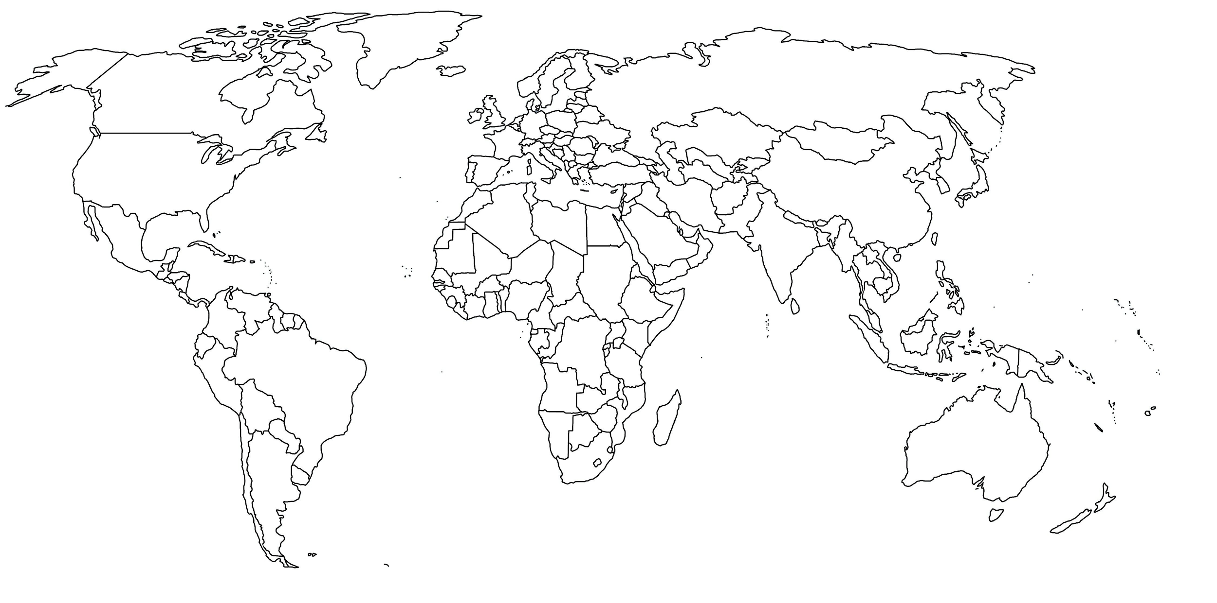 | Color and annotate this map to illustrate the colonies/trading post empires of the following:  - Spanish  - Portugese  - Dutch  - French  - British  In addition, please add routes and DATES for the following:  - Triangular Trade  - Voyage of Vasco da Gama  - Voyage of Magellan/his crew  - Voyage of Columbus

