Name:__________________________________________ Date:__________ Period:_______
Topic 4.4 Labor Systems Graphic Organizer (c. 1450 – 1750)
 | Encomienda | Chattel Slavery | Russian Serfdom
- Define the labor system
- Include the general role/purpose
- Were there revolts or rebellions associated with it?
What state/empire utilized this labor system?
When was this type of labor system abolished or when did it lose significance?

 | Inca Mita  (both before and after colonization) | Indentured Servitude | Hacienda
- Define the labor system  - Include the general role/purpose  - Were there revolts or rebellions associated with it? | Before Spanish:  After Spanish:
What state/empire utilized this labor system?
When was this type of labor system abolished or when did it lose significance?

Annotate the map below with the areas in which each of the coercive labor systems were utilized in the 1450-1750 time period.

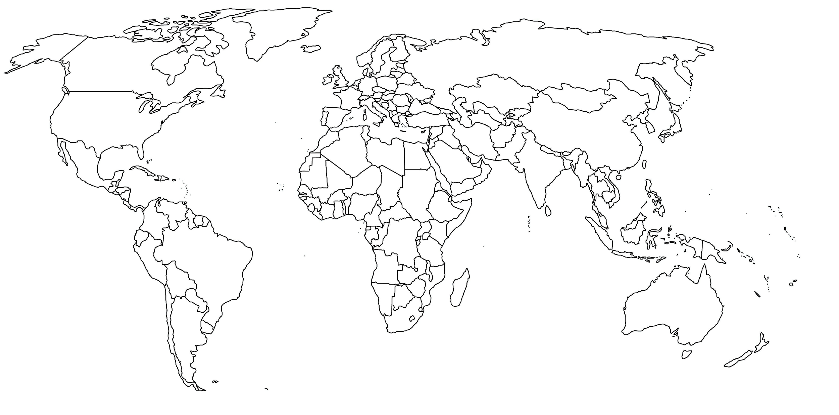 | KEY  - Encomienda  - Hacienda  - Chattel Slavery  - Inca Mita System  - Indentured Servitude

