Resistance to European Colonialism 1450-1750

Source 1: Letter to the King of Portugal, sent in 1526 by King Afonso I of the Kingdom of the Kongo

The slave trade of the 16th century was an economic boost to Portugal but was devastating to Africa. The Congo was a key location in the Portuguese slave trade. Initially, King Affonso, the Congolese leader, was cooperative with the Portuguese slave traders, letting them take lower-class citizens and prisoners of war. However, as Europe’s demand for slaves grew, Affonso became increasingly alarmed as he saw the trade destroying his society. In the following letter to the King of Portugal, Affonso pleads for his country.

“Moreover, Sir, in our Kingdoms there is another great inconvenience which is of little service to God, and this is that many of our people, keenly desirous as they are of the wares and things of your Kingdoms, which are brought here by your people, and in order to satisfy their voracious appetite, seize many of our people, freed and exempt men; and very often it happens that they kidnap even noblemen and the sons of noblemen, and our relatives, and take them to be sold to the white men who are in our Kingdoms; and for this purpose they have concealed them; and others are brought during the night so that they might not be recognized. And as soon as they are taken by the white men they are immediately ironed and branded with fire, and when they are carried to be embarked, if they are caught by our guards’ men the whites allege that they have bought them but they cannot say from whom, so that it is our duty to do justice and to restore to the freemen their freedom, but it cannot be done if your subjects feel offended, as they claim to be. And to avoid such a great evil we passed a law so that any white man living in our Kingdoms and wanting to purchase goods in any way should first inform three of our noblemen and officials of our court whom we rely upon in this matter, and these are Dom Pedro Manipanza and Dom Manuel Manissaba, our chief usher, and Gonçalo Pires our chief freighter, who should investigate if the mentioned goods are captives or free men, and if cleared by them there will be no further doubt nor embargo for them to be taken and embarked. But if the white men do not comply with it they will lose the aforementioned goods. And if we do them this favor and concession it is for the part Your Highness has in it, since we know that it is in your service too that these goods are taken from our Kingdom, otherwise we should not consent to this.

World History: Patterns of Interaction © McDougal Littell Inc. Source: Excerpt from Historia de Congo by Visconde de Paiva-Manso, translated in The African Past by Basil Davidson (Grosset & Dunlap, 1964).

Source 2: “Christian Martyrs Of Nagasaki” - painted by an unknown artist in the 1600s. Refers to the martyrdom of 26 Porgutuese Christians in 1597. (17 from Japan, the rest were foreigners)

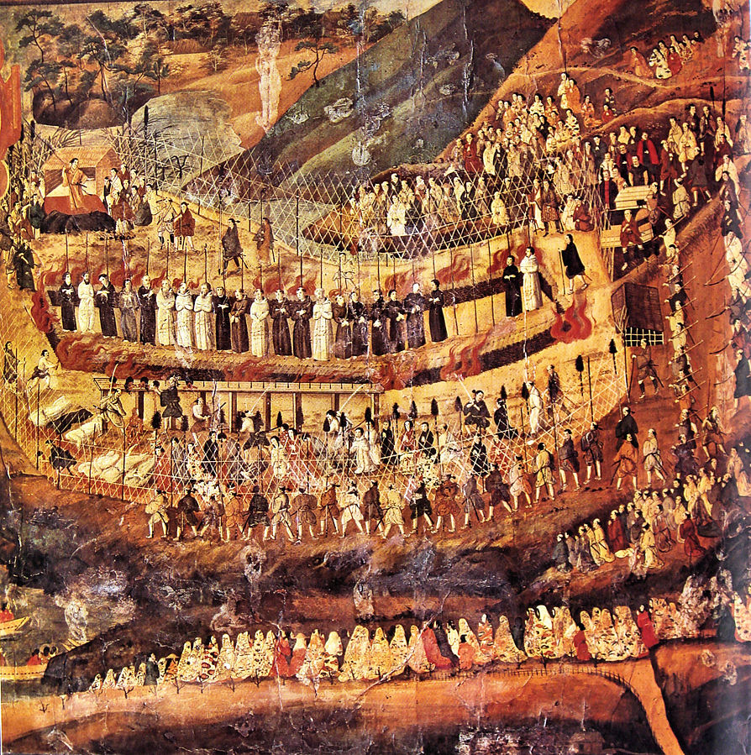

Source 3: “The Future Queen Nzinga Meets with the Portuguese Governor” ca. 1667

“This engraving depicts the future Queen Nzinga (or Njinga) as the representative of her brother, then king of Ndongo, sitting on the back of one of her servants before the Portuguese governor in Luanda in 1622. She observed that the governor was seated on the only chair in the audience chamber and immediately summoned one of her female retainers, who fell upon her hands and knees and became her seat. Portuguese sources record the visit, but not this incident. Giovanni Antonio Cavazzi da Montecuccolo (1621–1678) was an Italian Capuchin missionary. He arrived in Luanda in 1654 and traveled widely as a chaplain with the Portuguese Army, including a stay at the court of the king of Pungo Andongo in 1659, a visit to the court of Queen Nzinga in Matamba and the Kingdom of Kongo in 1660. He returned in 1662 and presided at Nzinga’s funeral. He and left Matamba in 1665 and returned to Italy in 1667. An Italian engraver for the edited version of Cavazzi’s original account created this visual interpretation of the event. Cavazzi's drawings were among the earliest known eyewitness sketches of African life by a European.”

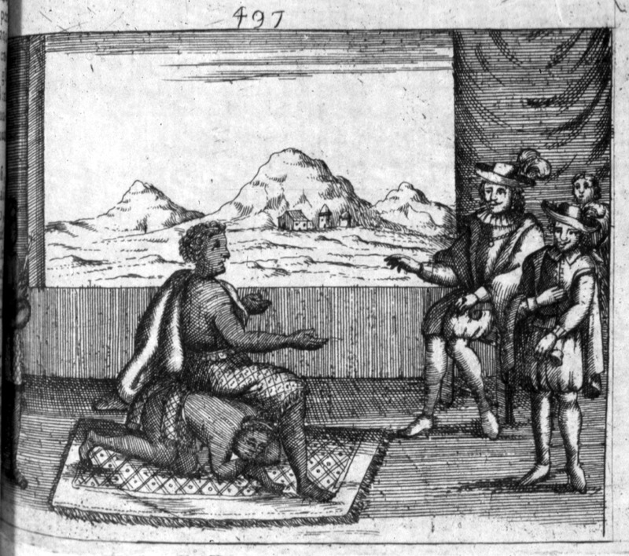
http://slaveryimages.org/s/slaveryimages/item/2238

Source 4: “Indians Attacking a Garrison House,” from an Old Wood Engraving. This is likely a depiction of the attack on the Haynes Garrison, Sudbury, April 21, 1676 during Metacom’s War, (King Philip’s War). It was engraved in the early 1800s. This war is still statistically the bloodiest in American History, as it was the English colonies fighting against an alliance of indigenous tribes. (Wikimedia Commons)

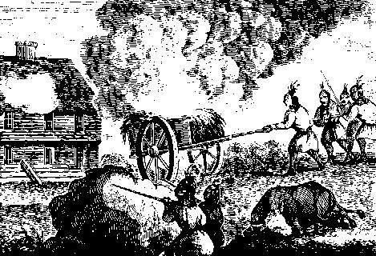

Source 5: In 1680, the Pueblo Indians of New Mexico rose up against the Spanish missionaries and soldiers, destroying every Catholic church in the region. They were led by Pope (Popay). Pedro Naranjo, an Indian prisoner, explains the reasons behind the revolt. (From Digital History)
“Asked whether he knows the reason or motives which the Indians of this kingdom had for rebelling...and why they burned the images, temples, crosses, rosaries, and things of divine worship, committing such atrocities as killing priests, Spaniards, women, and children...he said...they have planned to rebel on various occasions through conspiracies of the Indian sorcerers.... Finally, in the past years, at the summons of an Indian named Pope who is said to have communication with the devil, it happened that in an estufa [Indian temple] of the pueblo of Los Taos there appeared to the said Pope three figures of Indians who never came out of the estufa. They gave the said Pope to understand that they were going underground to the lake of Copala. He saw these figures emit fire from all the extremities of their bodies.... They told him to make a cord of maguey fiber and tie some knots in it which would signify the number of days that they must wait before the rebellion. He said that the cord was passed through all the pueblos of the kingdom so that the ones which agreed to it [the rebellion] might untie one knot in sign of obedience, and by the other knots they would know the days which were lacking.... The said cord was taken from pueblo to pueblo by the swiftest youths under the penalty of death if they revealed the secret. Everything being thus arranged, two days before the time set for its execution, because his lordship had learned of it and had imprisoned two Indian accomplices...it was carried out prematurely that night, because it seemed to them that they were now discovered; and they killed religious, Spaniards, women, and children. This being done, it was proclaimed in all the pueblos that everyone in common should obey the commands of their father whom they did not know, which would be given through...Pope.... As soon as the Spaniards had left the kingdom an order came from the said Indian, Pope, in which he commanded all the Indians to break the lands and enlarge their cultivated fields, saying that now they were as they had been in ancient times, free from the labor they had performed for the religious and the Spaniards, who could not now be alive. He said that this is the legitimate cause and the reason they had for rebelling....

Source 6: Caption: “Trelawney Town, the chief residence of the Maroons.” This is a panoramic view of Trelawney Town with a few human figures shown in foreground. Made in 1796. Trelawney Town was a large settlement of maroons - or runaway enslaved people.

