Document Analysis: The Enlightenment
Document 1

Source: Two Treatisies on Government, John Locke (England, 1690)
Sect. 22. The natural liberty of man is to be free from any superior power on earth, and not to be under the will or legislative authority of man, but to have only the law of nature for his rule. The liberty of man, in society, is to be under no other legislative power, but that established, by consent, in the commonwealth; nor under the dominion of any will, or restraint of any law, but what that legislative shall enact, according to the trust put in it. Freedom then is not what Sir Robert Filmer tells us, Observations, A. 55. a liberty for every one to do what he lists, to live as he pleases, and not to be tied by any laws: but freedom of men under government is, to have a standing rule to live by, common to every one of that society, and made by the legislative power erected in it; a liberty to follow my own will in all things, where the rule prescribes not; and not to be subject to the inconstant, uncertain, unknown, arbitrary will of another man: as freedom of nature is, to be under no other restraint but the law of nature.
Document 2
Source: On the Education of Women, Daniel Defoe (England, 1719)
I have often thought of it as one of the most barbarous customs in the world, considering us as a civilized and a Christian country, that we deny the advantages of learning to women. We reproach the sex every day with folly and impertinence; while I am confident, had they the advantages of education equal to us, they would be guilty of less than ourselves.
One would wonder, indeed, how it should happen that women are conversible at all; since they are only beholden to natural parts, for all their knowledge. Their youth is spent to teach them to stitch and sew or make baubles. They are taught to read, indeed, and perhaps to write their names, or so; and that is the height of a woman's education. And I would but ask any who slight the sex for their understanding, what is a man (a gentleman, I mean) good for, that is taught no more?

Document 3
Source: Émilie Du Châtelet (ca. 1740, France)
“If I were king, I would redress an abuse which cuts back, as it were, one half of human kind. I would have women participate in all human rights, especially those of the mind.”
“I feel the full weight of the prejudice which so universally excludes us from the sciences; it is one of the contradictions in life that has always amazed me, seeing that the law allows us to determine the fate of great nations, but that there is no place where we are trained to think... Why these creatures whose understanding appears in every way similar to that of men, seem to be stopped by some irresistible force, but until they do, women will have reason to protest against their education... I am convinced that many women are either unaware of their talents by reason of the fault in their education or that they bury them on account of prejudice for want of intellectual courage. My own experience confirms this.”

Document 4
Source: The Social Contract, Jean-Jacques Rousseau (France, 1762)
MAN is born free; and everywhere he is in chains. One thinks himself the master of others, and still remains a greater slave than they. How did this change come about? I do not know. What can make it legitimate? That question I think I can answer.
If then we discard from the social compact what is not of its essence, we shall find that it reduces itself to the following terms: "Each of us puts his person and all his power in common under the supreme direction of the general will, and, in our corporate capacity, we receive each member as an indivisible part of the whole.” . . .
In order then that the social compact may not be an empty formula, it tacitly includes the undertaking, which alone can give force to the rest, that whoever refuses to obey the general will shall be compelled to do so by the whole body. This means nothing less than that he will be forced to be free; for this is the condition which, by giving each citizen to his country, secures him against all personal dependence. In this lies the key to the working of the political machine; this alone legitimises civil undertakings, which, without it, would be absurd, tyrannical, and liable to the most frightful abuses.

Document 5
Source: “On Tolerance” – From A Treatisie on Tolerance, Voltaire (France, 1763)
It does not require great art, or magnificently trained eloquence, to prove that Christians should tolerate each other. I, however, am going further: I say that we should regard all men as our brothers. What? The Turk my brother? The Chinaman my brother? The Jew? The Siam? Yes, without doubt; are we not all children of the same father and creatures of the same God?
But these people despise us; they treat us as idolaters! Very well! I will tell them that they are grievously wrong. It seems to me that I would at least astonish the proud, dogmatic Islam imam or Buddhist priest, if I spoke to them as follows:
"This little globe, which is but a point, rolls through space, as do many other globes; we are lost in the immensity of the universe. Man, only five feet high, is assuredly only a small thing in creation. One of these imperceptible beings says to another one of his neighbors, in Arabia or South Africa: 'Listen to me, because God of all these worlds has enlightened me: there are nine hundred million little ants like us on the earth, but my ant-hole is the only one dear to God; all the other are cast off by Him for eternity; mine alone will be happy, and all the others will be eternally damned."

Document 6
Source: Observations on the Feeling of the Beautiful and Sublime, Immanuel Kant (Prussia, 1763)
Deep meditation and a long-sustained reflection are noble but difficult, and do not well befit a person in whom unconstrained charms should show nothing else than a beautiful nature. Laborious learning or painful pondering, even if a woman should greatly succeed in it, destroy the merits that are proper to her sex....A woman who has a head full of Greek, like Mme Dacier, or carries on fundamental controversies about mechanics, like the Marquise de Châtelet, might as well even have a beard....

Document 7
Source: Essay on Crime and Punishments, Cesare Beccaria (Italy, 1764)
The punishment of death is pernicious to society, from the example of barbarity it affords. If the passions, or the necessity of war, have taught men to shed the blood of their fellow creatures, the laws, which are intended to moderate the ferocity of mankind, should not increase it by examples of barbarity.... Is it not absurd, that the laws, which detest and punish homicide, should, in order to prevent murder, publicly commit murder themselves?
It is better to prevent crimes than to punish them. This is the fundamental principle of good legislation, which is the art of conducting men to the maximum of happiness, and to the minimum of misery.... Let the laws be clear and simple, let the entire force of the nation be united in their defence, let them be intended rather to favour every individual than any particular classes of men; let the laws be feared, and the laws only.

Document 8
Source: A Vindication of the Rights of Woman, Mary Wollstonecraft (England, 1792)
... the neglected education of my fellow-creatures is the grand source of the misery I deplore, and that women, in particular, are rendered weak and wretched by a variety of concurring causes.... One cause of this [is]... a false system of education, gathered from the books written on this subject by men who... have been more anxious to make them alluring mistresses than affectionate wives and rational mothers;
My own sex, I hope, will excuse me, if I treat them like rational creatures, instead of flattering their fascinating graces, and viewing them as if they were in a state of perpetual childhood, unable to stand alone. I earnestly wish to point out in what true dignity and human happiness consists. I wish to persuade women to endeavour to acquire strength, both of mind and body, and to convince them that the soft phrases, susceptibility of heart, delicacy of sentiment, and refinement of taste, are almost synonymous with epithets of weakness, and that of those beings who are only the objects of pity...

Document 9
Source: From The Morning Star, 78 (Wednesday 13 May 1789)
concerning William Wilberforce’s speech to the house of Commons on Tuesday, 12 May 1789
Mr. WILBERFORCE then called the attention of the House to what he was about to propose. He said that he rose with a confession of what operated in his mind relative to the abolition of the Slave Trade. When I consider, says he, how long this has been suggested by many, and of what importance it is to a race of men, possessing qualities equally commendable with our own—how many millions are at present involved in the decision of the question—it is impossible for me to object in being instrumental to the business. He then remarked, that he was convinced, whatever should be the decision, that in bringing forward the discussion, he performed nothing more than his duty; and he was so fully persuaded of the rectitude of his conduct, that no consideration whatever would make him swerve from his honour so far, as to dissuade him from marching boldly forward on the occasion. It was no party question, and he flattered himself that the voice of reason and truth would be heard. He was resolved to be regulated by temper and coolness, and challenged a fair discussion.—It was not a proposition grounded upon particular motives of policy, but founded in principles of philanthropy. It was no idle expedient or speculation of the moment, but derived from the most mature deliberation. He came not to accuse the Merchants, but to appeal to their feelings and humanity. He confessed, that in the weak state of health in which he now appeared, and precarious as it might seem to many, he would stand against every personal idea, and bear the burthen destined for a person who stood in his situation. The subject had already undergone many discussions, and he apprehended that previous to a final decision, it would undergo many more. What must make every man of feeling shudder was, that, after examining the annals of Africa, numbers had been carried every year from their native country, in order to satiate the avarice of a certain description of men whose whole thoughts were bent upon tyranny and oppression.

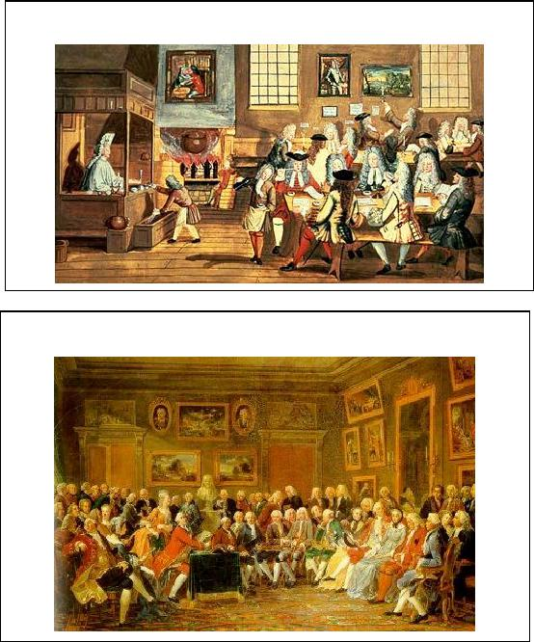
Document 10
Source: A London Coffee House, Anonymous (Painting in the British Museum, ca. 1700s)
Document 11
Source: Madame Geoffrin’s Salon, ca. 1755 (Paris, France 1815)

