FEVER MODEL OF A REVOLUTION
UNIT 5 KICKS OFF WITH . ONE WAY TO LOOK AT THESE IS TO VIEW THEM THROUGH THE METAPHOR OF A DISEASE FROM CANE BRITON’S ANATOMY OF A REVOLUTION (1965)
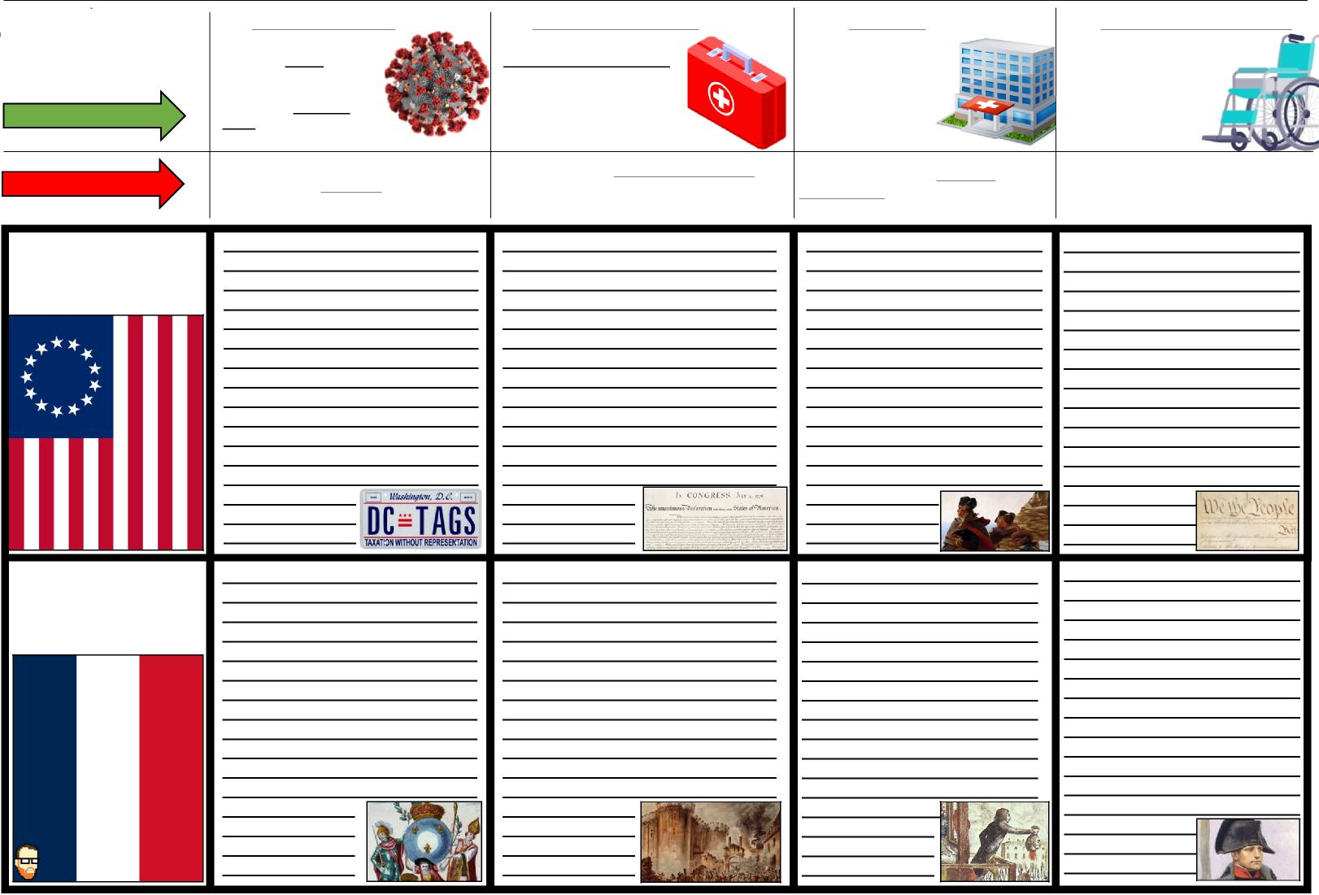
FEVER MODEL
MEDICAL DESCRIPTION
REVOLUTION DESCRIPTION
1. INCUBATION STAGE
This stage in an illness is
when the cause of the
sickness first comes
into contact with the
individual, infecting
them, but not yet causing
any symptoms to present themselves.
THE POLITICAL, SOCIAL, ECONOMIC, INTELLECTUAL CAUSES. THESE CAUSES COULD FESTER FOR YEARS BEFORE MANIFESTING IN ANY ACTION.
2. SYMPTOMATIC STAGE
This stage in when sickness
starts to affect the person
in observable ways.
Temperature may rise.
A cough may present itself.
The individual might
become weak, tired, or queasy.
THE STAGE WITH DIRECT ACTION STEMMING FROM THE CAUSES. THIS COULD BE PUBLICATION OF WORKS, RIOTS, OR ANY DIRECT ATTEMPT AT CHANGE.
3. CRISIS STAGE
This is the critical stage of an illness where two things can happen. The person either
breaks the fever & get better or they get
worse and never recover.
THE REVOLUTION IS IN FULL SWING. USUALLY INVOLVING DIRECT CONFLICTS RANGING FROM DEBATE TO WAR.
(SUCCESSFUL REVOLUTIONS SURVIVE THIS STAGE.)
4. CONVALESCENCE
This stage involves recovering
from the illness. The individual
might be weakened from
the experience, but they
eventually emerge
healthy & able to
prevent future illness.
THIS STAGE IS ALL ABOUT RECOVERY FROM THE CRISIS. THE CAUSES FROM STAGE 1 MUST BE ADDRESSED IN SOME WAY, THOUGH NOT NECA
AMERICAN
REVOLUTION
1765-1791
FRENCH
REVOLUTION
1789-1799

LIKE MANY PANDEMICS, THE LED TO A NEW VARIANT. THIS VARIANT BUILT ON THESE REVOLUTIONS TO CREATE A NEW SENSE SHARED SENSE OF CULTURE, POLITICS, TRADITIONS, ETC...
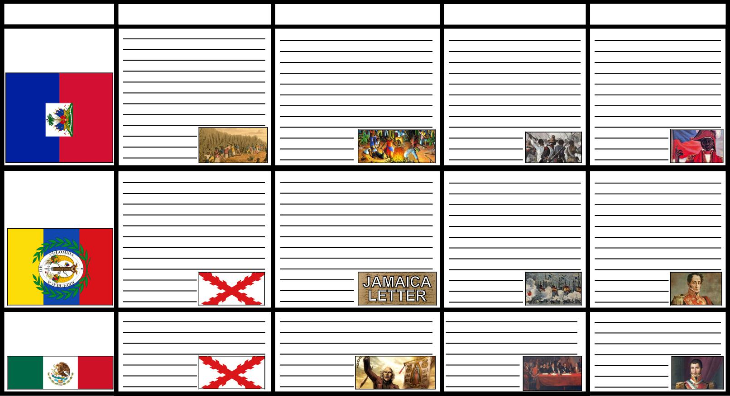
AMERICAN
REVOLUTIONS
1808-1833
FEVER MODEL
MEXICAN
INDEPENDENCE
HAITIAN
REVOLUTION
1791-1804
LATIN
1810-1821
1. INCUBATION
2. SYMPTOMATIC
3. CRISIS
4. CONVALESCNENCE
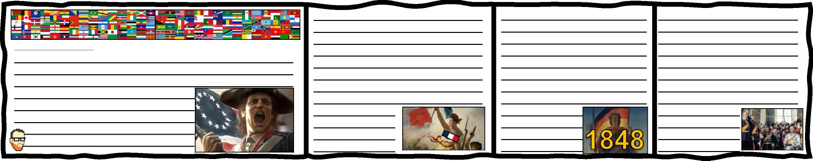
NALISNATM (n):IO NALI SM
NATIO

