NATIONALISM!

**NOW THAT WE’VE SEEN THE RISE OF NATIONALISM… LET’S MEET THE NATIONALISTS:**

NATIONALISM!

**GERMANY**

**PUERTO**

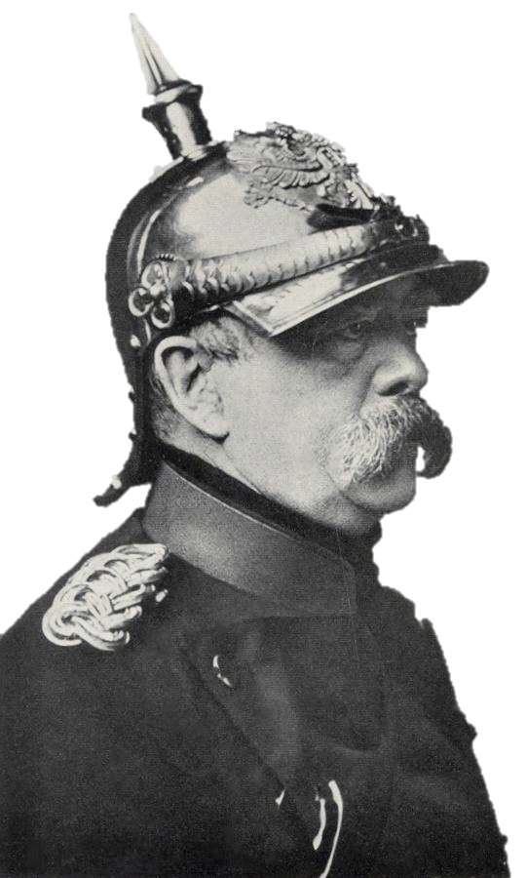

**___________  
 ________  
 __________________________  
 ________________________  
 ___________________________  
 ____________________________  
 ____________________________  
 ___________________________  
 ___________________________  
 _____________________________  
 ______________________________  
 ______________________________  
 __________  
 _______  
 _____  
 __**

**RICO**

**_________  
___________  
___________  
 __________  
 __________  
___________  
___________  
 _________  
 ________  
 _______  
 ______  
 ________  
 __________  
 ______________  
 ___________________  
 ______________________  
 ___ ______________  
 ____ ____  
 _____  
 _____**

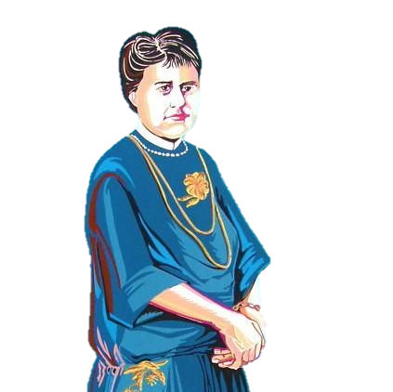





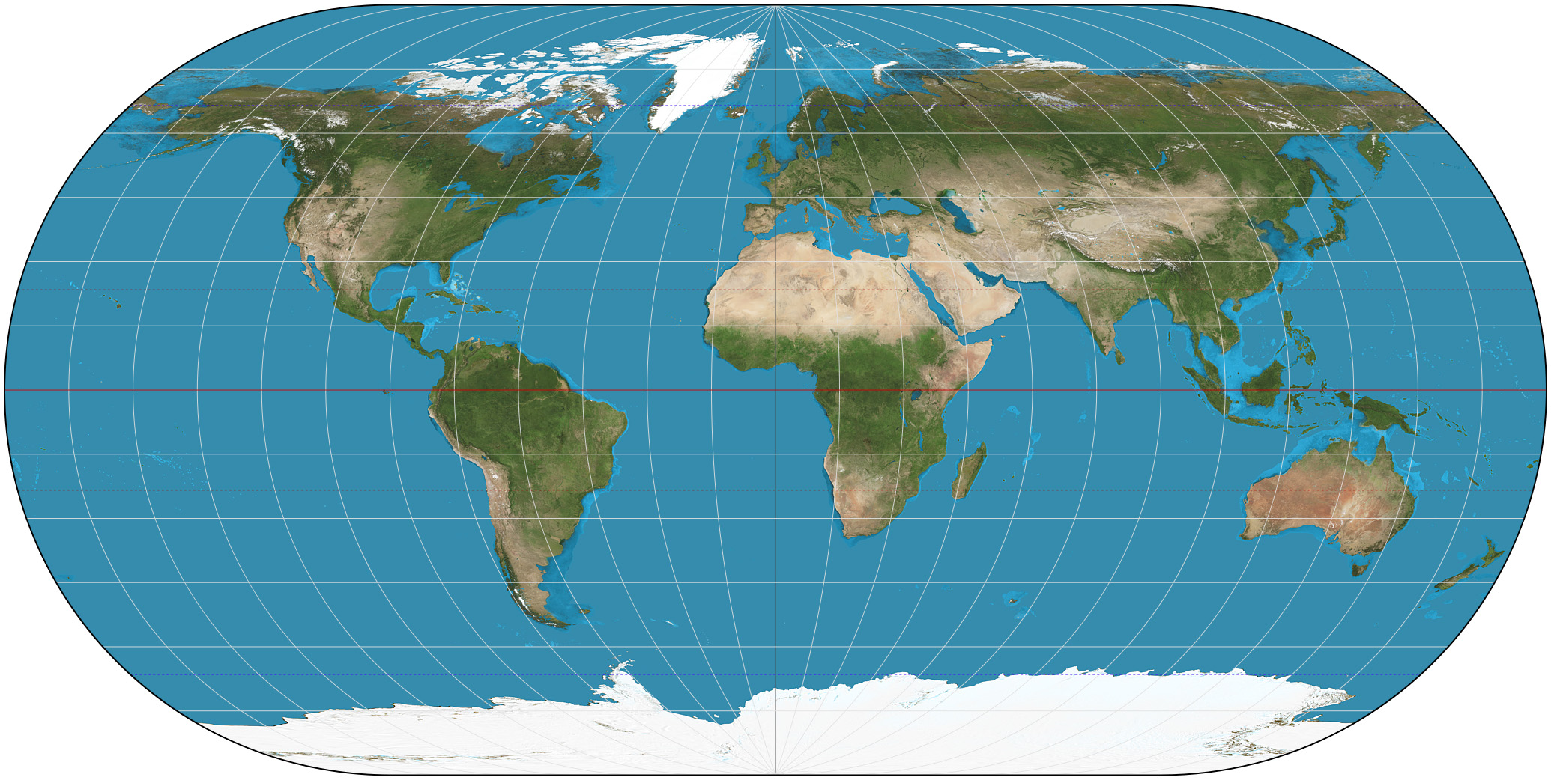





NATIONALISM!

NATIONALISM!

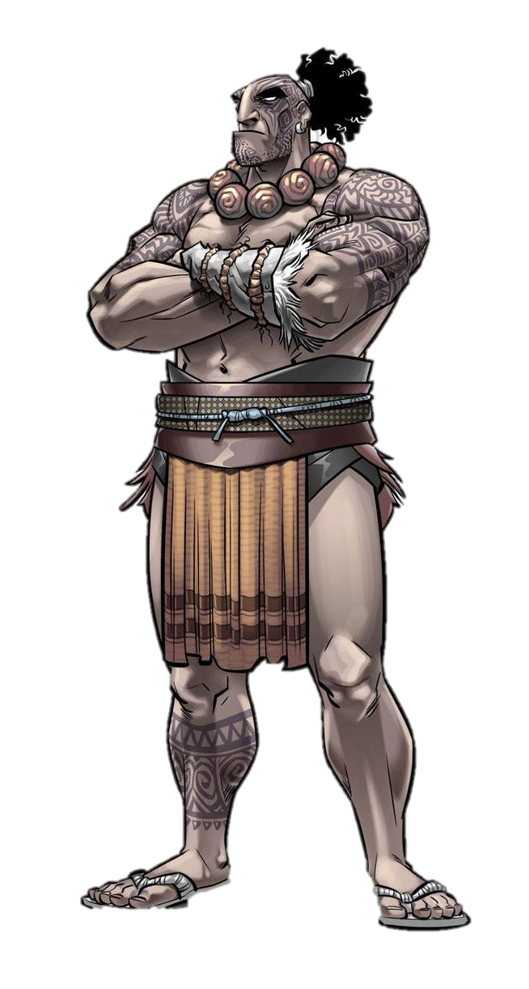

**PHILIPPINES**

**NOW THAT WE’VE SEEN THE RISE OF NATIONALISM… LET’S MEET THE NATIONALISTS:**

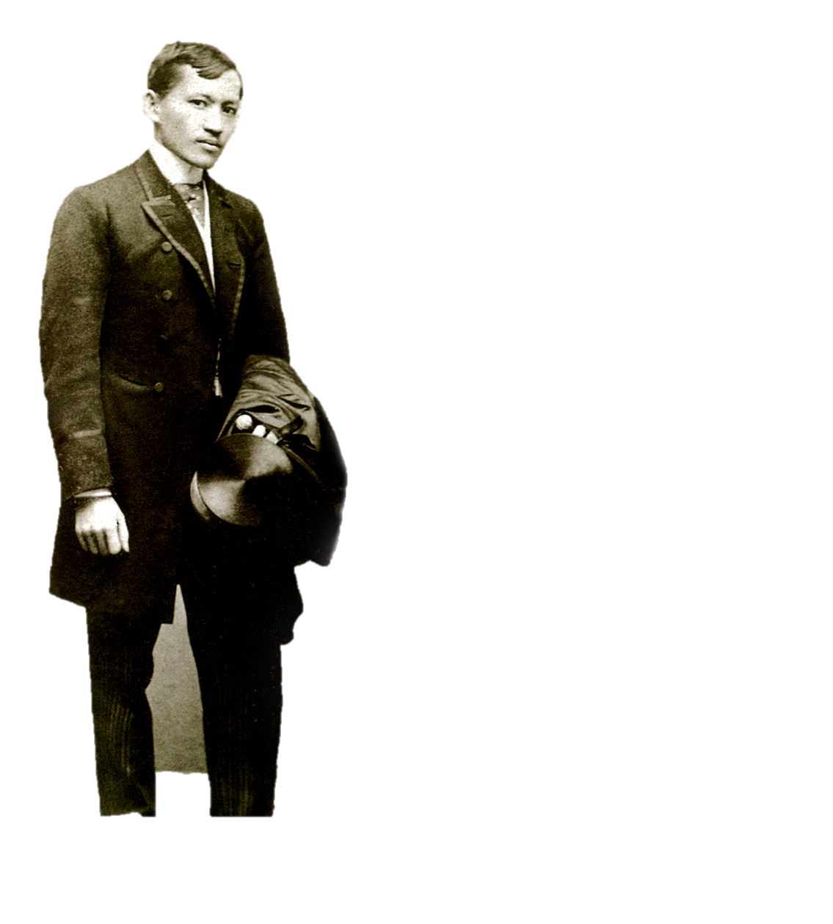

**MAORI**



**__________________________________  
___________________________________  
_________________________________  
________________________________  
________________________________  
 ___________  
 __________  
 ________**

**______  
 _____  
 ___**

**_**

**_______________________**

**_______________________**

**_______________________**

**_______________________**

**_______________________**

**_______________________**

**_______________________**

**______________ ____  
 _________ ___  
 _________ ___  
 _________ _____  
 _____   
 _____  
 ____**

**__  
 ___ _  
 __ __**

**_____ ___  
 ____ ___  
 ____ ___**



