Industrial Revolution Document Set

Evaluate the effects of the Industrial Revolution on European society during the period 1750 – 1900 CE.

Document 1

Source: Excerpt from “An Extract from an account of Mr. Dale’s Cotton Mills” by Thomas Bernhard, in A Report of the Society for Bettering the Condition and Increasing the Comforts of the Poor Volume II, 1798. London, England.

The village… contains about 1500 inhabitants, of whom all are capable of the work are employed in and about the mills. Of these there are 500 children who are entirely fed, clothed, and educated by Mr. Dale. The others live with their parents in the village and have a weekly allowance for their work. The healthy appearance of these children has frequently attracted the attention of the traveler. [Special] regulations, adopted by Mr. Dale for the preservation of the health and morals of those under his protection, have made this striking difference between his manufactory and many other similar undertakings in this kingdom… Out of the nearly 3000 children employed in the mills from 1785 to 1797, only fourteen have died; and not one has been the object of judicial punishment.

Document 2

Source: Excerpt from Charles Knight’s The Working Man’s Companion subtitled The Results of Machinery,
Namely Cheap Production and Increased Employment published in 1831. The book was intended to instruct workers about the benefits of industrialization after failed political riots in Bristol, England.

You are surrounded… with an infinite number of comforts and conveniences which had no existence two or three centuries ago and those comforts are not used by a few, but are within reach of almost all men. Every day is adding something to your comforts. Your houses are better built, your clothes are cheaper, you have an infinite number of domestic utensils. You can travel cheaply from place to place and not only travel at less expense, but travel ten times quicker than almost two hundred years ago.

Document 3

Source: Excerpt from Joseph Hebergam’s interview with the Sadler Commission in 1832. Hebergam was a British industrial textile mill worker. The Sadler Committee was investigating the working conditions in British factories, including child labor.

Sadler: What is the nature of your illness?
Hebergam: I have damaged lungs. My leg muscles do not function properly and will not support the weight of my bones.
Sadler: A doctor has told you that you will die within a year, is that correct?
Hebergam: I have been told so.
Sadler: Did he tell you the causes of your illness?
Hebergam: He told me it was caused by the dust in the factories and from overwork and insufficient diet …
Sadler: To what was his [your brother’s] death attributed?
Hebergam: He was cut by a machine and died of infection.
Sadler: Do you know of any other children who died at the R__________ Mill? [the name of the mill was withheld from the printed testimony]
Hebergam: There was about a dozen who died during the two and a half years I was there. At the L___________ Mill where I worked last, a boy was caught in a machine and both his thigh bones broke and from his knee to his hip the flesh was ripped up the same as if it had been cut by a knife. His hands were bruised, his eyes were nearly torn out and his arms were broken. His sister, who ran to pull him off had both her arms broke and her head bruised. The boy died. I do not know if the girl is dead, but she was not expected to live.
Sadler: Did the accident occur because a shaft was not covered?
Hebergam: Yes.

Document 4

Source: An excerpt from The Philosophy of Manufactures published in 1835, by Andrew Ure, a Scottish physician, scholar, and chemist.

I have visited many factories, both in Manchester and in surrounding districts, and I never saw a single instance of corporal chastisement [beating] inflicted on a child. They seemed to be always cheerful and alert, taking pleasure in the light play of their muscles … as to exhaustion, they showed no trace of it on emerging from the mill in the evening; for they began to skip about … it is moreover my firm conviction that children would thrive better when employed in our modern factories, than if left home in apartments too often ill-aired, damp and cold.

Document 5

Source: A speech made by Lord Ashley to Parliament in June of 1842 following the testimonies of the commission. Ashley was the head of a commission investigating the conditions of workers, including women and children in the coal mines. The commissioners visited mines, interviewed workers, and published the accounts, then presented it to parliament. The Coal Mines Act of 1842 was passed in August.

Sir, the next subject to which I shall request your attention is the nature of the employement in these localities. Now, it appears that the practice prevails to a lamentable extent of making young persons and children of a tender age draw loads by means of the girdle and chain. … The child, it appears, has a girdle bound round its waist, to which is attached a chain, which passes under the legs, and is attached to the cart. The child is obliged to pass on all fours, and the chain passes under what, therefore, in that posture, might be called the hind legs ; and thus they have to pass through avenues not so good as a common sewer, quite as wet, and oftentimes more contracted. This kind of labour they have to continue during several hours, hours in a temperature described as perfectly intolerable. By the testimony of the people themselves it appears that the labour is exceedingly severe ; that the girdle blisters their sides and causes great pain. ’ Sir ’, says an old miner, ’I can only say what the mothers say, it is barbarity- absolute barbarity .’

Robert North says, ’I went into the pit at 7 years of age. When I drew by the girdle and chain, the skin was broken and the blood ran down. . . . If we said anything, They would beat us. I have seen many draw at 6. They must do it or be beat. They cannot straighten their backs during the day. I have sometimes pulled till my hips have hurt me so that I have not known what to do with myself .’

In the West Riding, it appears, girls are almost universally employed as trappers and hurriers, in common with boys. The girls are of all ages from 7 to 21. They commonly worked quite naked down to the waist, and are dressed- as far as they are dressed at all- in a loose pair of trousers. These are seldom whole on either sex. In many of the collieries, whom these girls serve, work perfectly naked…

Document 6

Source: The Conditions of the Working Class in England by German socialist Friedrich Engels, published in 1844.

Every great town has one or more slum areas where workers struggle through life as best they can out of sight of the more fortunate classes of society. The slums … are generally an unplanned wilderness of one – or two – storied houses. Wherever possible these have cellars which are also used as dwellings. The streets are usually unpaved, full of holes, filthy and strewn with refuse. Since they have neither gutters nor drains, the refuse accumulates in stagnant, stinking puddles. The view of Manchester is quite typical. The main river is narrow, coal-black and full of stinking filth and rubbish which deposits on the bank … one walks along a very rough path on the river bank to reach a chaotic group of little one-storey, one room cabins … in front of the doors, filth and garbage abound …

Document 7

Source: The 1750 map: W.H. Thompson, History of Manchester to 1852, 1850's. The 1850 map: Adapted from Ashley Baynton-Williams, Town and City Maps of the British Isles, 1800-1855, late 1850's.

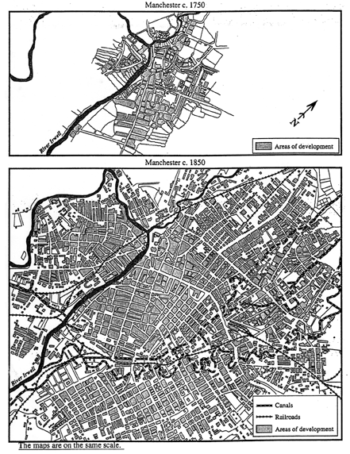

Document 8

Source: View of the production hall at Richard Hartman’s Factory in Saxony (Germany), 1868. Hartmann was one of the most successful entrepreneurs and largest employers in the Kingdom of Saxony.

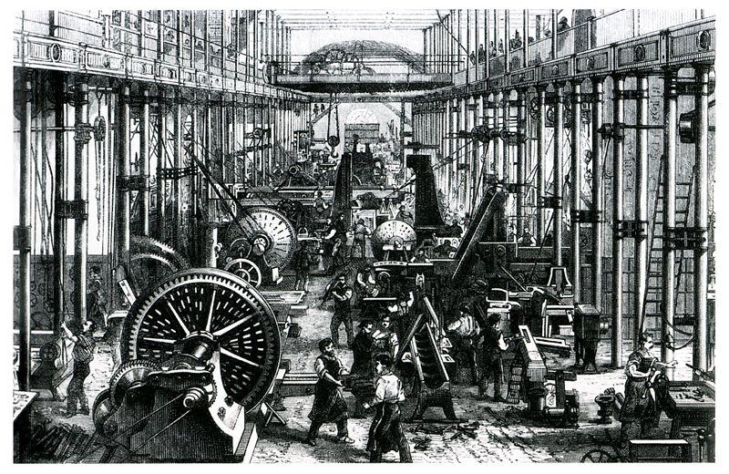

Document 9

Source: Two photographs of “pit brow women,” taken ca. 1865 by W. Clayton in Tredgar, South Whales, England. Tredgar took a series of photographs of the women who worked in Coal and Iron industries in Tredgar. Pit Brow Women worked on the surface at mines after being banned from working below the surface by the law of 1842.

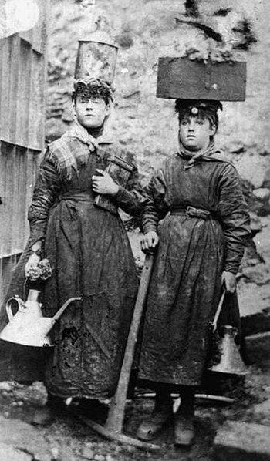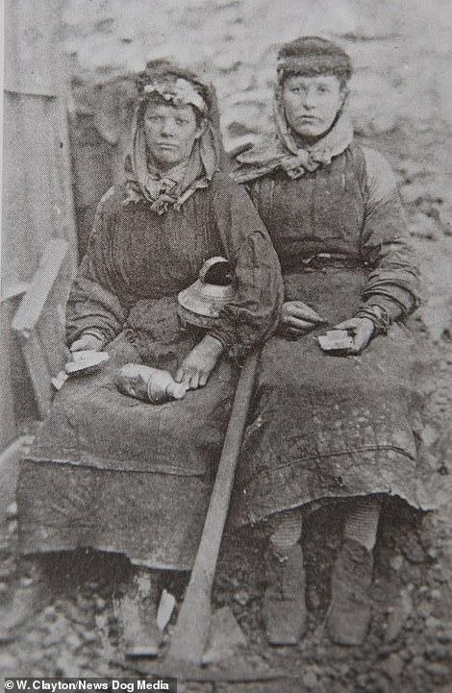

Document 10

Source: Table representing the Spread of Railways in Europe. Modern History Sourcebook, 1997.

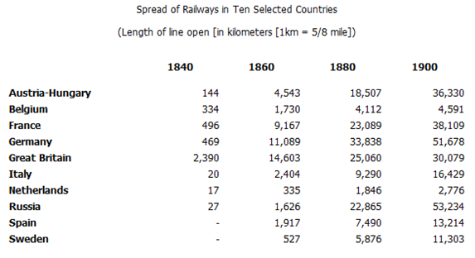

Document 11

Source: “All Mining Disasters” – specifically showing those from 1839 – 1870 in the United States. Produced by the National Institute for Occupational Safety and Health (NIOSH), subsidiary of the Center for Disease Control and Prevention in the United States, ca. 2010.

Date | Mine Name | City | State | Killed | Product | Type
03/18/1839 | Black Heath | Richmond | VA | 53 | Coal | Explosion
06/15/1844 | Black Heath | Richmond | VA | 11 | Coal | Explosion
01/12/1846 | No. 1 | Carbondale | PA | 14 | Coal | Cave-in
02/19/1847 | Spencer | Pottsville | PA | 7 | Coal | Explosion
11/30/1850 | Cox's Pit, Clover Hill | Winterpock | VA | 7 | Coal | Explosion
05/15/1854 | Chesterfield | New Richmond | VA | 20 | Coal | Explosion
03/19/1855 | Midlothian | Coalfield | VA | 55 | Coal | Explosion
04/13/1859 | Bright Hope | Winterpock | VA | 9 | Coal | Explosion
11/30/1863 | Raccoon, Clover Hill | Winterpock | VA | 17 | Coal | Explosion
04/03/1867 | Bright Hope | Winterpock | VA | 69 | Coal | Explosion
04/07/1869 | Kentucky-Yellow Jacket | Gold Hill | NV | 37 | Gold | Fire in timbers
09/06/1869 | Avondale | Plymouth | PA | 110 | Coal | Fire
03/22/1870 | Potts | Locustdale | PA | 5 | Coal | Explosion
08/10/1870 | Heins & Glassmire | Middleport | PA | 9 | Coal | Cage fall (shaft)
08/29/1870 | Preston No. 3 | Girardville | PA | 7 | Coal | Cage fall (shaft)

