Evaluate the factors that motivated Europeans to engage in
imperialism in the late 19th and early 20th centuries.
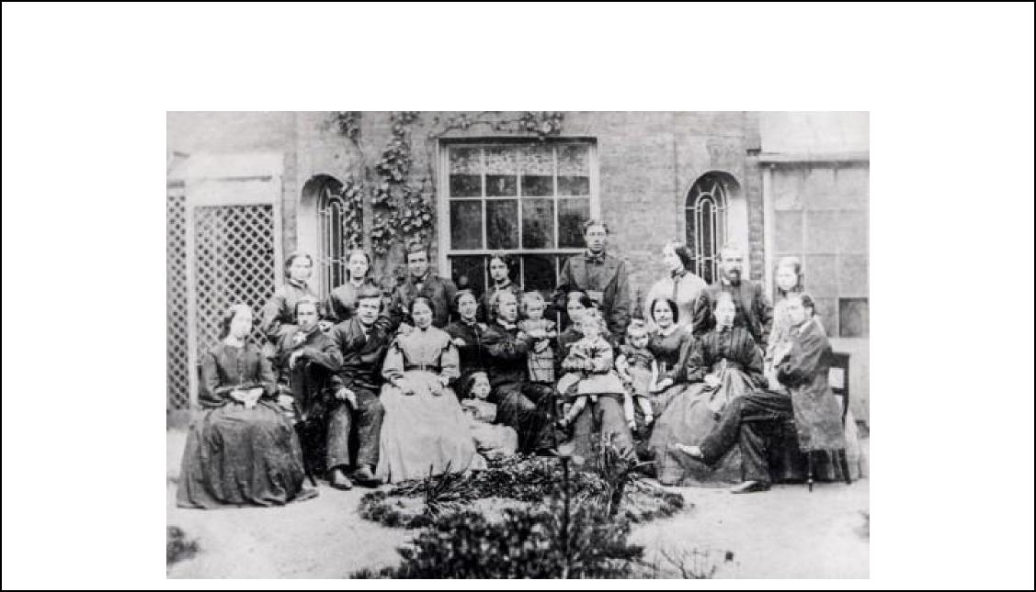
Document 1
Source: China’s Inland Mission (A Christian Missionary Effort), Photograph taken in 1866 prior to
departure for China.
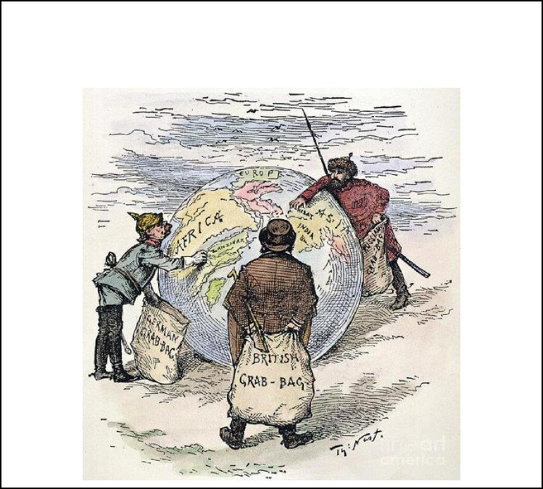
Document3
Source: "The World's Plunderers." Cartoon by Thomas Nast, 1885
(appeared in the American magazine Harper's Weekly)
Document 2 Source: Cecil Rhodes, British imperialist in Africa, Confessions of Faith, 1877
I contend that we [Britons] are the finest race in the world, and the more of the world we inhabit, the better it is for the human race...It is our duty to seize every opportunity of acquiring more territory and we should keep this one idea steadily before our eyes that more territory simply means more Anglo-Saxon race, more of the best, the most human, most honourable race the world possesses.

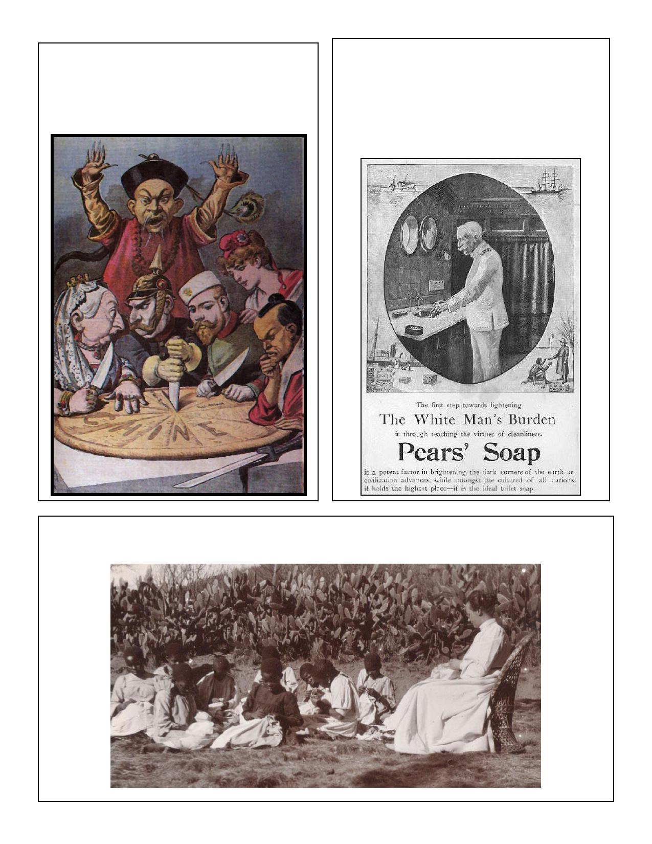
Document 4
Source: French Cartoon 1898 Titled: “En Chine - Le gâteau des Rois et... des Empereurs.” (English: "China - the cake of kings and... of emperors")
Document 5
Source: 1890s Advertisement for Pear’s Soap, made and advertised in London, England. Bottom caption reads Pears’ Soap is a potent factor in brightening the dark corners of the earth as civilization advances. While amongst the cultured of all nations it holds the highest place – it is the ideal toilet soap.
Document 6
Source: Swedish Missionary, Hedvig Posse instructing pupils in needlework at the mission in South
Africa, ca. 1895-1899.

Document 7

Document 9
Source: Kaiser Wilhelm II, King of Germany from
1888 – 1918.
Germany is a young and growing Empire. She has a worldwide commerce to which the legitimate ambition of patriotic Germans refuses to assign by any bounds. Germany must have a powerful fleet to protect that commerce and her interests in even the most distant seas. Only those powers which have great navies will be listened to with respect, when the future of Pacific comes to be solved; and if for that reason only, Germany must have a powerful fleet.
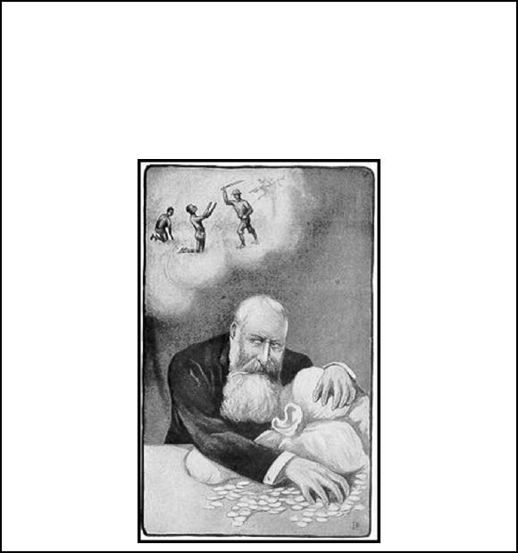
Document 10
Source: A caricature of Leopold II of Belgium with his private earnings from the Congo Free State. Original caption: "My yearly income from the Congo is millions of guineas" (1905)
Document 8
Source: Rudyard Kipling, “The White
Man’s Burden” 1899
Take up the White Man's burden--
Send forth the best ye breed--
Go bind your sons to exile
To serve your captives' need;
To wait in heavy harness,
On fluttered folk and wild--
Your new-caught, sullen peoples,
Half-devil and half-child.
Take up the White Man's burden--
In patience to abide,
To veil the threat of terror
And check the show of pride;
By open speech and simple,
An hundred times made plain
To seek another's profit,
And work another's gain.
Take up the White Man’s burden—
And reap his old reward:
The blame of those ye better
The hate of those ye guard—
The cry of hosts ye humour
(Ah slowly) to the light:
"Why brought ye us from bondage,
“Our loved Egyptian night?”
Take up the White Man’s burden-
Have done with childish days-
The lightly proffered laurel,
The easy, ungrudged praise.
Comes now, to search your manhood
Through all the thankless years,
Cold-edged with dear-bought wisdom,
The judgment of your peers!
Source: Wilfred Scawen Blunt: Britain's Imperial Destiny, 1896-1899. From a letter written in 1898.
I have had it out with George [Wyndham, parliamentary under-secretary in the War Office] about Fashoda. He states the English case with brutal frankness. "The day of talking," he says, "about legality in Africa is over, all the international law there is there consists of interest and understandings. It is generally agreed by all the powers that the end of African operations is to 'civilize' it in the interests of Europe, and that to gain that end all means are good. The only difference between England and France is which of them is to do it in which particular districts... We don't care whether the Nile is called English or Egyptian or what it is called, but we mean to have it and we don't mean the French to have it. The Khedive [Vassal of the Ottoman Empire] may be kept on for some years... but it will end in a partition of the Ottoman Empire between England, Germany, and Russia. France will be allowed Northwestern Africa. It is not worth while drawing distinctions of right and wrong in the matter, it is a matter entirely of interest."

