Name: _______________________________ Period: _______

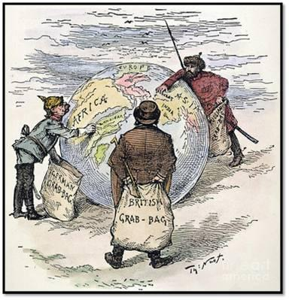
Evaluate the factors that motivated Europeans to engage in imperialism in the late 19th and early 20th centuries.

Understand and Analyze the Documents!

In order to write great historical analysis, you MUST have a good understanding of your evidence… AKA The DOCUMENTS!

What is the main point of the document? How does it connect to the question?

Source the documents that you choose. Remember “HAPPY” and choose ONE of those elements per document to try to analyze.

Historical Situation

Audience

Purpose

Point of View (Bias)

Document Number | What is the big takeaway or the significance of the document? How can I use this document to answer the question? | Pick ONE “Sourcing” or HAPPY Element to Analyze. (Don’t forget the WHY!)
1

2

3

4

5

6

7

8

9

10

