Reactions to Imperialism Documents
Evaluate the reactions to Western expansion/imperialism in the late
19th and early 20th centuries.
Document 1
Source: A letter to Queen Victoria of Britain from the “high imperial commissioner, president of the board of war” (Commissioner Lin) and more in regard to the sale of opium within China, 1839. The letter never reached the Queen.
We have heard that in your own country opium is prohibited with the utmost strictness and severity: ---this is a strong proof that you know full well how hurtful it is to mankind. Since then you do not permit it to injure your own country, you ought not to have the injurious drug transferred to another country...! Of the products which China exports to your foreign countries, there is not one which is not beneficial to mankind in some shape or other... Has China (we should like to ask) ever yet sent forth a noxious article from its soil? Not to speak of our tea and rhubarb, things which your foreign countries could not exist a single day without, if we of the Central Land were to grudge you what is beneficial, and not to compassionate your wants, then wherewithal could you foreigners manage to exist?
Document 2
Source: Summary of The Treaty of Nanjing: August 29, 1842. (Ended the Opium Wars)
Article 2. Determined the opening of five Chinese cities—Canton, Fuzhou, Xiamen, Ningbo, and Shanghai—to residence by British subjects and their families “for the purpose of carrying on their mercantile pursuits, without molestation or restraint.” It also permitted the establishment of consulates in each of those cities.
Article 3. “The Island of Hong Kong to be possessed in perpetuity” and ruled by Victoria and her successors.
Article 4. Payment of $6 million by the Chinese “as the value of the opium which was delivered up in Canton.”
Article 5. Permission at the five above-named ports for British merchants “to carry on their mercantile transactions with whatever persons they please.” Also Chinese pay $3 million in settlement of outstanding debts.
Article 6. Payment to the British of a further $12 million “on account of the expenses incurred” in the recent fighting, minus any sums already received “as ransom for cities and towns in China” since August 1, 1841.

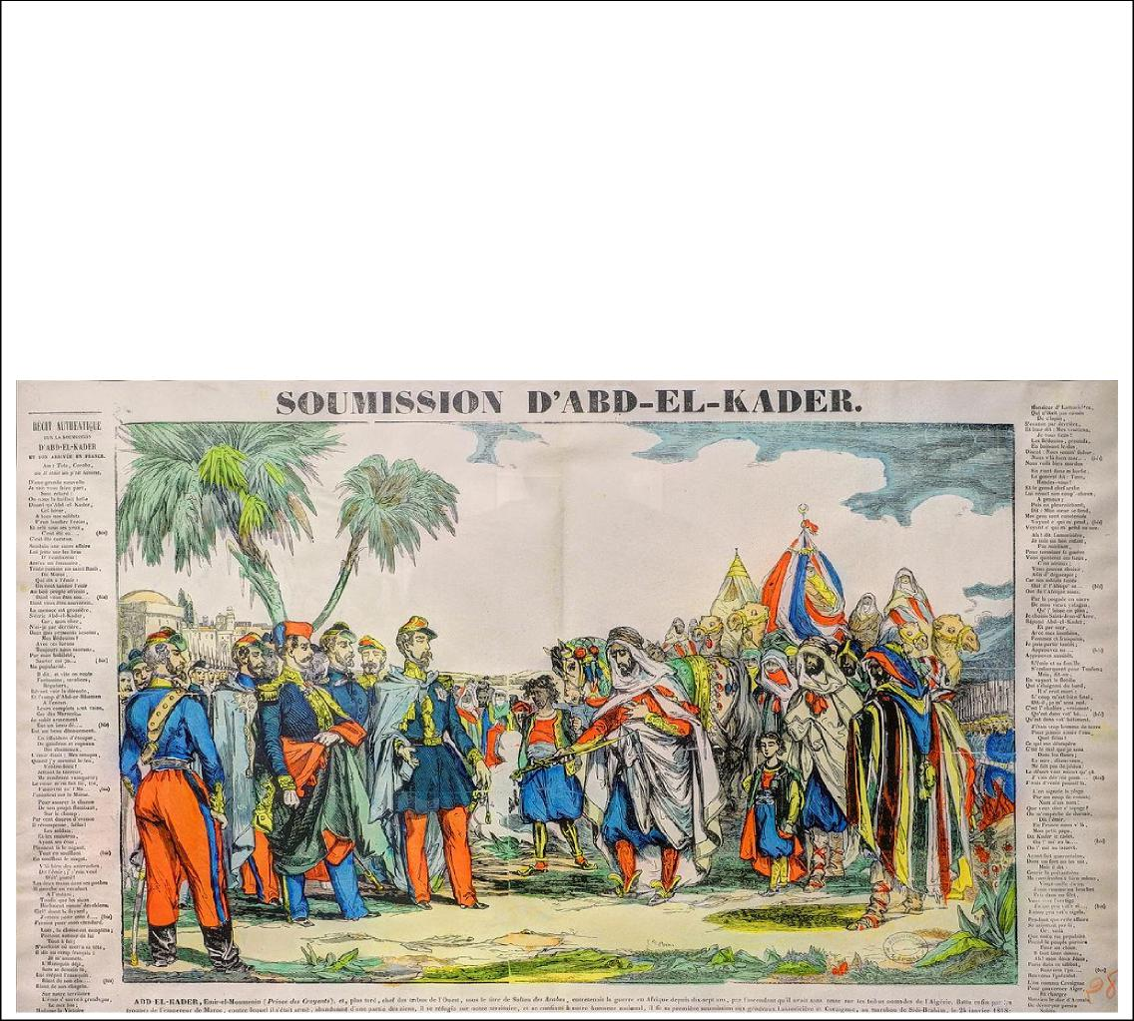
Document 3
Source: The Submission of Abd El-Kader, by Jean-Baptiste Vanson, 1847. (Photograph of the image taken by Thomas Bresson at the History Museum in Belfort).
El Kader was a freedom fighter, and part of the resistance against the French occupation and take-over of Algeria between 1840 and 1847. He was noted for adhering to the Quran as a warrior, and for his humane treatment of prisoners as well as compassion as a warrior. He negotiated a treaty with France in 1847 to end the fighting. After the treaty, he was imprisoned in France for a time, where he was beloved by his jailers. He was eventually allowed to be exiled to Damascus (he wished to reside in a Muslim nation) where he became famous for saving Christians from slaughter during a rebellion in 1860. He received gifts from Queen Victoria and Abraham Lincoln, and has a town, El Kader, Iowa, named after him.

Document 5
Source: The Benefits of British Rule, 1871. By Dadabhai Naoroji, a member of the British House of Commons, political and social leader, founder of the Indian National Congress (which sought independence from Britain)
In the Cause of Humanity: Abolition of suttee [practice of widows burning themselves alive on their husband’s grave] and infanticide. Destruction of... [negative cultural] pests of Indian society. Allowing remarriage of Hindu widows, and charitable aid in time of famine. Glorious work all this, of which any nation may well be proud, and such as has not fallen to the lot of any people in the history of mankind.
In the Cause of Civilization: Education, both male and female. Though yet only partial, an inestimable blessing as far as it has gone, and leading gradually to the destruction of superstition, and many moral and social evils. Resuscitation of India's own noble literature, modified and refined by the enlightenment of the West.
Politically: Peace and order. Freedom of speech and liberty of the press. Higher political knowledge and aspirations. Improvement of government in the native states. Security of life and property. Freedom from oppression caused by the caprice or greed of despotic rulers, and from devastation by war. Equal justice between man and man (sometimes vitiated by partiality to Europeans). Services of highly educated administrators, who have achieved the above-mentioned results.
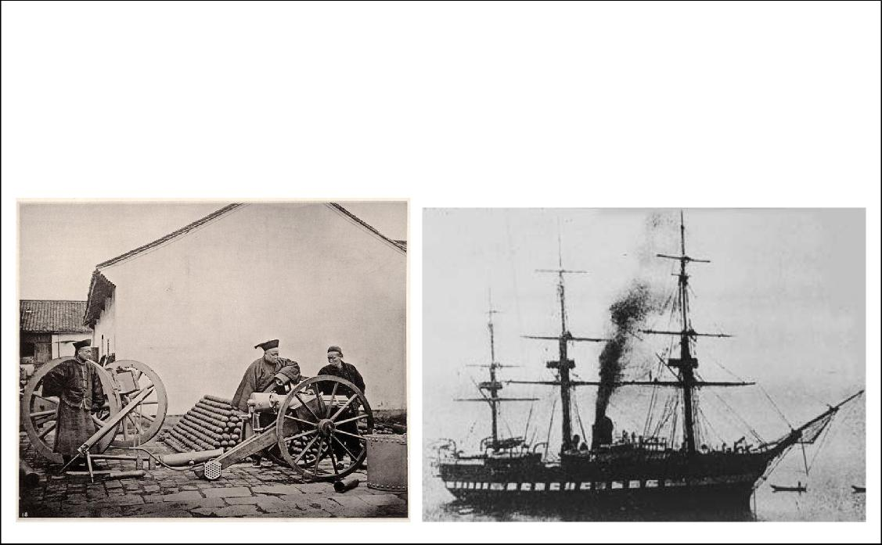
Source: Picture 1 is of the Nanjing Jinling Arsenal from 1865 in China, built by western-educated Li Hongzhang. Picture 2 is a Chinese Warship, either Hai-an or Yu-yuen from 1880. These were built as a part of the “Self-Strengthening Movement” in China, a move toward Westernization of military technology and armaments between 1861 and 1895 in China.
Picture 1 Picture 2
Document 4

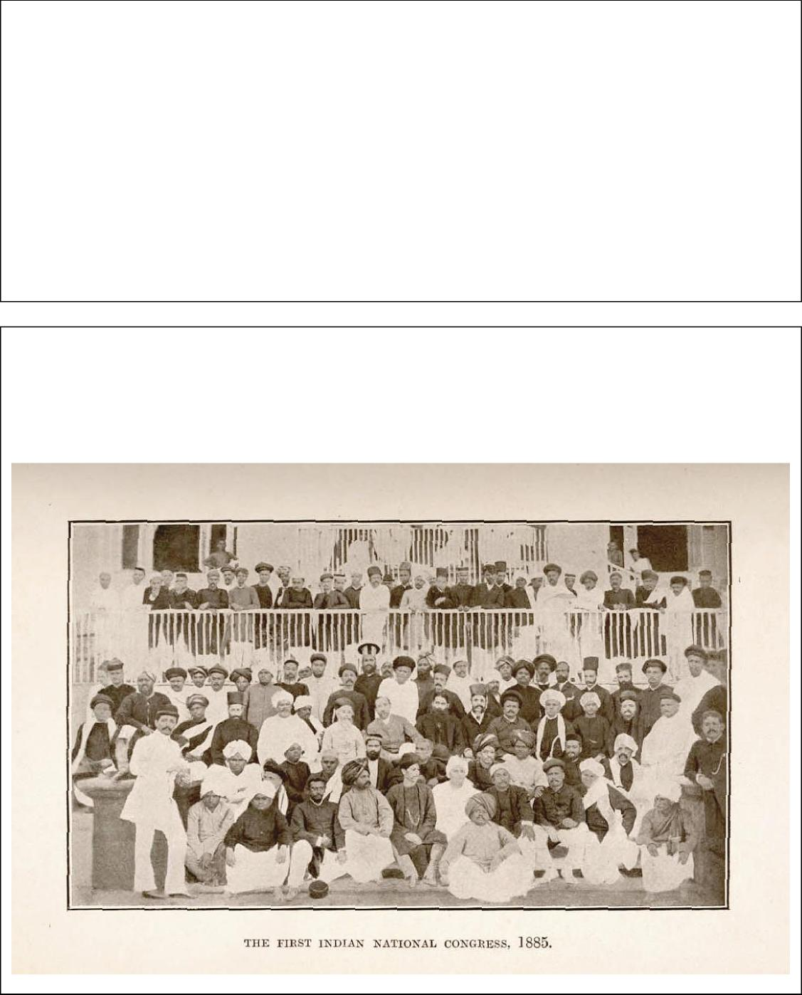
Source: Photograph of the First session of Indian National Congress, Bombay, December 28, 1885. Mahatma Gandhi would eventually lead this party after 1920 in the hopes of gaining independence from Great Britain.
Document 7
Document 6
Source: “Datsu-A Ron” (translation = “Good-bye Asia”) by Fukuzawa Yukichi (author and educator), 1885.
Once the wind of Western civilization blows to the East, every blade of grass and every tree in the East follow what the Western wind brings. The spread of civilization is like the measles. In my view, these two countries [China and Korea] cannot survive as independent nations with the onslaught of Western civilization to the East. It is not different from the case of the righteous man living in a neighborhood of a town known for foolishness, lawlessness, atrocity, and heartlessness. His action is so rare that it is always buried under the ugliness of his neighbors' activities. We do not have time to wait for the enlightenment of our neighbors so that we can work together toward the development of Asia. It is better for us to leave the ranks of Asian nations and cast our lot with civilized nations of the West. Those [who] are intimate with bad friends are also regarded bad, therefore I will deny those bad Asian friends from my heart.

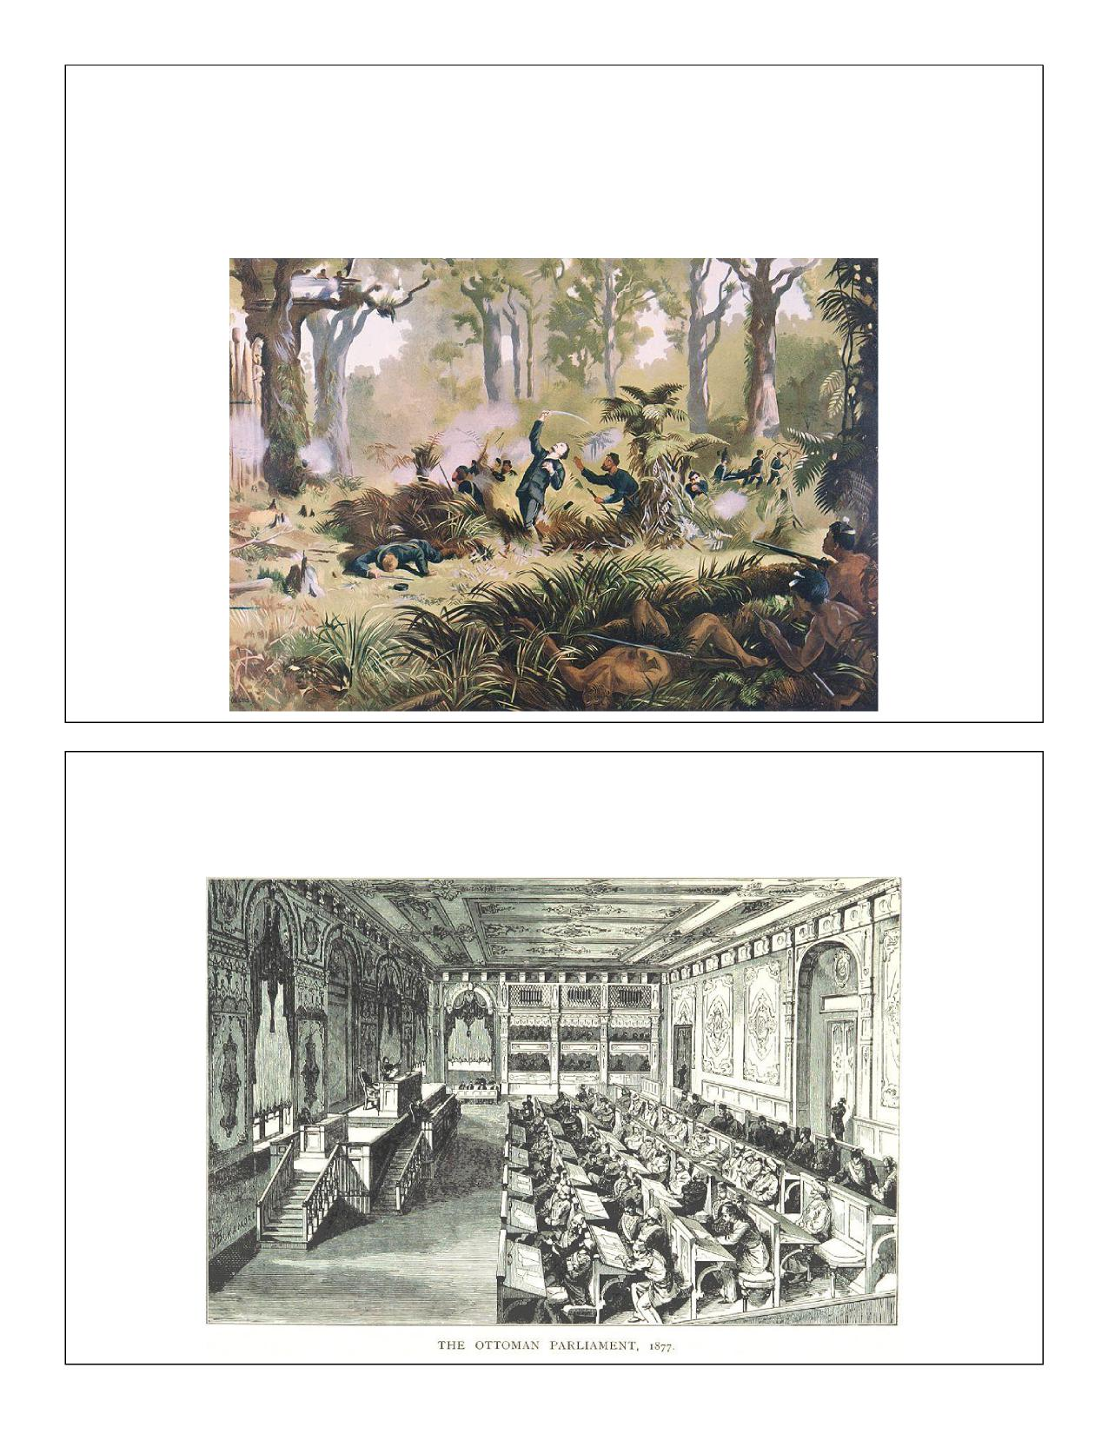
Document 8
Source: Lithograph of The Death of Von Tempsky at Te Ngutu o Te Manu. By Kennet Watkins, 1893.
It is a portrayal of an incident in the “New Zealand Wars” on 7 September 1868. The wars were in response to the continued surveying and settlement of confiscated land, and attempted to block the occupation of Maori land in New Zeland by white settlers.
Document 9
Source: The Ottoman Parliament in 1877, depicted in William James Joseph Spry’s book, Life on the Bosphorous: Doings in the City of the Sultan: Turkey, Past and Present published in 1895.

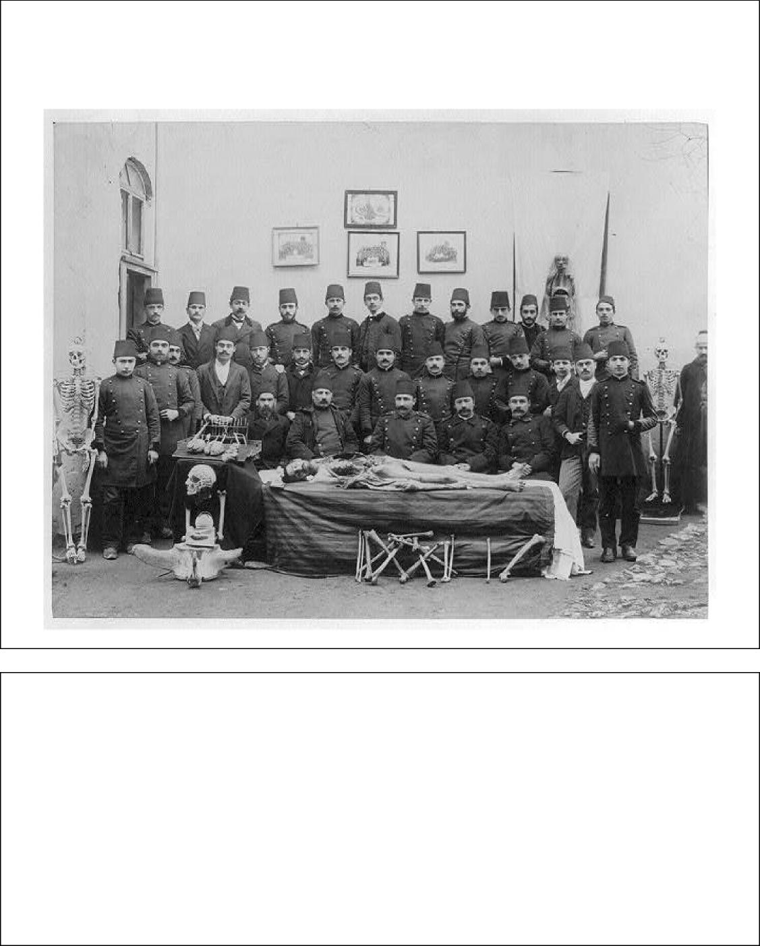
Document 10
Source: A group photograph of the students and the teachers of the Mekteb-i Tıbbiye-yi Mülkiye (Civil Medical School) in Istanbul in the Ottoman Empire, taken at some point between 1880-1893.
Document 11
Source: Ndansi Kumalo, African veteran of the Ndebele Rebellion against the British in southern Africa, 1896.
So we surrendered to the White people and were told to go back to our homes and live our usual lives and attend to our crops. We were treated like slaves. They came and were overbearing. We were ordered to carry their clothes and bundles. They harmed our wives and our daughters. How the rebellion started I do not know; there was no organization, it was like a fire that suddenly flames up. I had an old gun. They—the White men—fought us with big guns, machine guns, and rifles. Many of our people were killed in this fight: I saw four of my cousins shot. We made many charges but each time we were defeated. But for the White men’s machine guns, it would have been different.

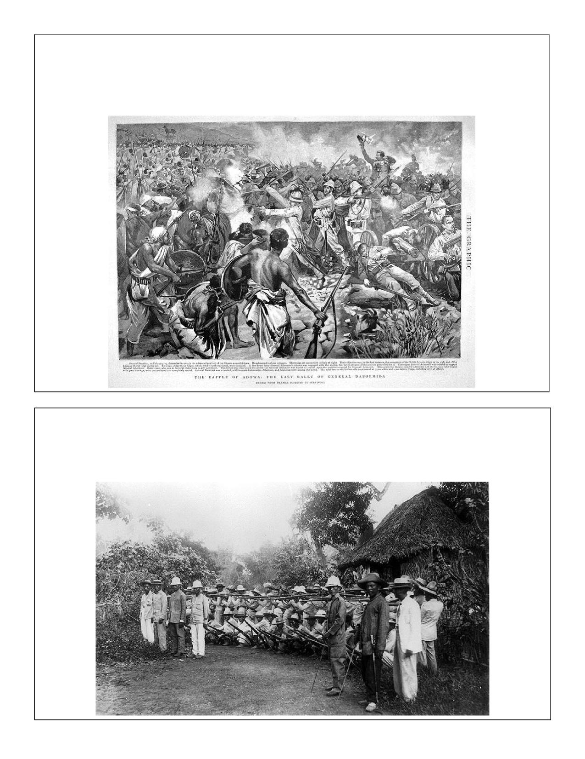
Document 12
Source: Engraving of the “Battle of Adowa: The Last Rally of General Dabormida” in 1896. This depiction of the Battle of Adwa is based on descriptions from people who were at the battle. At the Battle of Adwa, Ethiopia defeated Italy and remained independent for several more decades.
Document 13
Source: Filipino Soldiers Outside of Manila, 1899. This photograph was taken during the conflict against the United States, which was attempting to annex the Philippines in the midst of the Spanish-American War.

Document 14
Source: John A. Hobson, Imperialism, 1902. A well-known economist and critic of Imperialism
Imperialism is a depraved choice of national life, imposed by self-seeking interests which appeal to the lusts of quantitative acquisitiveness and of forceful domination surviving in a nation from early centuries of animal struggle for existence. Its adoption as a policy implies a deliberate renunciation of that cultivation of the higher inner qualities which for a nation as for an individual constitutes the ascendancy of reason over brute impulse.
Document 15
Source: Mojimba, African chief, describing a battle in 1877 on the Congo River against British and African mercenaries, as told to a German Catholic missionary in 1907.
And still those bangs went on; the long sticks spat fire, pieces of iron whistled around us, fell into the water with a hissing sound, and our brothers continued to fall. We ran into our village and they ran after us. We fled into the forest and flung ourselves on the ground. When we returned that evening our eyes beheld fearful things: our brothers, dead, bleeding, our village plundered and burned, and the river full of dead bodies.
You call us wicked men, but you White men are much more wicked! You think because you have guns you can take away our land and our possessions. You have sickness in your heads, for this is not justice.

