Causes of World War I Documents

World War I did not emerge overnight. There were multiple causes of the war. Many historians break it down into the “M-A-I-N” causes of the war - Militarism, Alliances, Imperialism, and Nationalism (with the Assassination as the Spark that Blew up the Powder Keg that was the Balkans area in Europe). Let’s take a look and categorize these documents as one of those causes of the war, and explain how they represent a cause of the war.

Source 1: Otto Von Bismarck, 1878 at the Congress of Berlin.

Europe today is a powder keg and the leaders are like men smoking in an arsenal ... A single spark will set off an explosion that will consume us all ... I cannot tell you when that explosion will occur, but I can tell you where ... Some damned foolish thing in the Balkans will set it off.

Source 2: Cartoon, titled “Sitting Tight” in the American Magazine Punch March 14, 1906. France is attempting to ride the Moroccan Camel, but Germany is holding its tail to prevent that. It refers to the First (of two) Moroccan Crises. (Morocco was technically independent, but under a French “Sphere of Influence.” Germany challenged that.

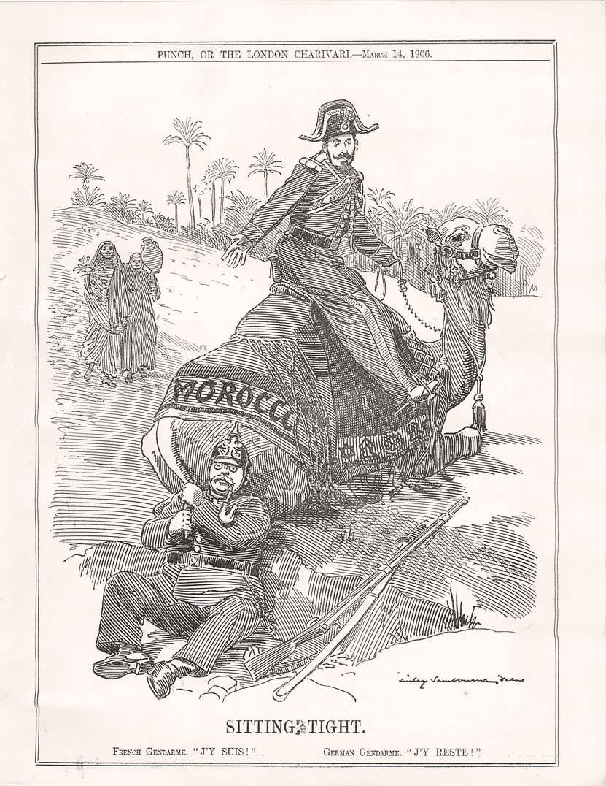

Source 3: “No Limit,” Cartoon published in the American Magazine, Puck, September 22, 1909. Illustration shows a high-stakes poker game with Uncle Sam, William II, the German Emperor, Meiji, the Emperor of Japan, Armand Fallières, President of France, and Edward VII, King of Great Britain; the emperor of Japan is raising the bid by one battleship. (Library of Congress)

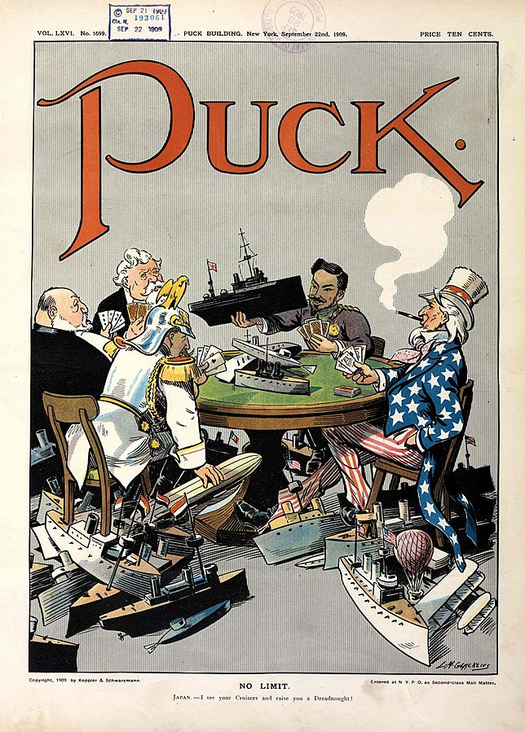

Source 4: German military chief of staff, General Helmuth Von Moltke on the Schlieffen Plan in a memorandum in 1911. (in AlphaHistory)

It may be safely assumed that the next war will be a war on two fronts. Of our enemies, France is the most dangerous and can prepare the most quickly. Accounts must be settled with her very soon after deployment. Should the defeat of the French be achieved quickly and decisively, it will also be possible to make forces available against Russia.

I agree with the basic idea of opening the war with a strong offensive against France while initially remaining on the defensive with weak forces against Russia. If a quick decision is sought against France, the attack should not be directed exclusively against the strongly fortified eastern front of that country. If, as may be expected, the French army remains on the defensive behind that front, there is no chance of quickly breaking through; and even a break-through would expose the German army, or those sections which have made it, to flank attack from two sides.

If one wants to meet the enemy in the open, the fortified frontier-line must be outflanked. This is only possible by means of an advance through Switzerland or Belgium. The first would encounter great difficulties and, because of the defence of the mountain roads, would take a long time. On the other hand, a successful outflanking of the French fortifications would have the advantage of forcing the French army towards the north. An advance through Belgium would force the French back into their interior. Nevertheless, it should be preferred because there one can count on quicker progress. We can count on the somewhat inefficient Belgian forces being quickly scattered, unless the Belgian army should withdraw without a battle to Antwerp, which would then have to be sealed of.…

However awkward it may be, the advance through Belgium must therefore take place without the violation of Dutch territory. This will hardly be possible unless Liège is in our hands...

Everything depends on meticulous preparation and surprise. The enterprise is only possible if the attack is made at once, before the areas between the forts are fortified. It must therefore be undertaken by standing troops immediately war is declared.

Source 5: Map of the Schlieffen Plan, 1905 (Red) and French Plan XVII (Blue), 1912-1914

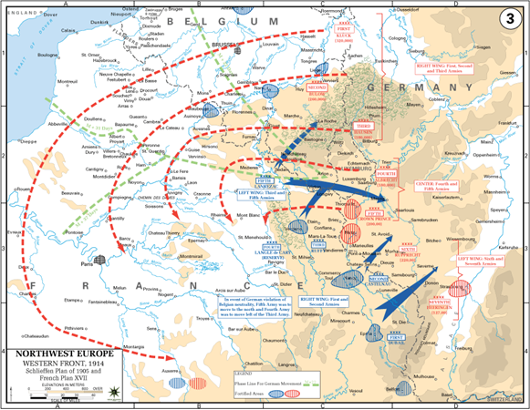

Source 6: Interview of Colonel Dragutin Dimitrevic, head of Serbian military intelligence and founder of the secret society, “Union or Death” (called “The Black Hand” by its opponents) published in Serbian newspaper, Pijemont Belgade, May 25, 1912.

The war between Serbia and Austria … is inevitable. If Serbia wants to live in honor, she can only do this by war. This war is determined by our obligation to our traditions and the world of culture. This war derives from the duty of our race which will not permit itself to be assimilated. This war must bring about the eternal freedom of Serbia, of the South Slavs, of the Balkan peoples. Our whole race must stand together to halt the onslaught of these aliens from the north.

Source 7: Dreadnought Battleships and Battle Cruisers, 1914–1915 in "Arms Race prior to 1914, Armament Policy" By Eric Brose in 1814-1918 Online, International Encyclopedia of the First World War, 2014.

Country | Dreadnought Battleships and Battle Cruisers (Completed in Bold, Laid Down or Budgeted in Parentheses) | Shipbuilding Expenditures in 1913 (Millions of Pounds Sterling, Current Prices) | Percentage Increase in Shipbuilding Expenditures (1902–1904 to 1911–1913)
Germany | 22 (4) | 11,4 | 131%
Austria-Hungary | 3 (5) | 4,4 | 270%
Italy | 4 (6) | 4,3 (1912) | 246%
Britain | 34 (3) | 17,1 | 38%
France | 4 (12) | 7,0 | 41%
Russia | 0 (4) | 11,1 | 105%
Turkey | 2 | 5,5 | 1100%

Source 8: An account of the assassination of Archduke Franz Ferdinand and his wife Sophie on June 28, 1914 by Count Franz von Harrach, apparently a body guard. He had been standing on the sideboard of the car when Gavrilo Princip shot Franz and Sophie. From his memoir, date unverified.

As the car quickly reversed, a thin stream of blood spurted from His Highness's mouth onto my right check. As I was pulling out my handkerchief to wipe the blood away from his mouth, the Duchess cried out to him, "For God's sake! What has happened to you?" At that she slid off the seat and lay on the floor of the car, with her face between his knees.

I had no idea that she too was hit and thought she had simply fainted with fright. Then I heard His Imperial Highness say, "Sophie, Sophie, don't die. Stay alive for the children!"

At that, I seized the Archduke by the collar of his uniform, to stop his head dropping forward and asked him if he was in great pain. He answered me quite distinctly, 'It's nothing!' His face began to twist somewhat but he went on repeating, six or seven times, ever more faintly as he gradually lost consciousness, 'It's nothing!' Then, after a short pause, there was a violent choking sound caused by the bleeding. It was stopped as we reached the Konak.”

Source 9: A telegram from the German chancellor, Bethmann-Hollweg, to the German ambassador in Vienna. Sometimes seen as an example of the ‘Kaiser’s blank cheque’ to Austria-Hungary. (AlphaHistory)

Berlin, July 6th 1914

Confidential. For Your Excellency’s personal information and guidance.

The Austro-Hungarian Ambassador yesterday delivered to the Emperor a confidential personal letter from Emperor Franz Joseph, which describes the present situation from the Austro-Hungarian point of view and describes the measures which Vienna has in view. A copy is now being forwarded to Your Excellency.

I replied to Count Szagyeny today on behalf of the Kaiser, that the Kaiser sends his thanks to Emperor Francis Joseph for his letter and would soon answer it personally. In the meantime, the Kaiser desires to say that he is not blind to the danger which threatens Austria-Hungary and thus the Triple Alliance…

Finally, as far as Serbia is concerned, His Majesty the Kaiser cannot, of course, interfere in the dispute now going on between Austria-Hungary and that country, as it is a matter outside his jurisdiction. Emperor Franz Joseph may, however, rest assured that His Majesty will faithfully stand by Austria-Hungary, as is required by the obligations of his alliance and of his ancient friendship.

Source 10: Cartoon titled “A Chain of Friendship,” appeared in the American newspaper The Brooklyn Eagle in July 1914. The caption read: “If Austria attacks Serbia, Russia will fall upon Austria, Germany upon Russia, and France and England upon Germany.”

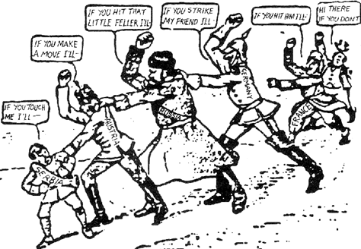

Source 11: Cartoon titled “The Crime of the Ages – Who Did It?” by John T. McCutcheon, published in the Chicago Tribune August 5, 1914.

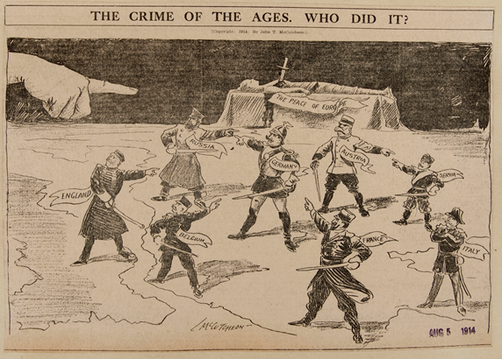

Source 12: World empires and colonies in 1914, just before the First World War. Wikimedia Commons, 2010.

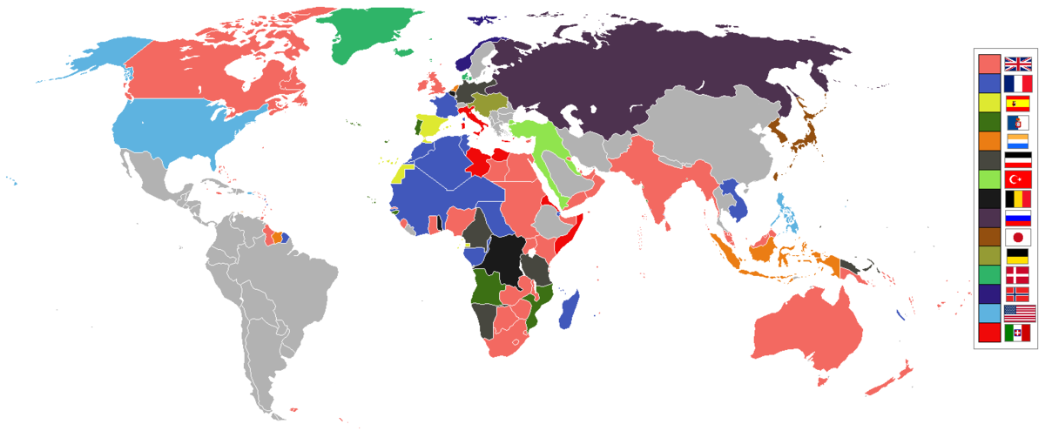
British Empire France Spain Portugal Netherlands German Empire Ottoman Belgium Russia
Japan Republic of China (ROC) Austria-Hungary Denmark Norway United States of America Italy
Independent/other countries

