Unresolved Tensions After World War I

Most students of history are aware that World War I and its “Peace Process” led to World War II. The topic in the College Board Curriculum is even called “Unresolved Tensions After World War I.” So let’s analyze some documents to fully understand these tensions, and why the “War to End All Wars” did not actually end war, and eventually helped to create the conditions for World War II.

Source 1: French General Ferdinand Foch in 1919 concerning the signing of the Treaty of Versailles. Foch was the Allied Commander-in-Chief in late March 1918. He accepted Germany’s wish to have a cease fire, and was at the armistice signing November 11, 1918.

“This is not a peace. It is an armistice for twenty years.”

Source 2: League of Nations member states. Map mode 2009. Wikimedia Commons author Maps & Lucy.

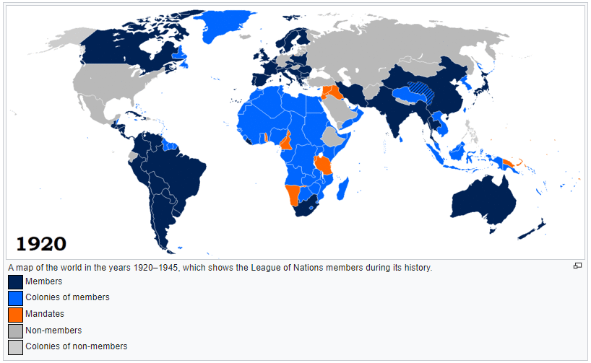

Link: The GIF that changes from 1920-1945

Source 3: “The Race Problem and the World League,” an excerpt from Kiyoshi Kari Kawakami’s Japan and World Peace, 1919]

It will be recalled that on February 13 the Japanese envoys proposed that the covenant of the League of Nations should include an article abolishing racial discrimination in future international dealings. The Peace Conference, without giving Japan even a semblance of a hearing, rejected the proposal. …
Ever since Japan opened her doors to foreign intercourse, the Japanese have observed that the Occidental nations had two standards of morals or justice, none for themselves, and one for Asiatic peoples. If ever there was an opportunity for the abolition of this anomalous state of relations between the East and the West, the Japanese thought that the present Peace Congress offered such an opportunity. They are wondering whether the feint of hearing, which their proposal received at the peace table, is an indication that the great Powers of the West mean to adhere to the double standards of justice which they have long maintained.

Source 4: Ex.-Lieut.-Col. T.E. Lawrence wrote an article to be published in The Sunday Times in London, August 22, 1920. He was a famous British general who fought with the Arab resistance against the Turks.

The people of England have been led in Mesopotamia into a trap from which it will be hard to escape with dignity and honour… Things have been far worse than we have been told, our administration more bloody and inefficient than the public knows. It is a disgrace to our imperial record, and may soon be too inflamed for any ordinary cure. We are to-day not far from a disaster. …
We say we are in Mesopotamia to develop it for the benefit of the world. All experts say that the labour supply is the ruling factor in its development. How far will the killing of ten thousand villagers and townspeople this summer hinder the production of wheat, cotton, and oil? How long will we permit millions of pounds, thousands of Imperial troops, and tens of thousands of Arabs to be sacrificed on behalf of colonial administration which can benefit nobody but its administrators?

Source 5: Maps creating Mandate States in the Middle East.
Left: Sykes-Picot Agreement Map. Agreement of 1916, created by Columbia University, 2016.
Right: The Mandate States created by the League of Nations in 1920, based on the Sykes Picot Agreement. Map by Geoffrey Gaudreault, National Public Radio, 2004.

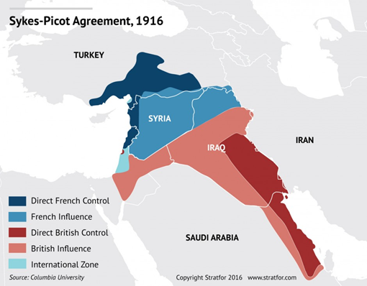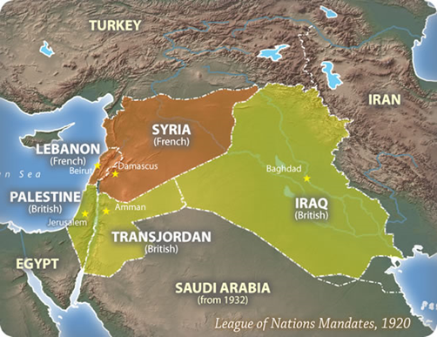

Source 6: Article 22 of the League of Nations Covenant, 1920.

ARTICLE 22.
To those colonies and territories which as a consequence of the late war have ceased to be under the sovereignty of the States which formerly governed them and which are inhabited by peoples not yet able to stand by themselves under the strenuous conditions of the modern world, there should be applied the principle that the well-being and development of such peoples form a sacred trust of civilisation and that securities for the performance of this trust should be embodied in this Covenant.

The best method of giving practical effect to this principle is that the tutelage of such peoples should be entrusted to advanced nations who by reason of their resources, their experience or their geographical position can best undertake this responsibility, and who are willing to accept it, and that this tutelage should be exercised by them as Mandatories on behalf of the League.

The character of the mandate must differ according to the stage of the development of the people, the geographical situation of the territory, its economic conditions and other similar circumstances.

Certain communities formerly belonging to the Turkish Empire have reached a stage of development where their existence as independent nations can be provisionally recognized subject to the rendering of administrative advice and assistance by a Mandatory until such time as they are able to stand alone. The wishes of these communities must be a principal consideration in the selection of the Mandatory.

Other peoples, especially those of Central Africa, are at such a stage that the Mandatory must be responsible for the administration of the territory under conditions which will guarantee freedom of conscience and religion, subject only to the maintenance of public order and morals, the prohibition of abuses such as the slave trade, the arms traffic and the liquor traffic, and the prevention of the establishment of fortifications or military and naval bases and of military training of the natives for other than police purposes and the defence of territory, and will also secure equal opportunities for the trade and commerce of other Members of the League.

There are territories, such as South-West Africa and certain of the South Pacific Islands, which, owing to the sparseness of their population, or their small size, or their remoteness from the centres of civilisation, or their geographical contiguity to the territory of the Mandatory, and other circumstances, can be best administered under the laws of the Mandatory as integral portions of its territory, subject to the safeguards above mentioned in the interests of the indigenous population.

In every case of mandate, the Mandatory shall render to the Council an annual report in reference to the territory committed to its charge.

The degree of authority, control, or administration to be exercised by the Mandatory shall, if not previously agreed upon by the Members of the League, be explicitly defined in each case by the Council.

A permanent Commission shall be constituted to receive and examine the annual reports of the Mandatories and to advise the Council on all matters relating to the observance of the mandates.

Source 7: “Japanese Leave The League Of Nations Assembly,” Geneva, February 24.
In an daily newspaper called the Barrier Miner published in South Wales, England on February 25, 1933.

Almost simultaneously with the beginning Chining of fighting in Johol, the Assembly of the League of Nations today adopted the report of the Committee of Nineteen on the Lytton report on Manchuria by 49 votes to
one; Japan being the only dissentient. The committee had recommended the evacuation of the Japanese troops from Manchuria and the appointment of a committee of negotiation. The climax to an electrical session, marked by dramatic and determined speeches by the Chinese and Japanese representatives, occurred when M. Matsuoka (Japan), declaring that Japan could not accept the draft report, led the Japanese delegation out of the chamber. M. Matsuoka asked that Japan be given a chance. "I beg you not to adopt the report for the sake of peace in the Far East and the peace of the world," he exclaimed. M. Matsuoka's speech is considered to, be one of the most pungent ever heard at Geneva. His voice rose
shrilly above the hum of the "talkie" apparatus. He shouted one staccato question after another, pointing a
forefinger at the delegates. He seemed almost on the brink of tears as he closed with an appeal to the
Assembly to reject the report. After the Japanese delegates had made a dramatic withdrawal, M. Matsuoka hemmed in by journalists In the lobby said: "We are not coming back."

Source 8: Japanese Images
Left: Japanese poster or postcard ca. 1930s. “Japan-Korea. Teamwork and Unity. Champions of the World.”
Right: 1935 poster of “Manchukuo” promoting harmony between Japanese, Chinese, and Manchu. The caption, written from right to left, says: "With the help of Japan, China, and Manchukuo, the world can be in peace." The flags shown are, left to right: the flag of Manchukuo; the flag of Japan; the "Five Races Under One Union" flag of China.

