Lead up to World War II -
Political Cartoons and Images Historical Situation

Political Cartoons are perfect for analyzing what the College Board calls “Historical Situation.” This is because in order to understand the message of the cartoon, you must first understand the backdrop and what is occurring in the world, country, or region in which the cartoon is made. What is going on in the time period that affects the author or source? Today we will use political cartoons concerning the lead up to World War II to practice your skills of analyzing Historical Situation in documents. (Cartoons are below!)

Document | Provide a quick, one sentence summary of the document. | Provide at least one sentence of “historical situation” in the boxes below for each document.
1 - “Let’s See You Collect”
(1920)
2 - “The Source”
(1930)

3 - “You and your infernal stock market”
(1930)
4 - Der Stürmer Cartoons
(1929 - 1930)

5 - “Manchuria 1931”

Document | Provide a quick, one sentence summary of the document. | Provide at least one sentence of “historical situation” in the boxes below for each document.
6 - “Vermin - Bed Bugs” (1934)

7 - “Spineless Leaders of Democracy” (1936)

8 - “Cuaderno” or Copybook (1936)

9 - “How Japan could attack the US” (1937)

10 - “The Moscow Purge” (1937)
11 - “Carriers of the New Black Plague” (1938)

Source 1: “Let’s See You Collect,” in New York World Magazine, 1921. (Wikimedia Commons)
The man underneath the large bag is labeled “Germany”
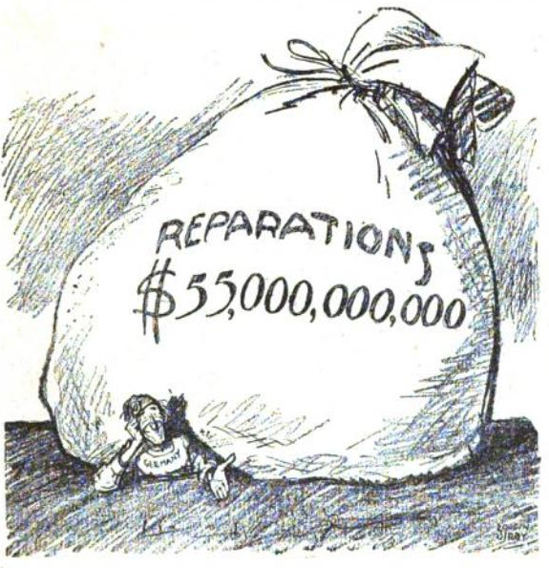

Source 2: “The Source,” cartoon by Daniel Fitzpatrick published in the St. Louis Post-Dispatch, October 30, 1930. (From the Opper Project, the Ohio State University Cartoon Research Library.)

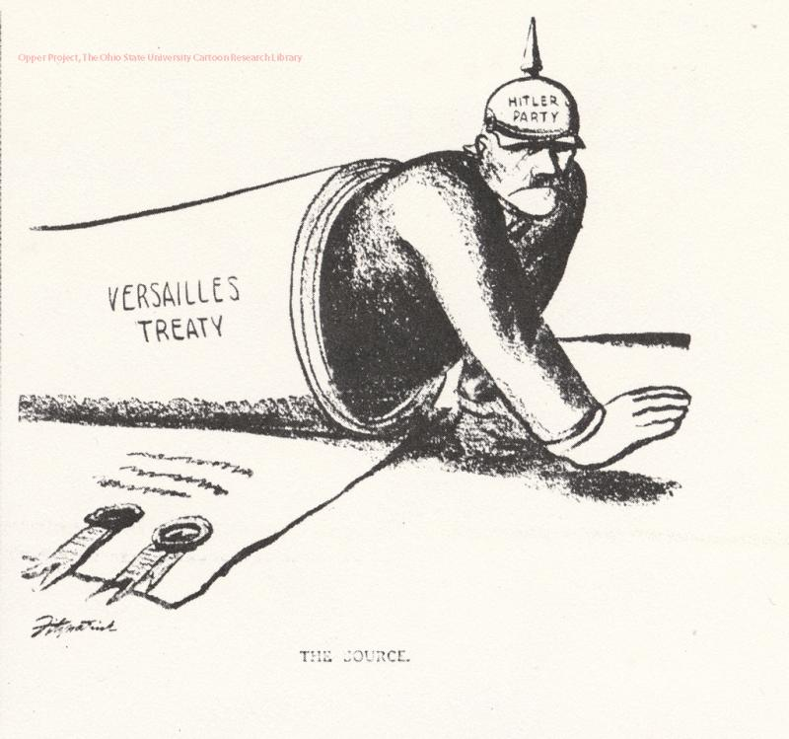
Source 3: Cartoon “You and your infernal stock market have hurt Italian progress terribly!” by Clifford Kennedy Barryman. Published December 21, 1930, New York Times. (Library of Congress)

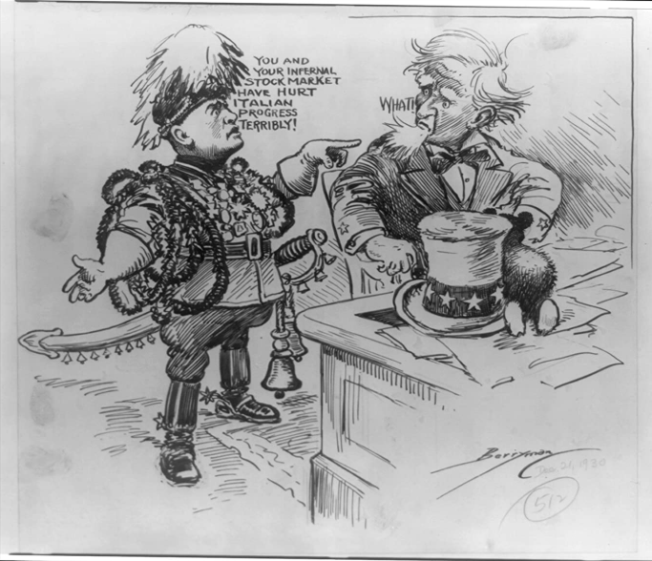

Source 4: Cartoons published in the specifically anti-semitic German newspaper Der Stürmer by Julius Streicher. The paper was founded in 1923. (In Calvin University’s German Propaganda Archive)

Title - “Sucked Dry,” Published February, 1930 | Title - “The Worm,” Published November, 1931. Caption - “Where something is rotten, the Jew is the cause.”
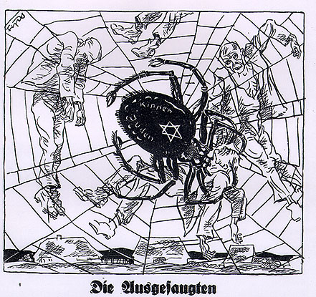 | 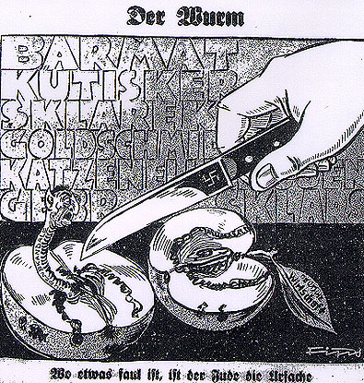
Caricature suggests the Jews are sucking the economic life from Gentiles. It is one of many Stürmer cartoons comparing Jews to inhuman/unpleasant creatures. | The names in the background are those of Jews involved in major financial scandals. The apple is named “the German economy.” The worm is named “Jewish scandals.”

Source 5: “Manchuria 1931” - an American cartoon commenting on Japan's seizure of Manchuria and its failure to abide by its promises and international treaty agreements. Cartoon, 1931. (Granger Academic - make a free educator account to download and access this cartoon)

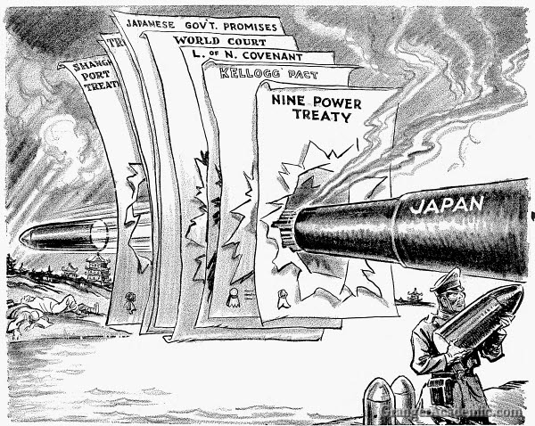

Source 6: “Ungeziefer: Völker Europas, wahrt eure heiligsten Güter!” (Translation - Vermin: People of Europe, Defend Your Sacred Treasures!) by Arthur Johnson. Published October 28, 1934 in Kladderadatsch, a satirical German magazine that frequently supported HItler from the 1920s onward, ceasing publication in 1944.

“A satirical map warning against the dangers of spreading Communism. Europe (metaphorically as a woman) awakens to an infestation of red bedbugs, each with the Soviet star on its back.” (From Cornell University – PJ Mode Collection of Persuasive Cartography.)

Source 7: “Spineless Leaders of Democracy” by New Zealand born, British Cartoonist David Low, published in the Evening Standard, July 8, 1936. (Spartacus Educational)

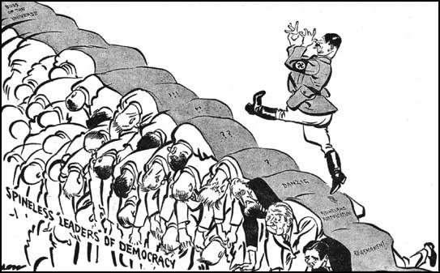

Source 8: “Quaderno” or a “Copybook” for Italian Students with 80 blank pages. Illustrated by Antonio Rigorini (well-known Italian artist), 1936. (From Cornell University – PJ Mode Collection of Persuasive Cartography.)

The quote from Mussolini on the cover is "Italy finally has its own empire . . . I will fertilize it with our labor and will defend against anyone with our arms."”

Source 9: "How Japan Could Attack U.S.: Step by Step Maneuvers by Which Nipponese Might Cross the Pacific and Swoop Out of the Air to Demolish U.S. West Coast Cities." by Howard A Burke, published in the Los Angeles Examiner, November 7, 1937. (From Cornell University – PJ Mode Collection of Persuasive Cartography.)

Source 10: “The Moscow Purge,” December 29, 1937. Published in the British Magazine Punch. Text: Russian Bear: "Must I really take this, after dancing for you so faithfully?" (A trained Russian bear complains at being force fed the Executions medicine by Stalin while holding the Soviet Elections) (Punch Magazine Archives)

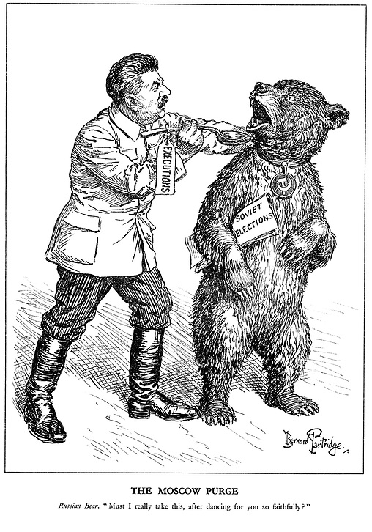

Source 11: “Carriers of the new black plague” in the anti-fascist Ken Magazine, published April 7, 1938. (From Cornell University – PJ Mode Collection of Persuasive Cartography.)

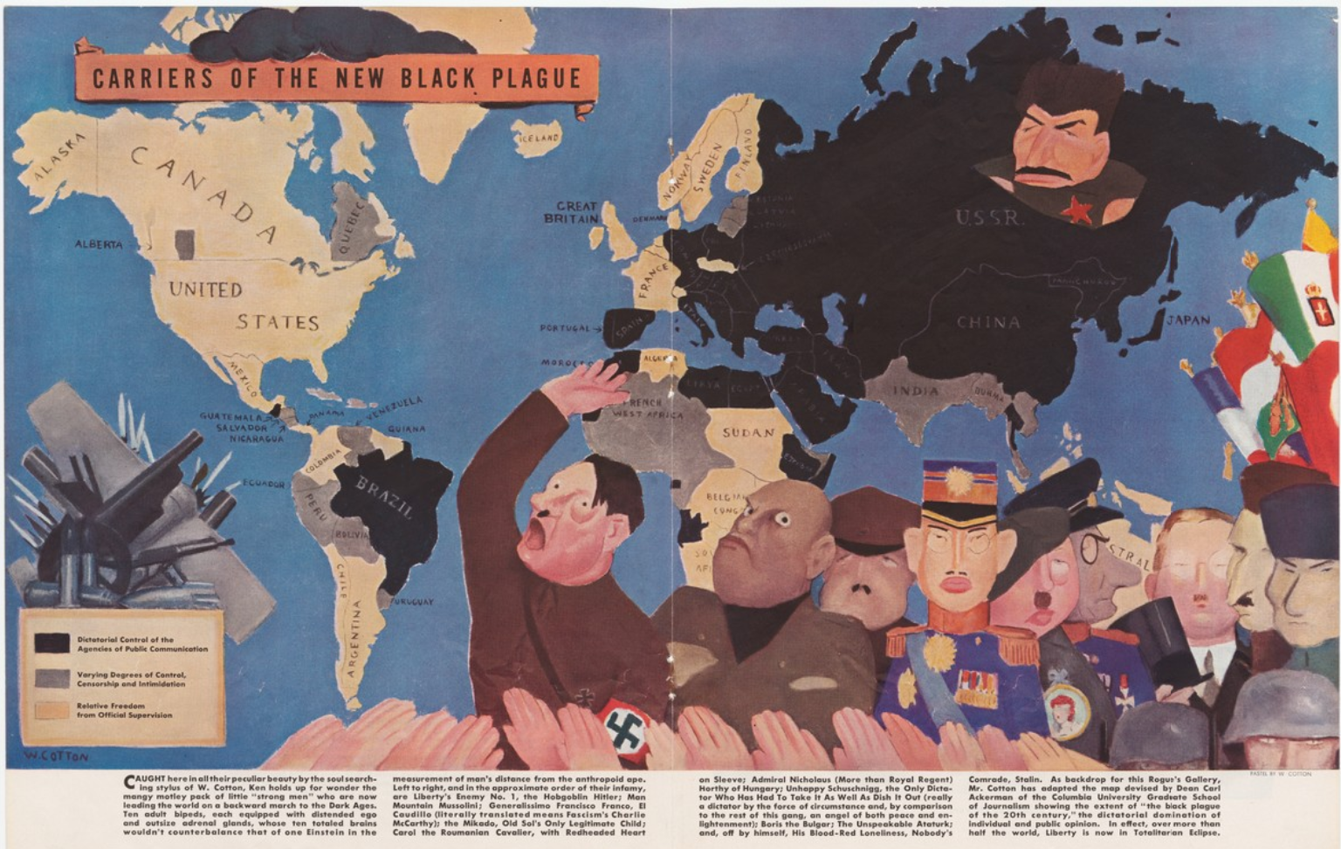

Words at the bottom say:
“Caught here in all their peculiar beauty by the soul-searching styles of W. Cotton (the artist), Ken holds up for wonder the mangy motley pack of little 'strong men' who are now leading the world on a backward march to the Dark Ages. Ten adult bipeds, each equipped with extended ego and outsized adrenal glands whose ten total brains wouldn’t eclipse that of one Einstein in the measurement of man’s distance from the anthropoid ape. Left to right, and in the approximate order of their infamy, are Liberty’s enemy No. 1, the Hobgoblin Hitler; Man Mountain Mussolini; Generalissimo Francisco Franco, El Caudillo (literally translated means Fascism’s Charlie McCarthy); the Mikado, Old Sol’s Only Legitimate Child; Carol the Roumanian Cavalier, with Redheaded Heart on Sleeve; Admiral Nicholaus (More than Royal Regent) Horthy of Hungary; Unhappy Schuschnigg, the Only Dictator Who Has Had To Take It As Well As Dish It Out (really a dictator by the force of circumstances and, by comparison to the rest of this gang, an angel of both peace and enlightenment); Boris the Burglar; The Unspeakable Ataturk; end, off by himself, His Blood-Red Loneliness, Nobody’s Comrade, Stalin. As a backdrop for this Rogue’s Gallery, Mr. Cotton has adapted the map devised by Dean Carl Ackerman of the Columbia University Graduate School of Journalism showing the extent of “the black plague of the 20th century,” the dictatorial domination of individual and public opinion. In effect, over more than half the world, Liberty is now in totalitarian Eclipse."

