Decolonization Podcast

Many Americans are not aware of just how many states were decolonized in the 1950s - 1980s. The Cold War was at the forefront of everyone’s minds, so their international knowledge tends to be more about that. So, we are going to work to change that. You will create a podcast about one nation or region that was decolonized during this period.
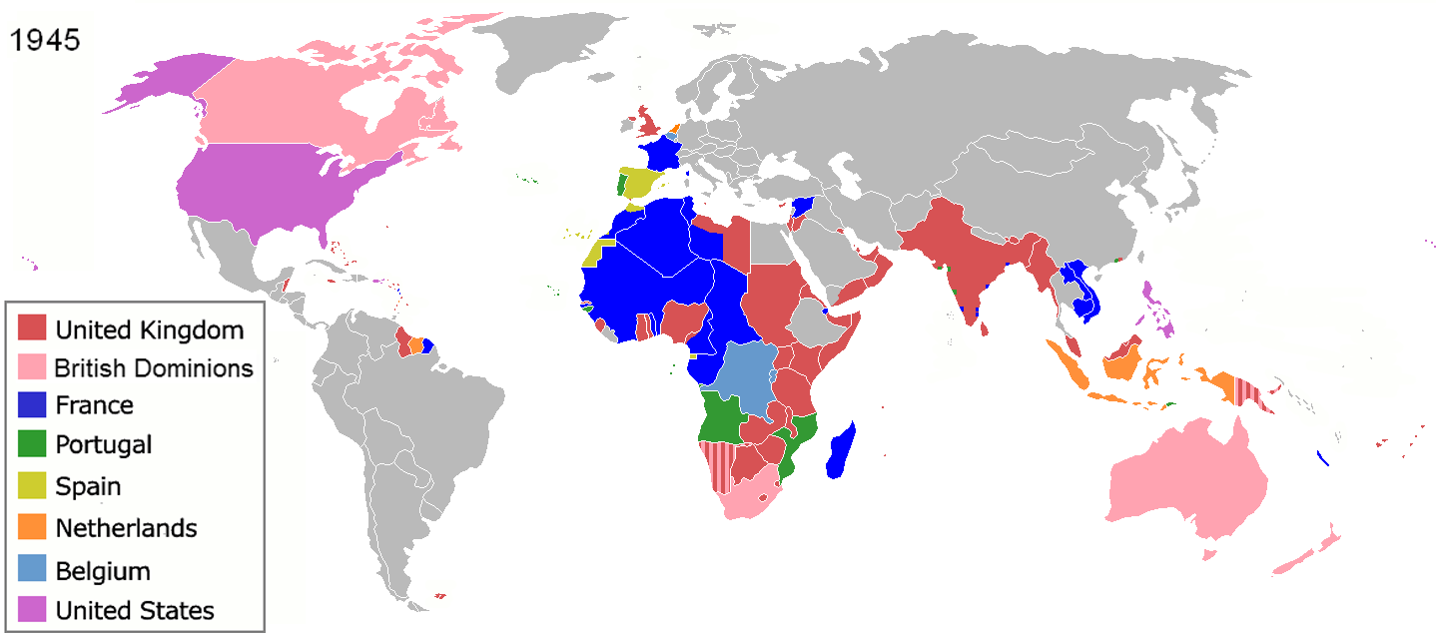
Step 1: What will you be podcasting about?
Although there are many decolonization and independence movements from 1945 - 1980, but you will choose either one smaller region or one country to podcast about. There are so many that we will not double up, so be sure to have a backup option.

Step 2: Must haves in your podcast:
- Introduction (First name only)
- Explain “Decolonization.”
- How the region or state you chose came to be colonized and how long it was under colonial rule.
- Important leaders who shaped the independence movement and why they became leaders.
- How was independence achieved?
  - Was it violent? Non-Violent?
  - How long did it take to gain independence?
  - Were there any groups competing for dominance during the attempt to gain independence?
  - What is its Independence Day?
  - What is its current relationship with its former colonizer?
- Any interesting or important facts that do not fit into one of the questions above.
- Include your sources verbally at the end of your podcast before you “sign off.” Say where the information from this podcast comes from.
- Conclusion (Do not simply end without saying “thank you for listening” etc.)

This example is from an 8 year old’s podcast: Natalie’s Interesting People Podcast. If an 8-year-old can research, write a script, create a podcast, record it with inflection, etc. you can definitely do this too!

Step 3: Research and write the script.
Research the questions above and keep track of your sources. Write a script for your podcast. Do not plagiarize. Also, write it how you would say it. Be conversational in your style, as though you’re speaking, since that will make it easier to read when you record. You will turn this in and get approval before moving into the recording phase!

Step 4: Record the podcast.
When your script has been approved, record the podcast. Use a clear voice. Enunciate, do not mumble. Note your speed - do you speak too fast or too slow? Use inflection in your voice. If you do not, it will sound VERY boring. Check your work and re-record pieces if necessary. Add background music and transitions where it is needed. You can use anchor.fm, Audacity, or GarageBand if you are a Mac user.

Step 5: Play it for the class.
Last, but certainly not least, you will submit it so your classmates can listen to it. The teacher will share everyone’s, so that you can learn about multiple places in the world that were decolonized and the different processes nations went through to achieve their independence.

Podcast Rubric
Criteria | Exemplary (4) | Proficient (3) | Basic (2) | Needs Improvement (1)
Content | The podcast covers all required aspects comprehensively and provides insightful analysis. Information is accurate, well-researched, and effectively communicated. It engages listeners with captivating details and relevant facts. | The podcast covers most required aspects adequately. Information is generally accurate and well-researched, with some areas lacking depth. It effectively communicates key points but may lack some engagement or detail. | The podcast covers some required aspects but lacks depth or clarity in several areas. Information may contain inaccuracies or be insufficiently researched. Key points are present but not effectively communicated. | The podcast fails to cover several required aspects adequately. Information is inaccurate or poorly researched, making it difficult for listeners to understand or engage with the content. Key points are unclear or missing.
Organization | The podcast is well-structured with a clear introduction, body, and conclusion. Transitions between sections are smooth, and the flow of information is logical and coherent. The script is effectively organized, keeping the listener engaged throughout. | The podcast is organized adequately, with a discernible structure. While transitions may be somewhat abrupt, the overall flow of information is understandable. The script is reasonably organized but may lack consistency in pacing or structure. | The podcast lacks clear organization, making it challenging for listeners to follow the sequence of information. Transitions between sections are unclear or absent. The script may lack coherence or logical progression. | The podcast is poorly organized, with little to no structure or coherence. Transitions between sections are nonexistent or confusing. The script lacks organization, making it difficult for listeners to follow or understand the content.
Delivery | The presenter demonstrates exceptional delivery skills, engaging the audience with a clear, confident, and expressive voice. Enunciation is excellent, and pacing is appropriate, keeping listeners attentive throughout the podcast. | The presenter delivers the content effectively, with clear pronunciation and appropriate pacing. While voice inflection may be somewhat limited, the delivery maintains listener interest. | The presenter's delivery is somewhat lacking in clarity or expression, occasionally hindering listener comprehension. Enunciation and pacing may need improvement, impacting overall engagement. | The presenter's delivery is unclear or monotonous, making it difficult for listeners to follow or stay engaged. Poor enunciation and pacing detract from the overall quality of the podcast, resulting in decreased listener interest.
Creativity and Engagement | The podcast demonstrates exceptional creativity, engaging listeners with innovative storytelling techniques, vivid descriptions, and compelling anecdotes. It captivates the audience's attention from start to finish, leaving a lasting impression. | The podcast engages listeners effectively through creative storytelling and engaging content. While it may lack some originality, it still maintains listener interest with interesting anecdotes or perspectives. | The podcast attempts to engage listeners but lacks creativity or originality in its approach. While some aspects may be engaging, overall, it may fail to captivate the audience's attention consistently. | The podcast lacks creativity and fails to engage listeners effectively. It may rely heavily on factual information without incorporating engaging storytelling or unique perspectives. As a result, listener interest may wane throughout the podcast.
Technical Quality | The podcast demonstrates exceptional technical quality, with clear audio, appropriate volume levels, and minimal background noise. Transitions, music, and sound effects enhance the listening experience without overshadowing the content. Recording and editing are seamless. | The podcast maintains good technical quality overall, with clear audio and minimal disruptions. While some minor issues with volume or background noise may be present, they do not significantly detract from the listening experience. Recording and editing are generally proficient. | The podcast has noticeable technical issues, such as inconsistent audio quality or distracting background noise. While the content is still audible, technical shortcomings may detract from the overall enjoyment of the podcast. Recording and editing may require improvement. | The podcast suffers from significant technical shortcomings, such as poor audio quality, excessive background noise, or frequent disruptions. These issues severely impact the listener's ability to engage with the content and may detract from the overall experience. Recording and editing are inadequate.
Overall Impact and Presentation Style | The podcast leaves a memorable impact on listeners, effectively conveying the significance of the chosen topic and inspiring further reflection. The presenter's engaging style and passion for the subject shine through, leaving the audience eager to learn more. | The podcast leaves a positive impression on listeners, effectively conveying the importance of the chosen topic. While presentation style may be somewhat conventional, it still resonates with the audience and encourages thoughtful consideration. | The podcast makes a limited impact on listeners, failing to convey the significance of the topic effectively. Presentation style may be uninspired or lack enthusiasm, resulting in a less engaging listening experience. | The podcast fails to make a meaningful impact on listeners, lacking clarity, enthusiasm, or relevance. Presentation style is monotonous or disengaged, leaving the audience feeling indifferent or disinterested in the content.

