Sources on the Green Revolution

Source: Dr. Norman Borlaug, United States agricultural scientist and wheat specialist, training Mexican scientists in 1950. The training was sponsored by the Mexican Ministry of Agriculture and Livestock that partnered with the Rockefeller Foundation. Photograph courtesy of the International Maize and Wheat Improvement Center.
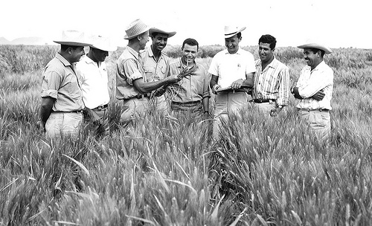

Source: Graph from Our World in Data in the article “Yields vs. Land Use: How the Green Revolution enabled us to feed a growing population” by Hannah Ritchie August 22, 2017

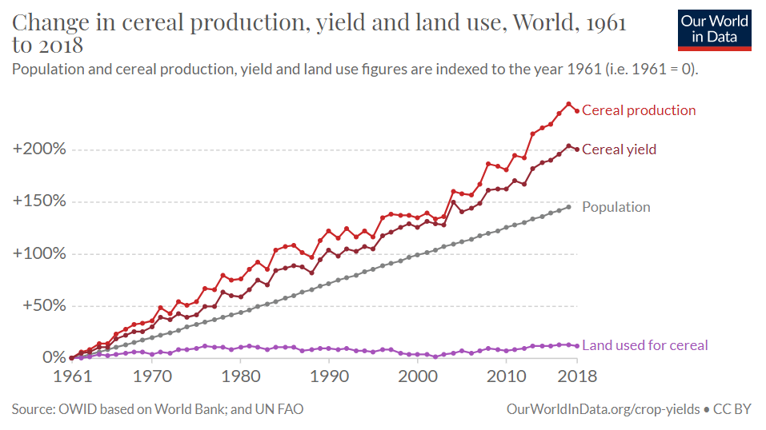

Source: William S. Gaud, Administrator of the Agency for International Development, in his speech “The Green Revolution: Accomplishments and Apprehensions” to the Society for International Development in Washington D.C., March 8, 1968.

… Record yields, harvests of unprecedented size and crops now in the ground demonstrate that throughout much the developing world - and particularly in Asia - we are on the verge of an agricultural revolution.

- In May 1967 Pakistan harvested 600,000 acres to new high-yielding wheat seed. This spring (1968) the farmers of Pakistan will harvest the new wheats from an estimated 3.5 million acres. They will bring in a total wheat crop of 7-1/2 to 8 million tons - a new record. Pakistan has an excellent change of achieving self-sufficiency in food grains in another year.

- In 1967 the new high-yielding wheats were harvested from 700,000 acres in India. This year they will be planted to 6 million acres. Another 10 million acres will be planted to high-yield varieties of rice, sorghum, and millet. India will harvest more than 95 million tons in food grains this year - again a record crop. She hopes to achieve self-sufficient in food grains in another three or four years. She has the capability to do so.

- Turkey has demonstrated that she can raise yields by two and three times with the new wheats. Last year's Turkish wheat crop set a new record. In 1968 Turkey will plant the new seed to one-third of its coastal wheat growing area. Total production this year may be nearly one-third higher than in 1965.

- The Philippines have harvested a record rice crop with only 14% of their rice fields planted to new high-yielding seeds. This year more land will be planted to the new varieties. The Philippines are clearly about to achieve self-sufficiency in rice.

These and other developments in the field of agriculture contain the makings of a new revolution. It is not a violet Red Revolution like that of the Soviets, nor is it a White Revolution like that of the Shah of Iran. I call it the Green Revolution…

Source: Norman Borlaug’s Acceptance Speech, on the occasion of the award of the Nobel Peace Prize in Oslo, December 10, 1970.

Your Majesty, Your Royal Highnesses, Madam Chairman, Members of the Nobel Committee, Your Excellencies, and Ladies and Gentlemen,

The requirement of an acceptance speech on this occasion implies that an incipient Nobel Laureate must have some reasons for rationalizing both his election and his acceptance. To refuse the honor of election would be to question the judgment of those who elected me. And this I would not do, except perhaps in private, especially here in the Land of my Fathers and in the presence of an international group of guests who have congregated to honor a significant occasion rather than a single individual.

Accordingly, I shall not dwell upon the personal honor, for I have not done so even within myself. Instead, I want to devote my remarks to commendation of the Nobel Committee which had the perspicacity and wisdom to recognize the actual and potential contributions of agricultural production to prosperity and peace among the nations and peoples of the world.

Obviously, I am personally honored beyond all dreams by my election. But the obligations imposed by the honor are far greater than the honor itself, both as concerns me personally and also the army of hunger fighters in which I voluntarily enlisted a quarter of a century ago for a lifetime term. I am acutely conscious of the fact that I am but one member of that vast army and so I want to share not only the present honor but also the future obligations with all my companions in arms, for the Green Revolution has not yet been won.

It is true that the tide of the battle against hunger has changed for the better during the past three years. But tides have a way of flowing and then ebbing again. We may be at high tide now, but ebb tide could soon set in if we become complacent and relax our efforts. For we are dealing with two opposing forces, the scientific power of food production and the biologic power of human reproduction. Man has made amazing progress recently in his potential mastery of these two contending powers. Science, invention, and technology have given him materials and methods for increasing his food supplies substantially and sometimes spectacularly, as I hope to prove tomorrow in my first address as a newly decorated and dedicated Nobel Laureate. Man also has acquired the means to reduce the rate of human reproduction effectively and humanely. He is using his powers for increasing the rate and amount of food production. But he is not yet using adequately his potential for decreasing the rate of human reproduction. The result is that the rate of population increase exceeds the rate of increase in food production in some areas.

There can be no permanent progress in the battle against hunger until the agencies that fight for increased food production and those that fight for population control unite in a common effort. Fighting alone, they may win temporary skirmishes, but united they can win a decisive and lasting victory to provide food and other amenities of a progressive civilization for the benefit of all mankind.

Then, indeed, Alfred Nobel’s efforts to promote Brotherhood between nations and their peoples will become a reality.

Let our wills say that it shall be so.

Source: Excerpt from the introduction to the book The Violence of the Green Revolution by Vandana Shiva, published in 1992. Shiva is an opponent and activist against the Green Revolution.

The Green Revolution has been heralded as a political and technological achievement, unprecedented in human history. It was designed as a techno-political strategy for peace, through the creation of abundance by breaking out of nature’s limits and variabilities. Paradoxically, two decades of the Green Revolution have left Punjab ravaged by violence and ecological scarcity. Instead of abundance, Punjab has been left with diseased soils, pest-infested crops, water-logged deserts, and indebted and discontented farmers. Instead of peace, Punjab has inherited conflict and violence...

...after two decades, the invisible ecological, political and cultural costs of the Green Revolution have become visible. At the political level, the Green Revolution has turned out to be a conflict-producing instead of conflict reducing. At the material level, production of high yields of commercial grain have generated new scarcities at the eco-system level, which in turn have generated new sources of conflict.

...Like Gandhi challenged the processes of colonisation linked with the first industrial revolution with the spinning wheel, peasants and Third World groups are challenging recolonisation associated with the biotechnology revolution with their indigenous seeds.

Source: “The Toxic Consequences of the Green Revolution” by Daniel Pepper, July 7, 2008 in US News and World Report.

...The Green Revolution hardly seems to have made much of an impact in terms of well-being here. Rural poverty abounds, malarial mosquitoes breed in stagnant pools of water, and bullock carts far outnumber motor vehicles.

And behind the walls villagers speak of cancer, which they say is on the rise along with other ailments such as renal failure, stillborn babies, and birth defects that researchers attribute to the overuse and misuse of pesticides and herbicides. Punjab represents only 1.5 percent of India's geography but accounts for nearly a 20 percent share of its pesticide consumption.

In many cases, rural farmers don't know proper usage and disposal techniques, with few using protective clothing or equipment when handling highly toxic chemicals. In farming villages, pesticide containers are sometimes reused as kitchen containers. And many farmers assume that applying more pesticides and herbicides is better, without understanding that the heavy use is gradually poisoning water supplies...

Source: “Caught up in the War on Communism” - Interview with Raj Patel, published in “The American Experience” April 3, 2020. Patel was a voice expert in 2020 American Experience film “The Man Who Tried to Feed the World” - a movie made about Norman Borlaug.

American Experience: What was happening during the post-World War II era in the global south that agronomists like Bourlag and others needed to come up with these new solutions?

Raj Patel: Well there was a border geopolitical thrust of which Borlaug was part, and that was the war on communism. What was happening elsewhere in the world, of course, were things like the Chinese revolution. Borlaug and other plant biologists were caught up in the war against communism, and their techniques and skills were deployed in service not of small farmers and the peasants, but of the large industrial farmers in Mexico and elsewhere.

American Experience: You mentioned the Rockefeller Foundation earlier, was its role in all of this?

Raj Patel: The Rockefellers were not kindly disposed towards the Mexican government because in the 1930s, the Mexican government had nationalized the assets of Standard Oil. Now when Standard Oil had what it saw as “its stuff” taken away by an unruly Mexican government, what they saw next on the horizon was communism. The Standard Oil Company was founded by John Rockefeller, and the Rockefeller Foundation saw very clearly its mission as one of bringing about a certain kind of model of prosperity in which communism played no part. And so the Rockefeller Foundation supported Norman Borlaug and his employment in Mexico as a part of a broader program in which they were hand in glove with the US government ,and which agriculture would be part of a comprehensive pushback against insurgent leftist tendencies in strategic countries around the world.

