Negritude - Literature and Paintings

“Notebook of a Return to my Native Land” by Aimé Césaire (1939)
Aimé Césaire (1913-2008) was a poet, politician, and co-founder of the negritude movement. He was from the Island of Martinique, and was considered brilliant. He eventually studied in France, where he met Léopold Sédar Senghor and they founded a journal called “The Black Student” in 1934. Césaire wrote many poems and essays against colonialism, and was eventually elected the mayor of the capital of Martinique. His famous poem “Cahier d’un retour au pays natal (or Notebook of a Return to my Native Land)” was the first time “negritude” as a term was used. (Article on Black Past and CATranslation. Translation by Clayton Eshleman and Annette Smith)

My negritude is not a stone, its deafness hurled against
the clamor of the day
my negritude is not a leukoma of dead liquid over the earth’s
dead eye
my negritude is neither tower nor cathedral
it takes root in the red flesh of the soil
it takes root in the ardent flesh of the sky
it breaks through opaque prostration with its upright patience

“Assassinations” by Léopold Sédar Senghor (Published 1948)
Léopold Sédar Senghor (1906-2001) was a poet, politician, and co-founder of the Negritude Movement. He was orn in Senegal and was also considered brilliant. He went to study in France where he met Aimé Césaire, founded a journal and the Negritude movement together. He fought in WWII and was taken prisoner for two years. He eventually became the president of Senegal when it was decolonized in 1960. (Article on BlackPast.org and Council for European Studies)

They lie there stretched out by the captive roads, along the
………..roads of disaster
The lean poplars, the statues of the dark gods
………..draped in their long gold coats
Senegalese prisoners miserably lying
………..on the French land.
In vain they cut your laughter, in vain the blacker the flower, the
………..blacker your flesh.
You are the flower of beauty among the first absence
………..nude flowers
Black flower blossom and its somber smile, diamond of a time
………..immemorial.
You are the mud and plasma of the world’s leafy
………..spring
From the primitive couple, you are the flesh of the womb, the
………..belly fertilizing milt
You are the sacred profusion of bright, blissful gardens
And the sovereign forest, victorious of fire and lightning
The vast song of your blood will defeat machines and canons
Your speech throbbing deceptions and lies
No hate in your soul, you are not hateful, no cunning
………..soul without cunning.
O Black Martyrs, immortal race, let me say the
………..words that forgive.
“Africa” by David Diop (1950s)
David Diop [1927-1960 ] was born in Bordeaux, France. He had a Cameroonian mother and a Senegalese father. Diop is often considered one of the most promising French West African poets. His short life's work often involved his longing for Africa and his empathy for those fighting against the French colonization of the mainland. His work shows a hatred for the oppressors and the aforementioned empathy for the oppressed.
He died in a plane crash, and only had one anthology of poems published in 1956. This is perhaps his most famous poem.
https://allpoetry.com/poem/8562839-Africa-by-David-Diop

Africa my Africa
Africa of proud warriors in ancestral savannahs
Africa of whom my grandmother sings
On the banks of the distant river
I have never known you
But your blood flows in my veins
Your beautiful black blood that irrigates the fields
The blood of your sweat
The sweat of your work
The work of your slavery
Africa, tell me Africa
Is this your back that is unbent
This back that never breaks under the weight of humiliation
This back trembling with red scars
And saying no to the whip under the midday sun
But a grave voice answers me
Impetuous child that tree, young and strong
That tree over there
Splendidly alone amidst white and faded flowers
That is your Africa springing up anew
springing up patiently, obstinately
Whose fruit bit by bit acquires
The bitter taste of liberty.

The Unsung Mothers of Négritude: An Examination of the Efforts of Women Behind the Movement
By Emily C. Sheffield, University of North Carolina at Chapel Hill Alumna (2017)
In Global Africana Review Vol. 2, Spring 2018

Article PDF: https://pdfs.semanticscholar.org/3392/5966bf80f7f42c4242d080d84ed1e7b2ed2b.pdf

Read the article above about the women involved in the negritude movement. They were authors in their own right, and contributed in other ways as well, but english translations of their work are not easy to find.

Quote from Paulette Nadal November 17, 1963 in a letter to Léopold Sédar Senghor’s biographer: “They [Senghor, Césaire, Damas] took the ideas tossed out by us and expressed them with more flash and brio. We might have just been women, but we were the real pioneers. We blazed the trail for them.”
Painting - “The Jungle” by Wilfredo Lam (1943)
Wilfredo Lam (1902-1982) was a Cuban painter, sculptor, print-maker, etc. His work is about the Afro-Cuban spirit and experience. He has a very distinctive and unique style, which was influenced by Surrealism but also influenced many other artists. The Jungle is considered to be his masterpiece. It is about the Afro-Cuban culture and experience.
“I wanted with all my heart to paint the drama of my country, but by thoroughly expressing the black spirit, the beauty of the plastic art of the blacks,” he once said. “I knew I was running the risk of not being understood. … But a true picture has the power to set the imagination to work even if it takes time.”
From the Museum of Modern Art (MoMA)

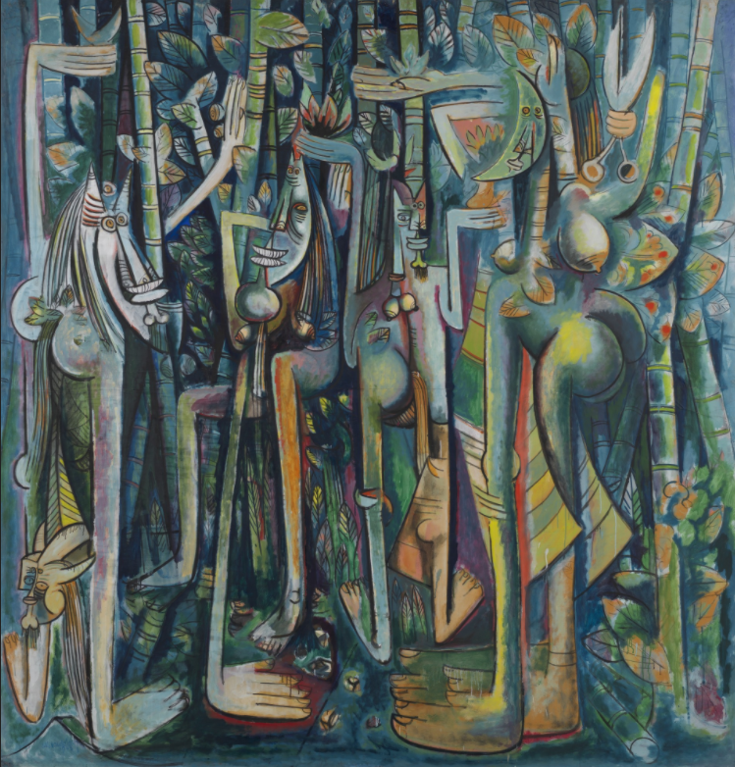

Painting “Negritude” (1957) and Sculpture “Anyanwu (Sun)" (1966) by Ben Enwonwu
Ben Enwonwu (1917 - 1994) might be the most influential African artist of the 20th century. He was one of the earliest African artists to be exhibited in Europe and the US, and he helped to increase the popularity of African art around the world. He gained an international reputation, and used his fame to support Black Nationalism and other Black artists.
Negritude at Art Anyanwu - United Nations

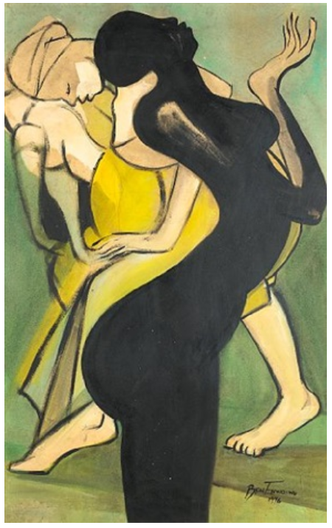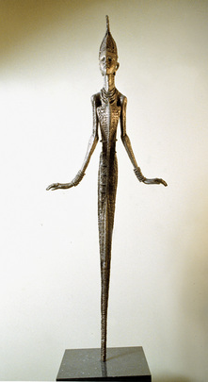

Quotes by Ben Enwonwu:
- “Negritude was an expression of Blackness, a celebration of the Black image. It was a great source of artistic wealth that Senghor, who had so much in him of poetry, personified. We, the artists, more or less drank from the fruits of his knowledge. I went to my home at Onitsha and began to use some of the traditional dances — particularly the dance movements and the colors — as a basis for representation.”
- "I will not accept an inferior position in the art world. Nor have my art called African because I have not correctly and properly given expression to my reality. I have consistently fought against that kind of philosophy because it is bogus.”
- “European artists like Picasso, Braque and Vlaminck were influenced by African art. Everybody sees that and is not opposed to it. But when they see African artists who are influenced by their European training and technique, they expect that African to stick to their traditional forms even if he bends down to copying them. I do not copy traditional art. I like what I see in the works of people like Giacometti but I do not copy them. I knew Giacometti personally in England, you know. I knew he was influenced by African sculptures. But I would not be influenced by Giacometti, because he was influenced by my ancestors."

