Name: _______________________________________________________ Date: __________ Period: _________
Topics 2.1, 2.3, & 2.4 Networks of Communication & Exchange Graphic Organizer (c.1200-1450)
 | Topic 2.1 Silk Roads  AMSCO pgs. 82-83, 98, 99, 105, 135, 151, 186, 190, 220, 229, 241, 243, 336  Ways of the World Ch. 3 pgs. 107-114 | Topic 2.3 Indian Ocean Trade  AMSCO pgs. 98, 106, 165-166, 171-172, 203, 204-205, 288-291  Ways of the World Ch. 3 pgs. 114-120, 122-124 | Topic 2.4 Trans-Saharan Trade Routes  AMSCO pgs. 165-166  Ways of the World Ch. 3 pgs. 124-129
Causes: What political, economic, and cultural factors caused the growth of this network of exchange? Consider: What empires/states supported this trade network?
Causes: What innovations/technology facilitated exchange along this network?
Effects: What crops, and/or disease pathogens were traded or diffused along this exchange network? (Topic 2.6)

Effects: What types of goods were transferred along this exchange network? Give specific examples.
Effects: What literary, artistic, cultural, and scientific traditions were diffused across this network? (Topic 2.5)
Effects: What religious/cultural beliefs were spread along this exchange network? (Topic 2.5)

Effects: How did the belief systems/religions you listed above CHANGE as they spread to new locations? (Topic 2.5)
Effects: What states developed/grew as a result of this trade route?

Take a Stand: Which trade network had the largest impact on the development of Afro-Eurasia? Pick one and defend it with five pieces of specific evidence from your reading and classwork. | Draw the three trade routes on the map below. Use different colors to indicate the three different routes:  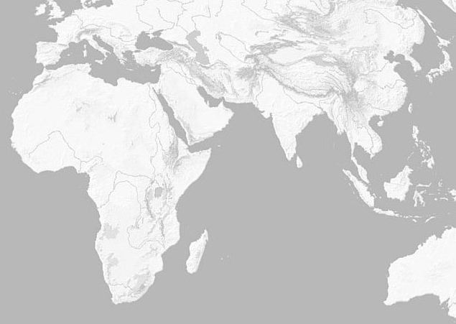
____________________________________________________________________________________________________________________________________________________________________________________________________________________________________________________________________________________________________________________________________________________________________________________________________________________________________________________________________________________________________________________________________________________________________________________________________________________________________________________________________________________________________________________________________________________________

Learning Objective: Explain the causes and effects of growth of networks of exchange after 1200.
Using your notes, write some generalized statements about the causes and effects of the rise of exchange networks.
General causes of the rise of trade networks | General effects of trade networks

