Ancient Trade Networks: A Connected World

The ancient world was much more connected than people think! Trade linked the new civilizations that had formed due to surpluses in agriculture, from Egypt to Mesopotamia to the Indus River Valley Civilizations. We will engage in a discussion focused on what CAUSED those relationships to form, and how these relationships are an EFFECT of the increase in civilization.

For this activity, we will use the “TQE” Model used sometimes by English/Language Arts teachers. TQE refers to Thoughts, Questions, and Epiphanies that you have as you read and view the sources.
- What observations did you make as you saw some of the images, or as you read the text of the sources? Were there some unique pieces of information you noticed as you read?
- What do you wonder as you look at these images and read the text? Were there knowledge gaps that you need filled?
- Did you have any “aha” moments as you read these images? Did you notice something that corroborated (supported) what you read or have already talked about in class?

Here are the expectations and what we will do:

- You will analyze the sources as homework. Read through them, look at them, annotate them if needed. Think about what the CAUSES and EFFECTS of ancient trade networks are. How and why did these networks develop, and how are they related to the increase in civilization across the world?
- Small Group
  - In class, you will be placed in a small group of 3-4 people for about 15 minutes
  - Once in that group, you’ll get out the sources, and each of you will silently write down at least three Thoughts, Questions, or Epiphanies you had while looking at the documents and sources.
  - Next, you’ll share what you wrote with your small group. You’ll choose your best two or three TQEs as a group, and write them up on the board.
- Large Group
  - Now we will come back as a large group. Here, we will discuss the TQE’s on the board in whatever order you wish to go in as a class.
  - At the end of class, you’ll answer these questions before leaving:
    - Identify ONE cause of the increase in trade networks between ancient civilizations.
    - Identify ONE effect of the increase in trade networks between ancient civilizations.

Sources to use in our discussions:

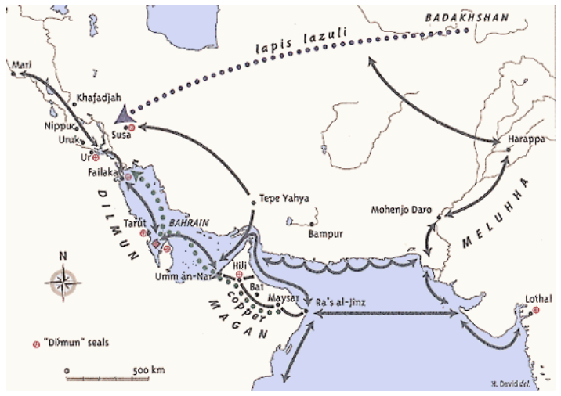
Source 1:
A map showing Bahrain/Dilmun at the crossroads of the trading routes of the early Bronze Age.

From an exhibition in July of 2000 at the Brunei Gallery at the School of Oriental and African Studies (SOAS) University of London called "Traces of Paradise - The Archaeology of Bahrain 2500 BC - 300 AD."

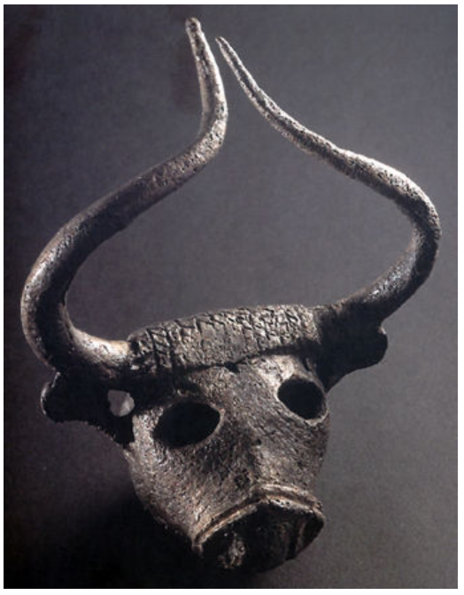
Source 2:
A Bull’s Head made of copper. This is from under Barbar temple in Dilmun ca. 2000 - 1800 BCE. It is generally seen as a decoration on a small harp, based on items that came from the Royal Graves of Ur (in Mesopotamia). It is difficult to determine whether it was produced by a bronze-caster in Dilmun or if it came through the trade networks with Mesopotamia.

From an exhibition in July of 2000 at the Brunei Gallery at the School of Oriental and African Studies (SOAS) University of London called "Traces of Paradise - The Archaeology of Bahrain 2500 BC - 300 AD."

Source 3:
A fresco of the town of Akrotiri on the island of Santorini in Greece, from around 1600 BCE. It’s during the age of the Minoan Civilization, that dominated the island of Crete and surrounding areas during that time. Source from the University of Texas, Classical.

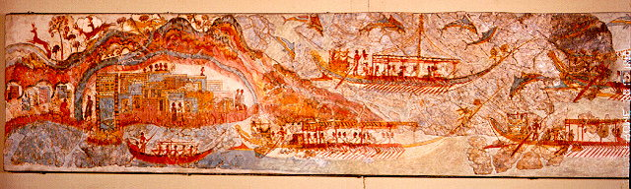

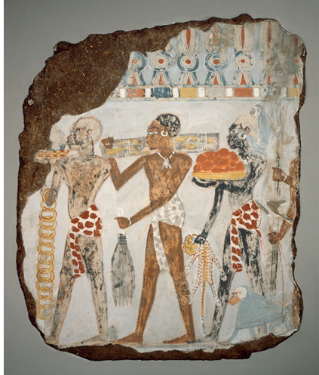
Source 4:
“Tribute from Nubia” - Painting from the tomb of Sebekhotep, a treasury official who worked for Egypt’s Pharaoh Thutmose IV. (14th Century BCE)

“One of Sebekhotep’s duties was to receive gifts sent to the king from overseas, and this painting was part of a larger scene depicting foreign trade missions bringing tribute. It shows three men from Nubia (present-day Sudan) carrying luxury items: gold rings, logs of ebony, giraffe tails, red jasper and a leopard skins as well as a live monkey and baboon.

In the ancient world, leaders of nations communicated by sending envoys to each other’s courts. As seen here, etiquette required exchanges of gifts as a sign of good faith and mutual respect. Letters were sent via messengers carrying ‘passports’ that gave them diplomatic protection. Since there was often no common language, discussions and correspondence usually required interpreters and translators.”

From The British Museum’s “Teaching History with 100 Objects”

Source 5:
One of “The Armarna Letters” - or letters sent between the Pharaoh of Egypt and other Mediterranean and Mesopotamian royalty during the 14th Century. Archaeologists found 382 tablets, all written in Cuneiform, since it was the language of trade in the Middle East at the time. This letter is from King Suppiluliuma, the King of Hatti (which is modern day Anatolia/Turkey), and is known as “EA41.” From Ancient Egypt Online.

“From Suppiluliuma, king of Hatti to Akhenaten (the Pharaoh of Egypt)

The messages I sent to your father (Amenhotep III) and the wishes he expressed to me will certainly be renewed between us. O King, I did not reject anything your father asked for, and your father never neglected none of the wishes I expressed, but granted me everything. Why have you, my brother, refused to send me what your father during his lifetime has sent me?

Now, my brother, you have acceded to the throne of your father, and similarly as your father and I have sent each other gifts of friendship, I wish good friendship to exist between you and me. I have expressed a wish to your father. We certainly shall make it come true between us. Do no refuse, my brother, what I wished to receive from your father. It concerns two statues of gold, one standing, the other sitting, two silver statues of women, a chunk of lapis lazuli and some other things. They are not gifts in the true sense of the word, but rather, as in the majority of similar cases, objects of a commercial transaction. If my brother should decide to deliver these, may my brother deliver them. If my brother should not decide to deliver them, as soon as my chariots are ready to carry the cloth, I shall send it to my brother. What you, my brother may want, write to me and I shall send it to my brother?”

Source 6: Phoenician Trade Routes. Map from Encyclopedia Britannica.

