SHORT ANSWER (SAQ) for AP History Exams
Get used to these, you’ll see them on:
AP World History: Modern
AP United States History
AP European History
What is an SAQ? What does it look like? What do I “do?”
- It is NOT an essay. However, you do need to answer in COMPLETE SENTENCES, and DIRECTLY.
- Typical answers are 3-5 Sentences for each part.
- There will be three separate “questions,” with three separate boxes for each question.
- See the sample sheet for what they look like. You CANNOT write outside of the box!
- The questions are divided into three tasks, labeled A, B, and C.
- Each of the sub-questions will be graded separately, so you should label these A-B-C on your paper and have 3-5 sentences for each part.
- Each question assesses a different skill set.
- Question 1 = Analyzing and interpreting a secondary source
- They may ask for evidence that supports an argument, or evidence that undermines (contradicts, refutes) it, prepare for both.
- Question 2 = Analyzing and interpreting a primary source, written text, or to visual sources such as images, charts, or maps.
- You might use information from the stimuli, or you might be bringing in outside information.
- This will be over the skill of comparison or continuity and change over time.
- Question 3 = you will have a choice, and it will ask you to respond to a question about world history without a stimulus. It’ll focus on the historical thinking skills of causation or continuity and change over time.
- Answer the question it’s ASKING, not the question you WISH it was asking.
What might a response look like? Make an easy, three-four sentence response with the acronym CE-E:
- Claim – Write your answer to the question, or your claim. If it includes a source, MENTION THAT SOURCE in your answer!
- Evidence – Support your answer with FACTS and NOUNS – specific evidence! (Who, What,
When, Where, Why, How? – You don’t need all of these, but make sure you have a few)
- Explain – Describe WHY your evidence answers the question.

PRACTICE SAQs
Use the sample “SAQ” Response sheet to answer the following SAQs Question 1: Answer all parts of the question that follows:
“To science we owe dramatic changes in our smug self-image. Astronomy taught us that our earth isn’t the center of the universe but merely one of billions of heavenly bodies... Now archaeology is demolishing another sacred belief: that human history over the past million years has been a long tale of progress. In particular, recent discoveries suggest that the adoption of agriculture, supposedly our most decisive step toward a better life, was in many ways a catastrophe from which we have never recovered...”
- Jared Diamond, “The Worst Mistake in the History of the Human Race,” Discover
Magazine, May 1987.

- Identify ONE specific historical example that corroborates the claim made by Jared Diamond.
- Explain ONE specific historical example that refutes the claim made by Jared Diamond.
- Explain ONE specific result of the adoption of agriculture by humankind.

Question 2: Answer all parts of the question that follows:

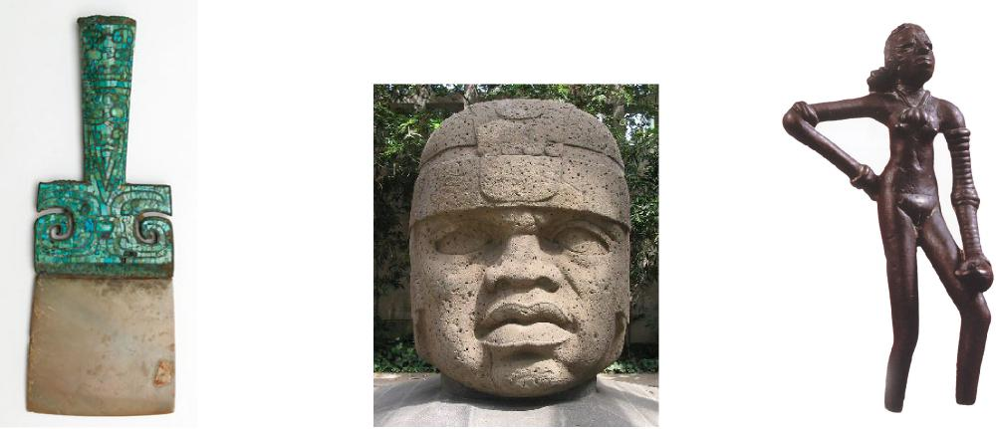

Ceremonial Bronze Chisel with Head, Olmec Dancing Girl, Harappa
Jade Inlay, Shang
- Identify ONE similarity between the civilizations that created the art depicted above.
- Explain ANOTHER similarity between the civilizations that created the art depicted above.
- Explain ONE difference between the civilizations that created the art depicted above.

