Unit 2: Networks of Exchange
C. 1200 - c. 1450
AP Exam Weighting: 8-10%

Topic 2.1 Silk Roads
Thematic Focus - Economic Systems (ECN)
As societies develop, they affect and are affected by the ways that they produce, exchange, and consume goods and services.
Learning Objective A  Explain the causes and effects of growth of networks of exchange after 1200. | Historical Developments  Improved commercial practices led to an increased volume of trade and expanded the geographical range of existing trade routes— including the Silk Roads—promoting the growth of powerful new trading cities  Trading cities:  - Kashgar  - Samarkand  The growth of interregional trade in luxury goods was encouraged by innovations in previously existing transportation and commercial technologies, including the caravanserai, forms of credit, and the development of money economies.  New forms of credit and money economies:  - Bills of exchange  - Banking houses  - Use of paper money  Demand for luxury goods increased in Afro-Eurasia. Chinese, Persian, and Indian artisans and merchants expanded their production of textiles and porcelains for export; manufacture of iron and steel expanded in China.

Topic 2.2 The Mongol Empire and the Making of the Modern World
Thematic Focus - Governance (GOV)
A variety of internal and external factors contribute to state formation, expansion, and decline. Governments maintain order through a variety of administrative institutions, policies, and procedures, and governments obtain, retain, and exercise power in different ways and for different purposes.
Learning Objective B  Explain the process of state building and decline in Eurasia over time. | Historical Developments  Empires collapsed in different regions of the world and in some areas were replaced by new imperial states, including the Mongol khanates.
Thematic Focus - Economic Systems (ECN)
As societies develop, they affect and are affected by the ways that they produce, exchange, and consume goods and services.
Learning Objective C  Explain how the expansion of empires influenced trade and communication over time. | Historical Developments  The expansion of empires—including the Mongols—facilitated Afro-Eurasian trade and communication as new people were drawn into their conquerors’ economies and trade networks.
Thematic Focus - Cultural Developments & Interactions (CDI)
The development of ideas, beliefs, and religions illustrates how groups in society view themselves, and the interactions of societies and their beliefs often have political, social, and cultural implications
Learning Objective D  Explain the significance of the Mongol Empire in larger patterns of continuity and change. | Historical Developments  Interregional contacts and conflicts between states and empires, including the Mongols, encouraged significant technological and cultural transfers  Technological and cultural transfers:  - Transfer of Greco– Islamic medical knowledge to western Europe  - Transfer of numbering systems to Europe  - Adoption of Uyghur script

Topic 2.3 Exchange in the Indian Ocean
Thematic Focus - Economic Systems (ECN)
As societies develop, they affect and are affected by the ways that they produce, exchange, and consume goods and services.
Learning Objective E  Explain the causes of the growth of networks of exchange after 1200. | Historical Developments  Improved transportation technologies and commercial practices led to an increased volume of trade and expanded the geographical range of existing trade routes, including the Indian Ocean, promoting the growth of powerful new trading cities.  The growth of interregional trade in luxury goods was encouraged by significant innovations in previously existing transportation and commercial technologies, including the use of the compass, the astrolabe, and larger ship designs (junk and dhow ships).  The Indian Ocean trading network fostered the growth of states such as:  - City-states of the Swahili-Coast  - Gujarat  - Sultanate of Malacca
Thematic Focus - Cultural Developments & Interactions (CDI)
The development of ideas, beliefs, and religions illustrates how groups in society view themselves, and the interactions of societies and their beliefs often have political, social, and cultural implications
Learning Objective F  Explain the effects of the growth of networks of exchange after 1200. | Historical Developments  In key places along important trade routes, merchants set up diasporic communities where they introduced their own cultural traditions into the indigenous cultures and, in turn, indigenous cultures influenced merchant cultures.  Interregional contacts and conflicts between states and empires encouraged significant technological and cultural transfers, including during Chinese maritime activity led by Ming Admiral Zheng He.  Diasporic communities:  - Arab and Persian communities in East Africa  - Chinese merchant communities in Southeast Asia  - Malay communities in the Indian Ocean basin
Thematic Focus - Humans and the Environment (ENV)
The environment shapes human societies, and as populations grow and change, these populations in turn shape their environments.
Learning Objective G  Explain the role of environmental factors in the development of networks of exchange in the period from c. 1200 to c. 1450. | Historical Developments  The expansion and intensification of long distance trade routes often depended on environmental knowledge, including advanced knowledge of the monsoon winds.

Topic 2.4 Trans-Saharan Trade Routes
Thematic Focus - Technology and Innovation (TEC)
Human adaptation and innovation have resulted in increased efficiency, comfort, and security, and technological advances have shaped human development and interactions with both intended and unintended consequences.
Learning Objective H  Explain the causes and effects of the growth of trans-Saharan trade. | Historical Developments  The growth of interregional trade was encouraged by innovations in existing transportation technologies.  Improved transportation technologies and commercial practices led to an increased volume of trade and expanded the geographical range of existing trade routes, including the trans-Saharan trade network.  Technologies encouraging interregional trade:  - Camel saddle  - Caravans
Governance (GOV)
A variety of internal and external factors contribute to state formation, expansion, and decline. Governments maintain order through a variety of administrative institutions, policies, and procedures, and governments obtain, retain, and exercise power in different ways and for different purposes.

Learning Objective I  Explain how the expansion of empires influenced trade and communication over time. | Historical Developments  The expansion of empires—including Mali in West Africa–facilitated Afro-Eurasian trade and communication as new people were drawn into the economies and trade networks.

TOPIC 2.5 Cultural Consequences of Connectivity
Thematic Focus - Cultural Developments and Interactions (CDI)
The development of ideas, beliefs, and religions illustrates how groups in society view themselves, and the interactions of societies and their beliefs often have political, social, and cultural implications.
Learning Objective J  Explain the intellectual and cultural effects of the various networks of exchange in Afro-Eurasia from c. 1200 to c. 1450. | Historical Developments  Increased cross-cultural interactions resulted in the diffusion of literary, artistic, and cultural traditions, as well as scientific and technological innovations  Diffusion of cultural traditions:  - The influence of Buddhism in East Asia  - The spread of Hinduism and Buddhism into Southeast Asia  - The spread of Islam in sub-Saharan Africa and Asia  Diffusion of scientific or technological innovations:  - Gunpowder from China  - Paper from China  The fate of cities varied greatly, with periods of significant decline and periods of increased urbanization, buoyed by rising productivity and expanding trade networks.  As exchange networks intensified, an increasing number of travelers within AfroEurasia wrote about their travels.  Travelers:  - Ibn Battuta  - Margery Kempe  - Marco Polo

TOPIC 2.6 Environmental Consequences of Connectivity
Thematic Focus - Humans and the Environment (ENV)
The environment shapes human societies, and as populations grow and change, these populations in turn shape their environments.
Learning Objective K  Explain the environmental effects of the various networks of exchange in Afro-Eurasia from c. 1200 to c. 1450. | Historical Developments  There was continued diffusion of crops and pathogens, with epidemic diseases, including the bubonic plague, along trade routes.  Diffusion of crops:  - Bananas in Africa  - New rice varieties in East Asia  - Spread of citrus in the Mediterranean

TOPIC 2.7 Comparison of Economic Exchange
The final topic in this unit focuses on the skill of argumentation and so provides an opportunity for your students to draw upon the key concepts and historical developments they have studied in this unit. Using evidence relevant to this unit’s key concepts, students should practice the suggested skill for this topic.
Learning Objective L  Explain the similarities and differences among the various networks of exchange in the period from c. 1200 to c. 1450. | Historical Developments  A deepening and widening of networks of human interaction within and across regions contributed to cultural, technological, and biological diffusion within and between various societies.  - Improved commercial practices led to an increased volume of trade and expanded the geographical range of existing trade routes—including the Silk Roads—promoting the growth of powerful new trading cities.  - The growth of interregional trade in luxury goods was encouraged by innovations in previously existing transportation and commercial technologies, including the caravanserai, forms of credit, and the development of money economies.  Changes in trade networks resulted from and stimulated increasing productive capacity, with important implications for social and gender structures and environmental processes  - Demand for luxury goods increased in Afro-Eurasia. Chinese, Persian, and Indian artisans and merchants expanded their production of textiles and porcelains for export; manufacture of iron and steel expanded in China.

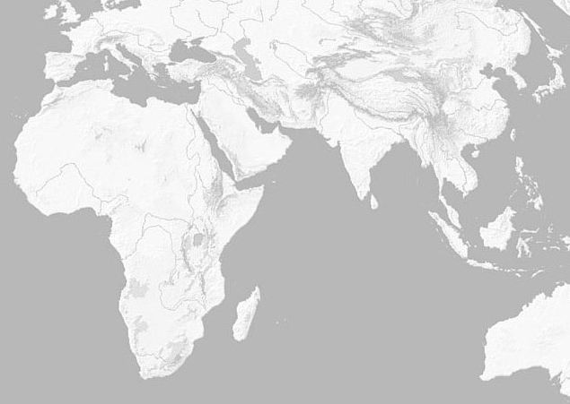
Use the map of Afro-Eurasia below to annotate information from this guide.

