Unit 3: Land-Based Empires
C. 1450 - 1750

Topic 3.1 Empires Expand
Learning Objective  Explain how and why various land-based empires developed and expanded from 1450 to 1750. | Historical Developments  Imperial expansion relied on the increased use of gunpowder, cannons, and armed trade to establish large empires in both hemispheres.  Land empires included the Manchu in Central and East Asia; the Mughal in South and Central Asia; the Ottoman in Southern Europe, the Middle East, and North Africa; and the Safavids in the Middle East.  Political and religious disputes led to rivalries and conflict between states.  State rivalries:  - Safavid–Mughal conflict  - Songhai Empire’s conflict with Morocco | - Explain how the land-based empires of the 1450-1750 time period developed (what allowed them to obtain and maintain power):  - Describe the Qing Dynasty (use SPICE-T characteristics):  - Describe the Mughal Empire (use SPICE-T characteristics):  - Describe the Ottoman Empire (use SPICE-T characteristics):  - Describe the Safavid Empire (use SPICE-T characteristics)

Topic 3.2 Empires: Administration
Learning Objective  Explain how rulers used a variety of methods to legitimize and consolidate their power in land-based empires from 1450 to 1750. | Historical Developments  Recruitment and use of bureaucratic elites, as well as the development of military professionals, became more common among rulers who wanted to maintain centralized control over their populations and resources  Bureaucratic elites or military professionals:  - Ottoman devshirme  - Salaried samurai  Rulers continued to use religious ideas, art, and monumental architecture to legitimize their rule.  Religious ideas:  - Mexica practice of human sacrifice  - European notions of divine right  - Songhai promotion of Islam  Art and monumental architecture:  - Qing imperial portraits  - Incan sun temple of Cuzco  - Mughal mausolea and mosques  - European palaces, such as Versailles  Rulers used tribute collection, tax farming, and innovative tax-collection systems to generate revenue in order to forward state power and expansion.  Tax-collection systems:  - Mughal zamindar tax collection  - Ottoman tax farming  - Mexica tribute lists  - Ming practice of collecting taxes in hard currency | - Describe how land-based empires utilized military professionals to maintain power:  - Explain how land-based empires utilized religious art and ideas to maintain power:  - Explain how land-based empires utilized monumental architecture to maintain power:  - How did land-based empires generate revenue to expand and maintain power?

Topic 3.3 Empires: Belief Systems
Learning Objective  Explain continuity and change within the various belief systems during the period from 1450 to 1750. | Historical Developments  The Protestant Reformation marked a break with existing Christian traditions and both the Protestant and Catholic reformations contributed to the growth of Christianity.  Political rivalries between the Ottoman and Safavid empires intensified the split within Islam between Sunni and Shi’a.  Sikhism developed in South Asia in a context of interactions between Hinduism and Islam. | - Explain the Protestant Reformation:  - What changes (political, social, cultural) occurred as a result of the Protestant Reformation?  - How could you connect the events of the Protestant Reformation to later events such as the Renaissance, Scientific Revolution, and Enlightenment?  - Explain the Sunni and Shi’a split.  - Why did this split intensify during the 1450-1750 time period?  - Explain how Sikhism developed in relation to the Mughal Empire.

Land-Based Empires of 1450-1750
Image via Freemanpedia.

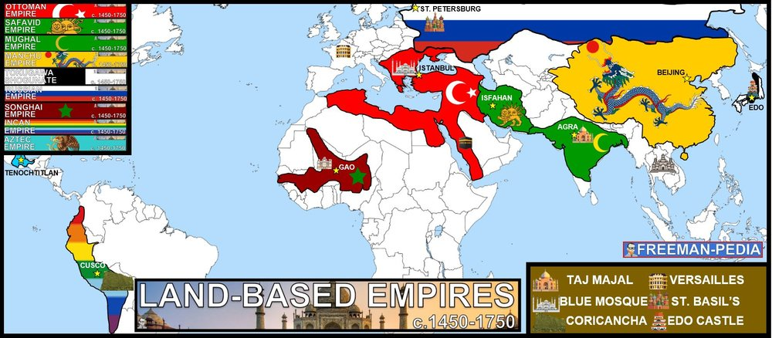

Unit 3: Land-Based Empires (1450-1750) Context Practice

Instructions: Write a contextual statement for each of the prompts below. This will not only help you review content from Unit 3 (1450-1750), but also help you practice writing context statements which, if done successfully, can earn you one point on both the DBQ and LEQ essays.

To earn this point, the response must relate the topic of the prompt to broader historical events, developments, or processes that occur before, during, or continue after the time frame of the question. This point is not awarded for merely a phrase or reference.

The final sentence of your context should narrow down to the topic of the prompt, tying your contextual statement to your thesis statement.

Prompt 1: Evaluate the extent to which religious ideals were utilized to legitimize political authority in land-based empires during the 1450-1750 time period.

Prompt 2: Evaluate the extent to which monumental art and architecture were utilized to legitimize political authority in land-based empires during the 1450 to 1750 time period.

Prompt 3: Evaluate the extent to which the rulers of land-based empires in the 1450-1750 time period managed diverse populations.

