**UNIT 6 IMPERIALISM CARTOON ANALYSIS**

**WE ARE ENTERING INTO A GOLDEN AGE FOR POLITICAL CARTOONS. SO, LET’S ANALYZE SOME OF THESE CARTOONS THAT APPLY TO 19TH CENTURY EUROPEAN IMPERIALISM.**

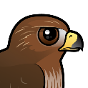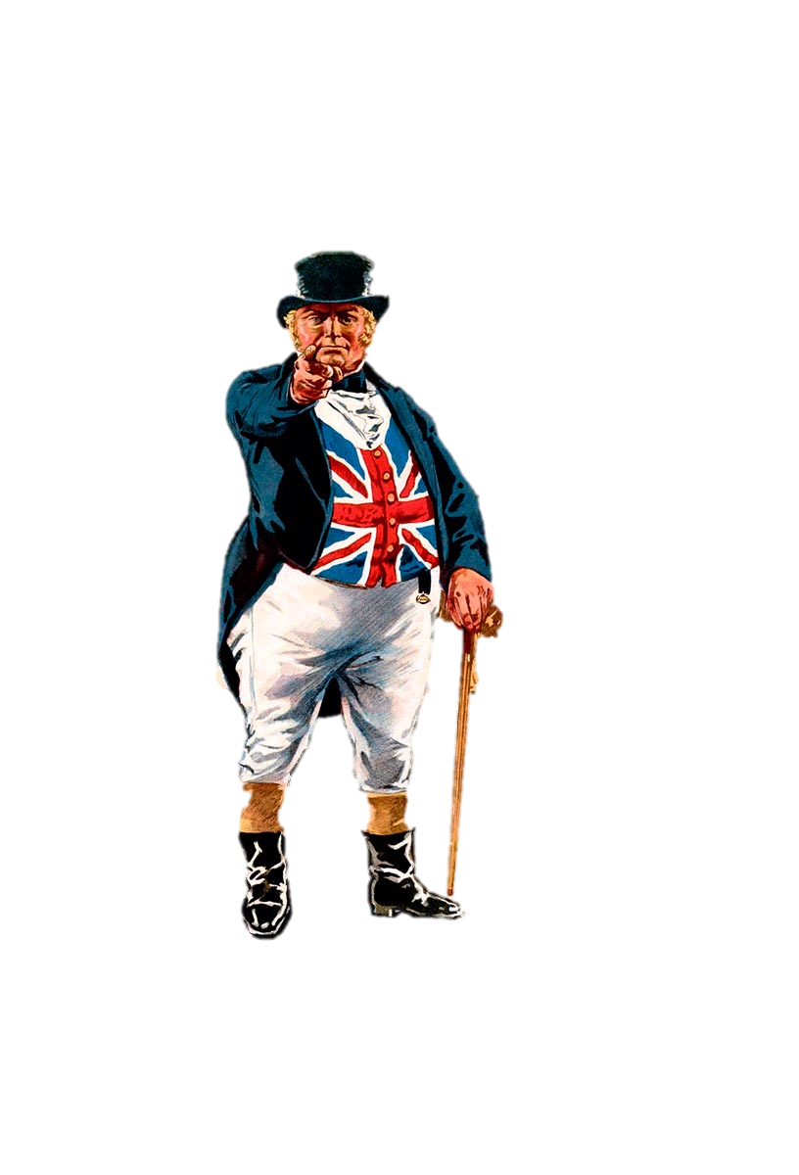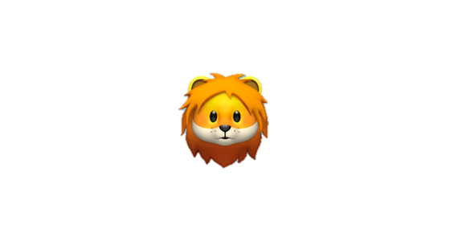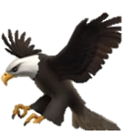

MEET THE



PLAYERS

**BALD EAGLE DRAGON CROCODILE LION JOHN BULL BEAR ROOSTER EAGLE/ TIGER LEOPARD WOLF**

**VULTURE**

**WHO DO THESE SYMBOLS REPRESENT?**

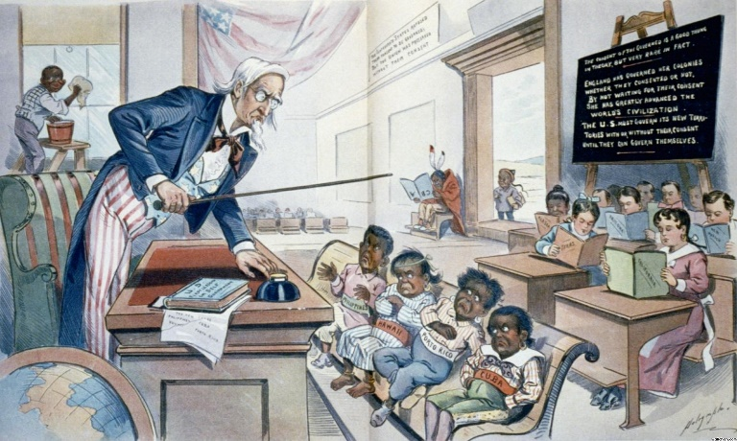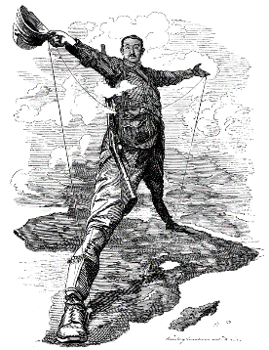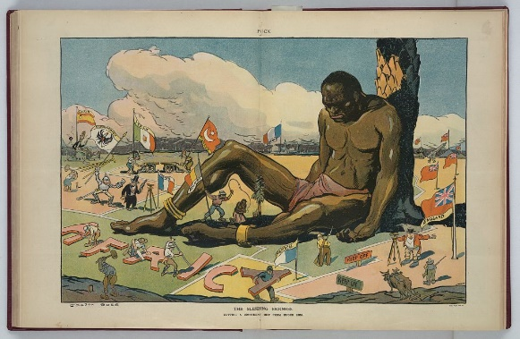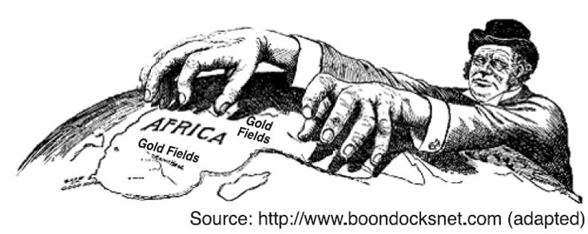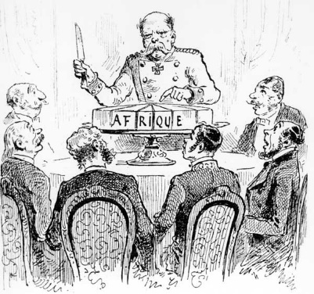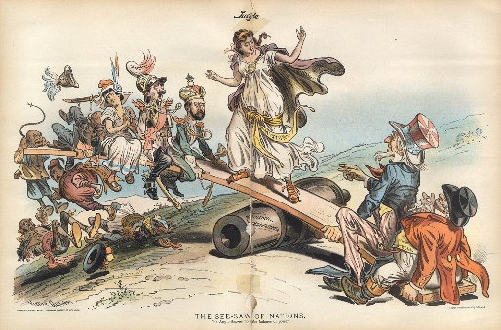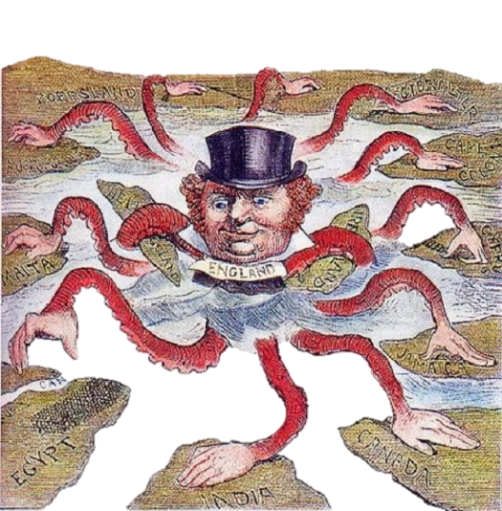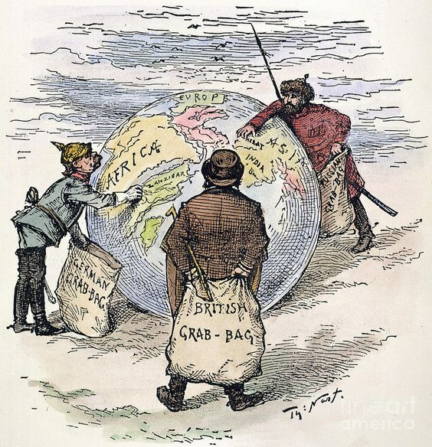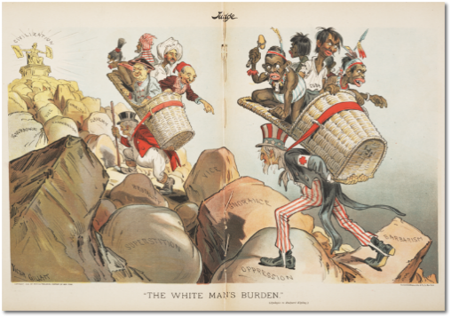

**1 2 3 4 5 6 7 8 9**

**SMALLER VERSION OF THE CARTOONS WE SAW IN CLASS. CHECK THE CLASS NOTES FOR THE FULL VERSION**

CAPTION?

**WHAT TEXT IS WRITTEN ON THE CARTOON?**

**1.   
2.   
3.   
4.   
5.**

**1.   
2.   
3.   
4.   
5.**

**1.   
2.   
3.   
4.   
5.**

**1.   
2.   
3.   
4.   
5.**

**1.   
2.   
3.   
4.   
5.**

**1.   
2.   
3.   
4.   
5.**

**1.   
2.   
3.   
4.   
5.**

**1.   
2.   
3.   
4.   
5.**

**1.   
2.   
3.   
4.   
5.**

LIST THE

OBJECTS:

**_______  
represents  
_______**

**_______  
represents  
_______**

**_______  
represents  
_______**

**_______  
represents  
_______**

**_______  
represents  
_______**

**_______  
represents  
_______**

**_______  
represents  
_______**

**_______  
represents  
_______**

**_______  
represents  
_______**

SYMBOLS?

**_______  
represents  
_______**

**_______  
represents  
_______**

**_______  
represents  
_______**

**_______  
represents  
_______**

**_______  
represents  
_______**

**_______  
represents  
_______**

**_______  
represents  
_______**

**_______  
represents  
_______**

**_______  
represents  
_______**

**WHICH OF THE OBJECTS YOU LISTED ABOVE ARE ACTUALLY SYMBOLS?**

WHAT’S THE MESSAGE?

/

/

/

/

/

/

/

/

/

**WHAT IS THE ARTIST TRYING TO CONVEY?**

AGREE/DISAGREE

**WHAT GROUPS WOULD AGREE/ DISAGREE WITH THIS MESSAGE?**

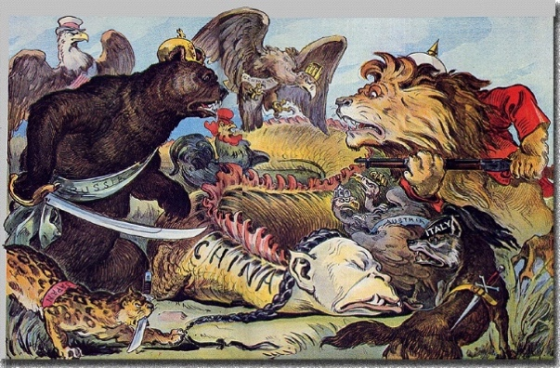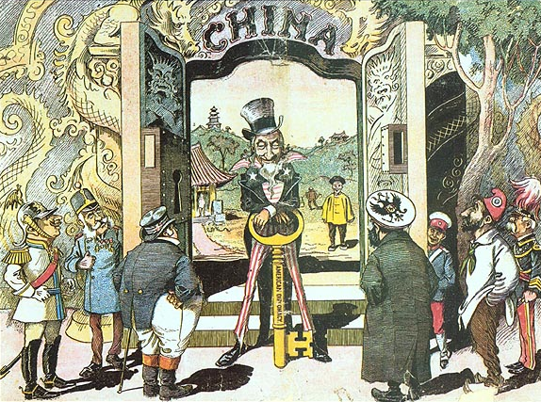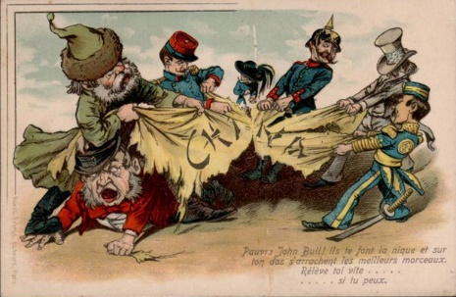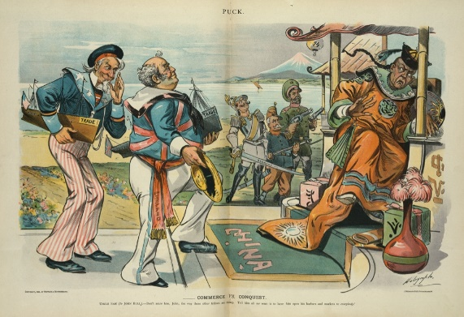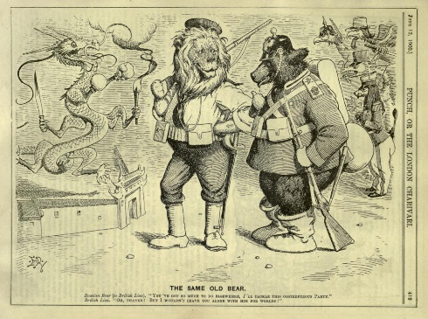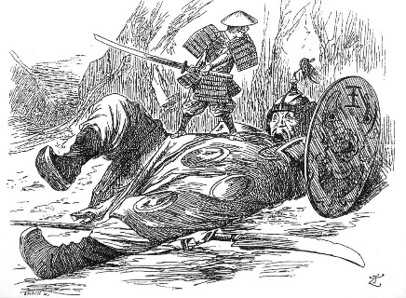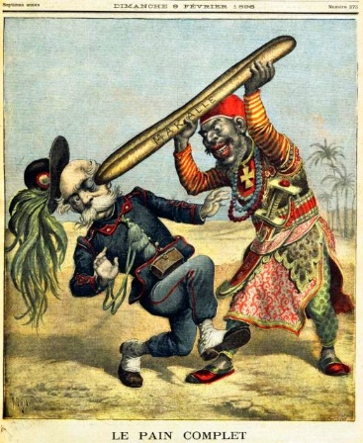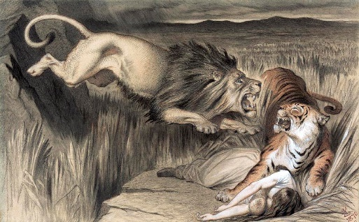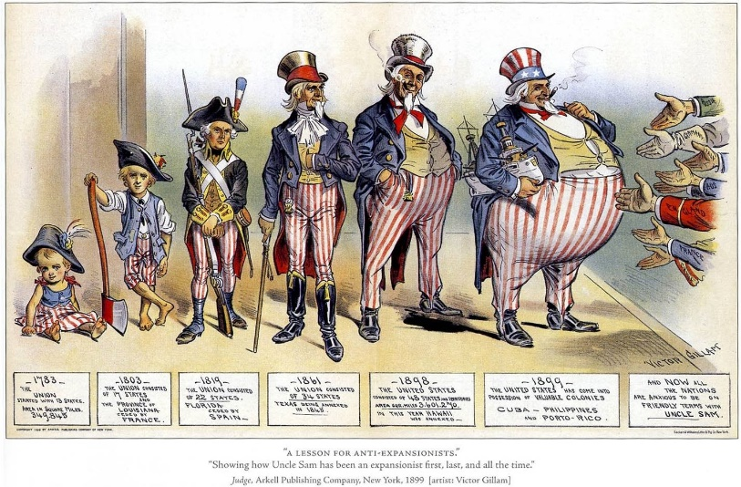

**10 11 12 13 14 15 16 17 18**

CAPTION?

**SMALLER VERSION OF THE CARTOONS WE SAW IN CLASS. CHECK THE CLASS NOTES FOR THE FULL VERSION**

LIST THE

**1.   
2.   
3.   
4.**

**1.   
2.   
3.   
4.**

**1.   
2.   
3.   
4.**

**1.   
2.   
3.   
4.**

**1.   
2.   
3.   
4.**

**1.   
2.   
3.   
4.**

**1.   
2.   
3.   
4.**

**1.   
2.   
3.   
4.**

**1.   
2.   
3.   
4.**

OBJECTS:

SYMBOLS?

**_______  
represents  
_______**

**_______  
represents  
_______**

**_______  
represents  
_______**

**_______  
represents  
_______**

**_______  
represents  
_______**

**_______  
represents  
_______**

**_______  
represents  
_______**

**_______  
represents  
_______**

**_______  
represents  
_______**

**WHICH OF THE OBJECTS YOU LISTED ABOVE ARE ACTUALLY SYMBOLS?**

MESSAGE?

WHAT’S THE



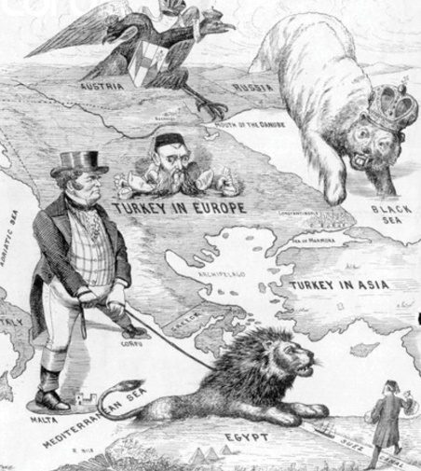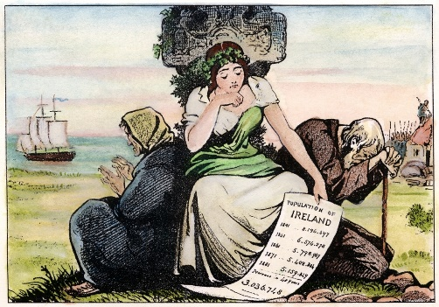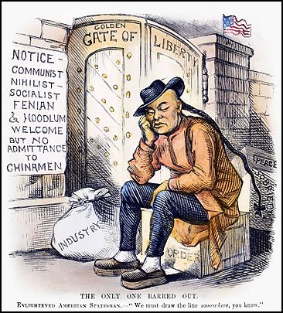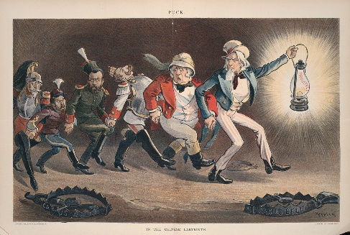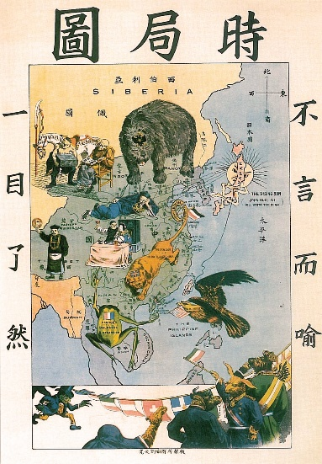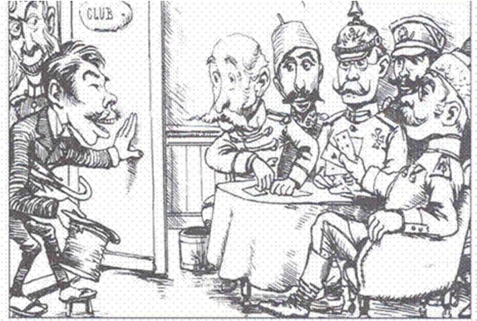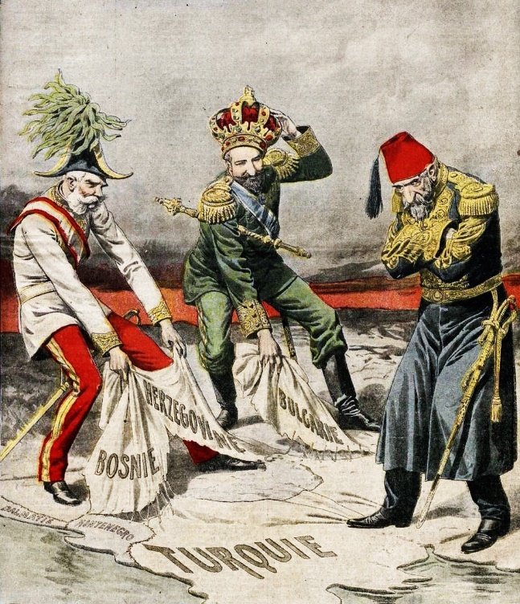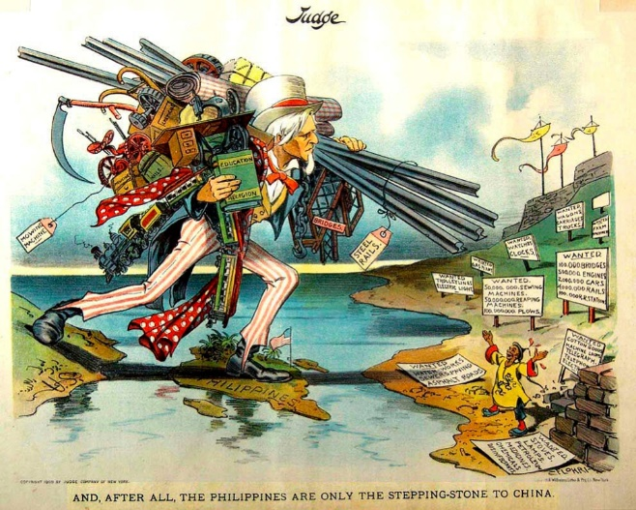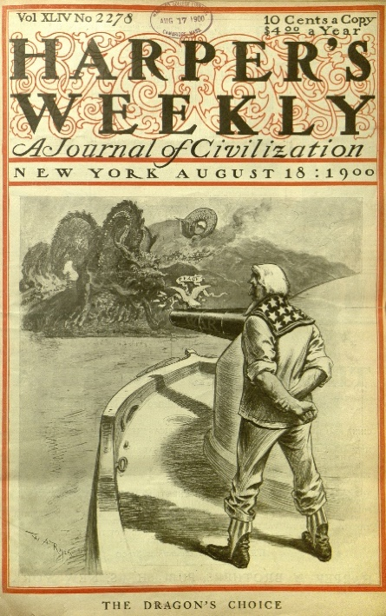

**SMALLER VERSION OF THE CARTOONS WE SAW IN CLASS. CHECK THE CLASS NOTES FOR THE FULL VERSION**

**19 20 21 22 23 24 25 26 27**

MESSAGE?

WHAT’S THE

**WHICH OF THE OBJECTS YOU LISTED ABOVE ARE ACTUALLY SYMBOLS?**

SYMBOLS?

OBJECTS:

LIST THE

CAPTION?

**1.   
2.   
3.   
4.**

**1.   
2.   
3.   
4.**

**1.   
2.   
3.   
4.**

**1.   
2.   
3.   
4.**

**1.   
2.   
3.   
4.**

**1.   
2.   
3.   
4.**

**1.   
2.   
3.   
4.**

**1.   
2.   
3.   
4.**

**1.   
2.   
3.   
4.**

**_______  
represents  
_______**

**_______  
represents  
_______**

**_______  
represents  
_______**

**_______  
represents  
_______**

**_______  
represents  
_______**

**_______  
represents  
_______**

**_______  
represents  
_______**

**_______  
represents  
_______**

**_______  
represents  
_______**